Grammaria: An Android-Based Tutorial Application in English for Grade 6 Students

**A Capstone Project Presented to the Faculty of the**

**Information and Communications Technology Program STI College Balayan**

**In Partial Fulfilment**

**of the Requirements for the Degree Bachelor of Science in Information Technology**

**Zyber Riel L. Adona**

**Harold G. Factor**

**Mark Jonel H. Garcia**

**Kenneth P. Jardiniano**

**November 2024**

**ENDORSEMENT FORM FOR FINAL DEFENSE**

**TITLE OF RESEARCH: Grammaria: An Android-Based Tutorial Application in English for Grade 6 Students**

**NAME OF DEVELOPERS:** Zyber Riel L. Adona

Harold G. Factor

Mark Jonel H. Garcia

Kenneth P. Jardiniano

In Partial Fulfilment of the Requirements

for the degree Bachelor of Science in Information Technology

has been examined and is recommended for Oral Defense.

**ENDORSED BY:**

Ms. Terranya M. Tiamson

**Capstone Project Adviser**

**APPROVED FOR FINAL DEFENSE:**

Ms. Terranya M. Tiamson

**Capstone Project Coordinator**

**NOTED BY:**

Ms. Terranya M. Tiamson

**Program Head**

**November 2024**

# APPROVAL SHEET

This capstone project proposal titled: **“Grammaria: An Android-Base Tutorial Application in English for Grade 6 Students”** prepared and submitted by **Zyber Riel L. Adona**, **Harold G. Factor**, **Mark Jonel H. Garcia**, and **Kenneth P. Jardiniano**, in partial fulfillment of the requirements for the degree of Bachelor of Science in Information Technology, has been examined and is recommended for acceptance and approval.

Ms. Terranya M. Tiamson

**Capstone Project Adviser**

Accepted and approved by the Capstone Project Review Panel

in partial fulfillment of the requirements for the degree of

Bachelor of Science in Information Technology

|  |  |
| --- | --- |
| Ms. Maria Lalaine L. Ilang-Ilang | Mr. Jim Alfred M. Comia |
| **Panel Member** | **Panel Member** |

Ms. Maria Teresa J. Olea

**Lead Panelist**

**Noted:**

|  |
| --- |
| Ms. Terranya M. Tiamson |
| **Capstone Project Coordinator/ Program Head** |

**November 2024**

**ACKNOWLEDGEMENTS**

Creating Grammaria: An Android-Based Tutorial Application in English for Grade 6 Students has been a journey of learning, growth, and collaboration, and we are deeply grateful to all those who supported us along the way.

First and foremost, we would like to express our sincere gratitude to Ms. Maria Teresa J. Olea, our thesis adviser, whose invaluable advice, tolerance, and support have been a continual source of motivation. We appreciate your encouragement to strive for excellence and your belief in our vision.

Our Capstone Project Coordinator, Ms. Terranya M. Tiamson, is also greatly appreciated for her unwavering support and ability to keep us on course. We appreciate all of your time and work in making our success possible.

We would like to express our sincere gratitude to the Capstone Panelists, Ms. Richelle Q. Abiad, Ms. April Joy A. Reyes, and Ms. Terranya M. Tiamson, who served as the Lead Panelist. Their comments and recommendations enabled us to make our work better. We sincerely appreciate your advice and insights.

Our School STI College Balayan, especially to our President, Mrs. Ellen Christy A. Dimaano, for providing us with the best education.

Fifth, to our beloved family for their unconditional support and financial assistance.

Above all, we to our Almighty God, who guided us by giving wisdom and determination in conducting this project. We are very thankful to have you, our God, for making all of these things possible.

# ABSTRACT

Title of research: **Grammaria: An Android-Based Tutorial Application in English for Grade 6 Students**

Researchers: **Zyber Riel L. Adona**

**Harold G. Factor**

**Mark Jonel H. Garcia**

**Kenneth P. Jardiniano**

Degree: **Bachelor of Science in Information Technology**

Date of Completion: **November 2024**

Keywords: **Tutorial Application, Supplementary Tool, English Subject, Grade 6, Interactive, Android-Based**

This capstone project introduces an Android-based tutorial application in English for Grade 6 students to help them learn English. The Android-based tutorial application aims to give students a supplementary tool that will help them learn more in the English subject. It promotes learning among Grade 6 students by allowing them to explore topics and concepts independently. The application integrates elements of fun and interactivity to create an enjoyable and effective learning experience for students.

This application is an interactive tutorial app aiming to address the challenges faced by Grade 6 students in learning the English subject. Through simple and user-friendly interfaces, the application aims to make the learning process of English enjoyable

# Table of Contents

|  |  |  |
| --- | --- | --- |
|  | | Page |
| Title Page | | i |
| Endorsement Form for Oral Defense | | ii |
| Abstract | | iii |
| Approval Sheet | | iii |
| Acknowledgments | | iv |
| Table of Contents | | vi |
| List of Figures | | viii |
| List of Tables | | x |
| Introduction | | 1 |
|  | Project Context | 1 |
|  | Purpose and Description | 2 |
|  | Objectives | 3 |
|  | Scope and Limitations  Review of Related Literature/Studies/Systems | 5  16 |
| Methodology | | 24 |
|  | Requirements Analysis | 31 |
|  | Requirements Documentation | 32 |
|  | Design of Software, System, Product, and/or Processes | 39 |
|  | Development | 43 |
| Results and Discussion | | 44 |
|  | Testing | 44 |
|  | Description of Prototype | 48 |
|  | Implementation Plan | 61 |
|  | Implementation Results | 61 |
| Conclusion | | 61 |
| References | | 62 |
| Appendices | | 65 |
| Appendix A. Resource Persons | |  |

|  |  |
| --- | --- |
| **Appendix B. Letter to Respondents** |  |
| Letter to the Beneficiary (Mrs. Aida S. Cudiamat - Pook Elementary School) | B-1 |
| Letter to the Beneficiary (Mr. Eric B. Panganiban- Baclaran Elementary School) | B-2 |
| Letter to the Beneficiary (Mrs. Geresa C. Alday - Santol Elementary School) | B-3 |
| **Appendix C. Transcript of Interview** |  |
| Transcript of Interview (Pook Elementary School) | C-1 |
| Transcript of Interview (Baclaran Elementary School) | C-2 |
| Transcript of Interview (Santol Elementary School) | C-3 |
| **Appendix D. Sample Survey Questionaire** |  |
| **Appendix E. Survey Summary** |  |
| Survey Summary of Baclaran Elementary School | E-1 |
| Survey Summary of Pook Elementary School | E-2 |
| Survey Summary of Santol Elementary School | E-3 |
| **Appendix F. Source Document** |  |
| **Appendix G. Letter of Approval** |  |
| **Appendix H. Relevant Source Code** |  |
| **Appendix I. Evaluation Tool or Test Documents** |  |
| **Appendix J. User’s Manual**  **Appendix K. Sample Accomplishment and Consultation Form** |  |
| **Appendix L. Personal Technical Vitae** |  |

|  |  |
| --- | --- |
| **List of Figures** |  |

|  |  |  |  |
| --- | --- | --- | --- |
| **Figure 1:** Hierarchical Diagram of Grammaria | 32 | Hierarchical Diagram of Maharlika | **Figure 1** |
| **Figure 2:** Hierarchical Diagram of Grammaria: Tutorial Topics | 33 | Block Diagram of Creating a New Game | **Figure 2** |
| **Figure 3:** Block Diagram of Grammaria – Settings | 35 | Story Boarding | **Figure 3** |
| **Figure 4:** Block Diagram of Grammaria - Leaderboards | 35 | Block Diagram of Leaderboard | **Figure 4** |
| **Figure 5:** Block Diagram of Grammaria - About | 35 | Block Diagram of Settings | **Figure 5** |
| **Figure 6:** Block Diagram of Grammaria - Exit | 36 | Block Diagram of About | **Figure 6** |
| **Figure 7:** Storyboard of Grammaria from Main Menu to Verb Tenses Topic | 36 | Block Diagram of Exit Game | **Figure 7** |
| **Figure 8:** Storyboard of Grammaria from Main Menu to Conjunction Topic | 37 | Storyboard of Maharlika from Main Screen to Stage 1 | **Figure 8** |
| **Figure 9:** Storyboard of Grammaria from Main Menu to Adverb Topic | 37 | Storyboard of Maharlika - Main Module | **Figure 9** |
| **Figure 10:** Storyboard of Grammaria – Main Menu Module | 38 | Waterfall Methodology Waterfall Methodology | **Figure 10** |
| **Figure 11:** Waterfall Model of Grammaria | 39 | Context Diagram | **Figure 11** |
| **Figure 12:** Entity Relationship Diagram of Grammaria | 41 | Entity Relationship Diagram | **Figure 12** |
| **Figure 13:** Context Diagram of Grammaria | 41 | Start Screen of Maharlika | **Figure 13** |
| **Figure 14:** Start Screen | 48 | Signup Menu of Maharlika | **Figure 14** |
| **Figure 15:** Sign-up | 48 | Main Menu of Maharlika | **Figure 15** |
| **Figure 16:** Home | 49 | Setting Module of Maharlika | **Figure 16** |
| **Figure 17:** Topic Selection | 50 | About Module of Maharlika | **Figure 17** |
| **Figure 18:** Verb Tenses | 50 | Maharlika Saved Game | **Figure 18** |
| **Figure 19:** Activity Selection | 51 | Opening Animation of Maharlika | **Figure 19** |
| **Figure 20:** Verb Tenses Tutorial Video | 51 | NPC Dialog | **Figure 20** |
| **Figure 21:** Simple Tense Quiz | 52 | In-game Interface | **Figure 21** |
| **Figure 22:** Perfect Tense Tutorial Video | 52 | Stage 1 Sample Trivia | **Figure 22** |
| **Figure 23:** Perfect Tense Quiz | 53 | Stage 1 Sample Question | **Figure 23** |
| **Figure 24:** Conjunction | 53 | Correct Answer Feedback | **Figure 24** |
| **Figure 25:** Coordinating Conjunction Tutorial Video | 54 | Incorrect Answer Feedback | **Figure 25** |
| **Figure 26:** Coordinating Conjunction Quiz | 54 | Stage 2 Sample Trivia | **Figure 26** |
| **Figure 27:** Subordinating Conjunction Tutorial Video | 55 | Stage 2 Sample Question | **Figure 27** |
| **Figure 28:** Subordinating Conjunction Quiz | 55 | Correct Answer Feedback | **Figure 28** |
| **Figure 29:** Adverbs | 56 | Incorrect Answer Feedback | **Figure 29** |
| **Figure 30:** Adverb of Manner Tutorial Video | 56 | Stage 3 Sample Trivia | **Figure 30** |
| **Figure 31:** Adverb of Manner Quiz | 57 | Stage 3 Sample Question | **Figure 31** |
| **Figure 32:** Adverb of Time Tutorial Video | 57 | Correct Answer Feedback | **Figure 32** |
| **Figure 33:** Adverb of Time Quiz | 58 | Incorrect Answer Feedback | **Figure 33** |
| **Figure 34:** Adverb of Place Tutorial Video | 58 | Final Boss Interface | **Figure 34** |
| **Figure 35:** Adverb of Place Quiz | 58 | Story Animation-Ending | **Figure 35** |
| **Figure 36:** User Profile | 59 | Leaderboard Interface | **Figure 36** |
| **Figure 37:** Leaderboards | 60 |  |  |
| **Figure 38:** About | 60 |  |  |

|  |  |
| --- | --- |
| **List of Tables** |  |
| **Table 1:** Tenses of Verb Topic | 9 |
| **Table 2:** Conjunction Topic | 11 |
| **Table 3:** Adverb Topic | 14 |
| **Table 4:** Mini Game | 15 |
| **Table 5:** IT Capstone 1 Gantt Chart of Activities | 27 |
| **Table 6:** IT Capstone 2 Gantt Chart of Activities | 28 |
| **Table 7:** Data Dictionary: Users | 42 |
| **Table 8:** Data Dictionary: Leaderboards | 42 |
| **Table 9:** Home Module Testing | 44 |
| **Table 10:** Signup Module Testing | 45 |
| **Table 11:** Start Module Testing | 45 |
| **Table 12:** Tutorial Module Testing | 46 |
| **Table 13:** User Profile Module Testing | 47 |
| **Table 14:** Leaderboard Module Testing | 47 |

# INTRODUCTION

Technology continues to grow rapidly, incorporated into everyday life, including education and work. This leads to an innovative way for students to learn through the development of educational applications. According to Shoaib (2023), Player uses critical thinking skills to advance. This allows students to push themselves into using critical thinking, planning, and coming up with creative solutions. These problem-solving abilities go beyond the virtual environment and aid in the development of student's capacity to tackle difficulties in the actual world with consideration and analysis. This creative integration has not only revolutionized educational practices but has also led to remarkable outcomes, enhancing student involvement and promoting better understanding across different learning stages.

**Project Context**

Students need to understand the importance of learning English. It is one of the five core subjects along with Science, Mathematics, Filipino, and Araling Panlipunan. However, it is a challenging subject for the students to learn, because it is not their first language. But it is an important subject to learn as it can be used to communicate with people outside the country, and with the era of technology communicating through the internet is much more apparent and the main language that is used here is the English language.

Currently, the teachers in the different schools in District 1, where the developers conducted their survey, use the traditional method of teaching. The traditional method of teaching uses discussion, groupings, inquiry method, cooperative, collaborative, interactive and student- centered activity. (See Appendix C)

Based on the interview and survey conducted by the proponents, these are the following reasons why students struggle in learning English: (See Appendix C)

**Lack of English practice**

English is one of the hardest subjects for students to learn and with the lack of practice the students will have a hard time learning. Lack of practice in English can lead to students' having difficult time understanding English. Without many opportunities to practice speaking, listening, reading, and writing in English, students may struggle to understand concepts.

**Lack of supplementary learning materials**

Most schools do not have sufficient resources for students to access a wide range of learning materials. Learning materials are more focused on basic skills in most schools, so learning materials for students lack more specialized topics. In addition, in a technological era, not all students have access to digital learning materials, which limits their ability to access these learning materials.

**Purpose and Description**

The primary purpose of this capstone project is to develop a tutorial application that will provide an entertaining way of learning to Grade 6 students in selected topic of English subject in which the student deemed to find most difficult, such as Tenses of Verb, Subordinating and Coordinating Conjunctions, and Adverbs of Manner, Place, and Time. The developer is making the application like a fun challenge, with quizzes and rewards to complete. This will help students stay interested and motivated to learn. The students will get better at understanding and remembering the topics that they find difficult. The application will let students learn at their own speed, which helps boost their confidence. Teachers can also use this application in class to support their lessons and let the students use it on their own to practice and improve their English skills.

The developers created an Android-based tutorial application, “Grammaria”, which is designed to be easy to use and exciting to play. The application consists of video discussions, quizzes, and mini games which focuses on developing understanding on specific topics in English such as Tenses of Verb, Subordinating and Coordinating Conjunctions, and Adverbs of Manner, Place, and Time. The player must watch the videos and answer questions in order to finish the topic. The students will receive points based on the task they have completed. This will help students stay interested and motivated to learn.

**Objectives**

Grammaria, is an Android-based tutorial application aiming for the Grade 6 curriculum, focusing on English lesson. The developed application includes specific topics covering grammar, vocabulary, sentence structure, and critical thinking of the students.

The general objective of the application “Grammaria” is to implement an interactive digital app aimed at addressing the specific challenges faced by Grade 6 students in mastering aspects of the English subject. This application aims to aid the students to learn different topics relating to English and make it easier to understand. The app can provide the students additional learning materials for English to help students access more specialized topics. By incorporating elements of fun and interactivity, the application is intended to foster a more enjoyable and effective learning experience for students.

The developers based the application on gathered information from interviews and surveys of the students and Grade 6 advisers. (See Appendix C and Appendix D)

The following are specific objectives of the developed application:

**To develop and implement a captivating mobile learning application that offers students English practice**

Most of Grade 6 students today spend a substantial amount of time immersed in various applications. To be able to help them practice their English skills and make the process more enjoyable and engaging, a learning application can be developed. By integrating conversational English elements into this app, students can learn and practice their proficiency while being entertained at the same time. This approach allows them to practice their English skills in a fun and interactive way, keeping them interested and motivated to continue learning the English language

**To develop and implement a learning application that will serve as a supplementary tool for students.**

The developers developed an application aims to give students a supplementary tool that will help them learn more in English. This objective focuses on empowering students to take control of their learning journey by providing them with opportunities to progress through the app. By allowing students to explore topics and concepts independently, the app promotes self-directed learning among Grade 6 students

The Android-based tutorial application will benefit the following:

**Students**

The app that will be created can assist students in developing both their interest and understanding pertaining to the English language and grammar.

**Teachers**

The teachers will benefit from the developed application because it can be used as a teaching aid for their students. Teachers can use it to help students’ practice, consolidate, and apply their knowledge and language abilities in a fun and interesting way.

**Parents**

This will help parents to make sure that their kids can learn through tutorial applications that emphasize English language and grammar in addition to more traditional physical methods.

**Future Researchers**

Future researchers will receive ideas that can be used as a guide as they conduct the same study. This will make it easier for them to create tutorial applications in the future.

**Developers**

The developed application will showcase the developers' technical abilities and demonstrate their creativity and problem-solving skills in designing educational tools that address specific learning challenges.

**STI College Balayan**

The development of the tutorial application by the students of STI College Balayan will demonstrate the dedication of the institution to offer high-quality education and training to its students. The institution will gain a reputation for excellence in technology and programming education, attracting students who are interested in pursuing careers in this field.

**Scope and Limitations**

**Scope**

**Player**

Before starting the application, the player needs to log in their account by inputting their username then click the log in button. If the player does not have an account, they need to create a new account by clicking the signup button and provide a username.

**Application Characters**

**Player**

The player is the application user that is eager to learn to improve their English and grammar skills. The player interacts with Teacher Mark, participates in activities, and answer quizzes

**Teacher Mark**

The engaging and supportive English teacher who provides lessons and guides the player through activities

**Main Menu**

**Home**

This button will be used to display the application’s home screen which includes the description of the app.

**Start**

This button will be used to initiate the app and directs the player to the topic’s selection screen. Each topic includes English tutorial and quizzes focusing in verb tenses, conjunctions, and adverb.

**User Profile**

This button will be used to display the process of the user showing the highest score for each topic.

**About**

This button will be used to display the developers of the application.

**Leaderboard**

This button will be used to display the player points and players with highest points.

**Exit**

This button will be used to let the player leave the app.

**Application Functions**

The player will use these functions to perform actions in the app.

**Tap**

This control will be used to select and interact with buttons, menu items, and other interactive elements on the screen

**Drag and Drop**

This control will be used for activities that require matching or sorting words to form proper sentence.

**Tap and Hold**

This control will be used for activities that require attaching and connecting words to form proper sentence.

**Pause Menu**

This paused button will be used to stop the quiz and let players to have the options to choose.

**Music Toggle**

This option will allow the user to turn on or turn off the background music.

**Sound Toggle**

This option will allow the user to turn on or turn off the sound effects.

**Resume**

This option will allow the user to continue the quiz.

**Exit**

This option will allow the user to exit the quiz and return to previous menu.

**Points Indicator**

The points indicator will be display on the top right screen which allow the players to see the number of points they gained after completing the quiz. These points will be used to show the player's rank on the leaderboard.

**Coins Indicator**

The coins indicator will be display under the points indicator which indicates the number of coins the player gathered during the quiz. For the first time players, they will receive a total of 200 coins. These coins can be used to buy hints.

**Hint Indicator**

The hint indicator will be display under the coins indicator which indicates the number of hints the player has. The hint costs 100 coins and can only be used once during the quiz.

**Mechanics**

Upon pressing the start button on the home screen, the player will be directed to the topic’s selection screen.

* **Lesson Selection and Subtopics**: Players will be presented with a screen of different lesson such as tenses of verbs, conjunctions, and adverbs. When the player selects a lesson topic, they will see the subtopics listed underneath it.
* **Subtopic Selection**: After selecting the subtopic, players will enter the quiz screen where they are presented with a series of questions designed to test their knowledge.
* **Tutorial**: To unlock the quiz, players must first watch a tutorial discussion associated with that lesson. The tutorial discussion features Teacher Mark explaining the concept, providing examples, and offering tips for understanding.
* **Interactive Quizzes**: Initially, the quizzes are locked, indicated by lock icon. Each subtopic consists of different interactive quizzes, offering a variety of challenges to keep app engaging. Questions may vary in complexity, requiring players to identify the correct answers to form a proper sentence.
* **Revisiting Tutorials:** Players can revisit the tutorials at any time for reinforcement or clarification. This encourages continuous learning and reinforces understanding of the lesson concepts.
* **Point System:** After answering each quiz, players will receive immediate feedback on their response. Correct answers earn points, while incorrect answers do not deduct points.
* **Time Limit:** To add an extra challenge, players have a five minutes time limit to complete each quiz. This encourages quick thinking and reinforces fluency in identifying and applying the correct answers.
* **Hint System:** If players get stuck on an activity, they can use hints. Hints might provide clues about the correct answer or offer guidance on forming the sentence properly.
* **Test Completion:** At the end of each quiz, players receive feedback on their performance, including the number of correct answers, points earned, and coins rewarded.

**Tenses of Verb Topic**

**Simple Tenses**

* In this quiz, the player will be presented with a set of scattered words and must form a proper sentence by connecting them in the correct order.
* The player needs to tap and hold a word, then draws a line to connect it to the next word in the sentence. This process is repeated until all words are connected.
* The quiz consists of 10 different sentences. If the sentence is correct, the player earns 10 points. If incorrect, no points are awarded and then proceed to the next sentence until all are answered or the timer runs out.
* The player will have a total of 5 minutes to complete all ten sentences. Players must complete each sentence within this period to earn points. If the timer runs out, the quiz stops, and display the summary of their correct answers.
* Players can use hints to get assistance with forming the sentence. The hint highlights the next correct word in the sequence. The hint costs 100 coins and can only be used once during the entire quiz.
* If the player answers all 10 correctly, they will receive 100 bonus coins. If the player scores 9 correctly, they will receive 80 bonus coins and if they score 8 correctly, they will receive 50 bonus coins as a reward. If the player scores 7 correct answers or less, they will receive no rewards.

**Perfect Tenses**

* In this quiz, players will construct proper sentences using perfect tenses by tapping the right words in the correct order scattered on the screen. This activity aims to reinforce their understanding of how to form sentences in the perfect tenses.
* The quiz consists of 10 different sentences. If the sentence is correct, the player earns 10 points. If incorrect, no points are awarded and then proceed to the next sentence until all are answered or the timer runs out.
* The player will have a total of 5 minutes to complete all ten sentences. Players must complete each sentence within this period to earn points. If the timer runs out, the quiz stops, and display the summary of their correct answers.
* Players can use hints to get assistance with forming the sentence. The hint highlights the next correct word in the sequence. The hint costs 100 coins and can only be used once during the entire quiz.
* If the player answers all 10 correctly, they will receive 100 bonus coins. If the player scores 9 correctly, they will receive 80 bonus coins and if they score 8 correctly, they will receive 50 bonus coins as a reward. If the player scores 7 correct answers or less, they will receive no rewards.

Table 1: Tenses of Verb Topic

|  |  |  |
| --- | --- | --- |
| Topic | Activity | Mechanics |
| Verb Tenses | Simple Tenses  Interactive Challenge: Connecting words using lines | Score: 1 correct = 10 points  Hint Price: 100 coins  8/10 score reward: 50 coins  9/10 score reward: 80 coins  10/10 score reward: 100 coins |
| Perfect Tenses  Interactive Challenge: Tapping the words in correct order |

**Conjunction Topic**

**Coordinating Conjunction**

* In this quiz, players will complete a jigsaw puzzle to practice the use of coordinating conjunctions. The puzzle consists of jigsaw pieces: the two pieces are in fix place containing parts of sentences, and there are three pieces below containing conjunctions as options. The player must choose the jigsaw piece correctly from the options to form a proper sentence.
* The player will be presented with the jigsaw puzzle pieces on the screen. The player needs to drag the correct piece to the drop zones to form a correct sentence. The goal is to connect the two sentence pieces with the appropriate conjunction.
* The quiz consists of 10 different sentences. If the sentence is correct, the player earns 10 points. If incorrect, no points are awarded and then proceed to the next sentence until all are answered or the timer runs out.
* The player will have a total of 5 minutes to complete all ten sentences. Players must complete each sentence within this period to earn points. If the timer runs out, the quiz stops, and display the summary of their correct answers.
* Players can use hints to get assistance with forming the sentence. The hint automatically removes a piece from the options. The hint costs 100 coins and can only be used once during the entire quiz.
* If the player answers all 10 correctly, they will receive 100 bonus coins. If the player scores 9 correctly, they will receive 80 bonus coins and if they score 8 correctly, they will receive 50 bonus coins as a reward. If the player scores 7 correct answers or less, they will receive no rewards.

**Subordinating Conjunction**

* In this quiz, players will complete sentences using subordinating conjunctions by forming the correct conjunction from a selection of letters provided at the bottom of the screen. This activity aims to reinforce their understanding of how to use subordinating conjunctions to create complex sentences.
* The player is presented with a sentence that needs a subordinating conjunction to be complete. A set of individual letters is displayed at the bottom of the screen.
* The player needs to select and tap letters from the letter bank to form the correct conjunction. After tapping the letters, it will display to the blank space on the screen.
* The quiz consists of 10 different sentences. If the sentence is correct, the player earns 10 points. If incorrect, no points are awarded and then proceed to the next sentence until all are answered or the timer runs out.
* The player will have a total of 5 minutes to complete all ten sentences. Players must complete each sentence within this period to earn points. If the timer runs out, the quiz stops, and display the summary of their correct answers.
* Players can use hints to get assistance with forming the sentence. The hint automatically displays a correct letter in the blank space. The hint costs 100 coins and can only be used once during the entire quiz.
* If the player answers all 10 correctly, they will receive 100 bonus coins. If the player scores 9 correctly, they will receive 80 bonus coins and if they score 8 correctly, they will receive 50 bonus coins as a reward. If the player scores 7 correct answers or less, they will receive no rewards.

Table 2: Conjunction Topic

|  |  |  |
| --- | --- | --- |
| Topic | Activity | Mechanics |
| Conjunctions | Coordinating Conjunction  Interactive Challenge: Jigsaw Puzzle | Score: 1 correct = 10 points  Hint Price: 100 coins  8/10 score reward: 50 coins  9/10 score reward: 80 coins  10/10 score reward: 100 coins |
| Subordinating Conjunction  Interactive Challenge: Sentence Completion |

**Adverb**

**Adverb of Manner**

* In this quiz, players will choose the correct adverb form of the given adjectives. Players will be presented with adjectives, and they need to select the appropriate adverb form from the options provided.
* The player is presented with an adjective and three adverb form options. The player needs to select the appropriate adverb form by dragging it to the corresponding answer box next to the adjective.
* The quiz consists of 10 different adjectives. If the answer is correct, the player earns 10 points. If incorrect, no points are awarded and then proceed to the next word until all are answered or the timer runs out.
* The player will have a total of 5 minutes to complete all ten questions. Players must complete each question within this period to earn points. If the timer runs out, the quiz stops, and display the summary of their correct answers.
* Players can use hints to get assistance. The hint removes one of the words in the options. The hint costs 100 coins and can only be used once during the entire quiz.
* If the player answers all 10 correctly, they will receive 100 bonus coins. If the player scores 9 correctly, they will receive 80 bonus coins and if they score 8 correctly, they will receive 50 bonus coins as a reward. If the player scores 7 correct answers or less, they will receive no rewards.

**Adverb of Time**

* In this quiz, players will practice identifying and matching adverbs of time to appropriate sentences. The player is presented with a sentence on the top and a list of adverbs of time below. The player needs to draw lines to connect the sentence with the correct adverb of time.
* The player is presented with a sentence and three adverbs of time. The player needs to draw a line from the sentence to the correct adverb of time below.
* The quiz consists of 10 different sentences. If the sentence is correct, the player earns 10 points. If incorrect, no points are awarded and then proceed to the next sentence until all are answered or the timer runs out.
* The player will have a total of 5 minutes to complete all ten sentences. Players must complete each sentence within this period to earn points. If the timer runs out, the quiz stops, and display the summary of their correct answers.
* Players can use hints to get assistance with forming the sentence. The hint highlights the correct adverb of time for the sentence. The hint costs 100 coins and can only be used once during the entire quiz.
* If the player answers all 10 correctly, they will receive 100 bonus coins. If the player scores 9 correctly, they will receive 80 bonus coins and if they score 8 correctly, they will receive 50 bonus coins as a reward. If the player scores 7 correct answers or less, they will receive no rewards.

**Adverb of Place**

* In this quiz, players will form correct sentences using adverbs of place by tapping the correct order of words into specified boxes based on an image provided. The image serves as a visual clue to help players understand the context and correctly use the adverb of place.
* The quiz consists of 10 different images. If the sentence is correct, the player earns 10 points. If incorrect, no points are awarded and then proceed to the next image until all are answered or the timer runs out.
* The player will have a total of 5 minutes to complete all ten sentences. Players must complete each sentence within this period to earn points. If the timer runs out, the quiz stops, and display the summary of their correct answers.
* Players can use hints to get assistance with forming the sentence. The hint automatically places a word in the correct box. The hint costs 100 coins and can only be used once during the entire quiz.
* If the player answers all 10 correctly, they will receive 100 bonus coins. If the player scores 9 correctly, they will receive 80 bonus coins and if they score 8 correctly, they will receive 50 bonus coins as a reward. If the player scores 7 correct answers or less, they will receive no rewards.

Table 3: Adverb Topic

|  |  |  |
| --- | --- | --- |
| Topic | Activity | Mechanics |
| Adverb | Adverb of Manner  Interactive Challenge: Word Matching | Score: 1 correct = 10 points  Hint Price: 100 coins  8/10 score reward: 50 coins  9/10 score reward: 80 coins  10/10 score reward: 100 coins |
| Adverb of Time  Interactive Challenge: Sentence Matching |
| Adverb of Place  Interactive Challenge: Sentence Structure Based on the Image |

**Mini Game**

**Word Search**

* The discussion includes a word search activity as a mini game for students.
* The word search mini-game is designed to provide a fun and interactive way for players to test their concentration and visual scanning skills. The player needs to search for words that is also related to topics in verb tenses, conjunctions, and adverbs.
* The player needs to find and click all the letters in sequence to form a word from the word list. Each set has 4 words. Every correct word earns the player 10 points.
* After a set of words is complete, players will receive the total points they earned from the number of words they found.

Table 4: Mini Game

|  |  |  |
| --- | --- | --- |
| Topic | Activity | Mechanics |
| Word Search | Word Search  Interactive Challenge: Find the word by clicking the correct letters in sequence. | Score: 1 correct = 10 points |

**Limitations**

**The application does not support cross-platform.**

The application is only compatible in Android operating system version 7.0 and higher. It does not support other operating system such as iOS, Windows, or Linux

**The application only focuses in specific topics in English VI.**

The application does not cover all the topics. It only consists of Tenses of Verbs, Conjunctions, and Adverbs.

**The application will require an internet connection to access leaderboard.**

The application needs an internet connection for accessing leaders and monitor plate.

**REVIEW OF RELATED LITERATURE/SYSTEMS**

**Local Literature**

**Technology in Education**

According to Espinosa, et al (2023) The COVID-19 pandemic has led to a shift from onsite to online teaching and learning in the Philippines, highlighting existing issues in technology and education. This case study aims to provide insights on how technology can address education challenges and success beyond the pandemic. It uses a systematic review of literature and rapid assessment to identify key factors affecting education technology use. Despite challenges, the study highlights scenarios where education technology can positively affect learning outcomes and education governance. The quality of technology-oriented teaching and assessment has been a growing concern, particularly in online teaching and learning, where authenticity of assessment can be difficult to maintain. Concerns include ensuring student engagement, assessing their understanding of subject matter, and maintaining academic integrity in remote learning environments. Developing effective strategies and tools for assessing student learning in a technology-oriented environment is crucial to ensure students receive quality education relevant to the 21st century demands.

The impact of digital technology on education was discussed in the associated literature. It implies that exposure to technology can improve their educational experiences. These technologies can also be used by teachers as platforms for collaboration, communication, information referencing, and instructional support. By analyzing this study, the developers can evaluate potential challenges and opportunities in integrating technology into education.

**Effectiveness of Animated Video Presentation (AVP) as Supplementary Reading Materials in Reading Comprehension of Grade 3 Learners**

According to Alcala, M. & Tamban, V. (2022) The study explored the effectiveness of Animated Video Presentation (AVP) in improving reading comprehension among Grade 3 students. Using a quasi-experimental design, researchers compared two groups of 72 matched participants. Both groups initially showed low reading comprehension levels in a pre-test. After the intervention, the experimental group, which used AVP, performed significantly better on reading comprehension tests than the comparison group. Statistical analysis confirmed this improvement. The study concluded that AVP is a helpful supplementary tool for enhancing reading comprehension in young learners.

This related literature is relevant to the developer’s project because it highlights the benefits of using video Animated Video Presentation. This understanding guided the developers by integrating Animated Video Presentation in the developed application, ultimately contributing to the improvement of English skills and decision-making of students.

**The Role of Gamification in the Academic Performance of Junior High School Students in Language Subject**

According to Caballero, et al. (2022) The study aimed to investigate the impact of gamification on students' academic performance in Filipino language classes. Using purposive sampling, twenty grade seven students were selected. Both control and experimental groups were tested before and after gamification. Results showed that gamification significantly improved the experimental group's academic performance compared to the control group. This suggests that gamification positively impacts students' academic success, and students expressed enthusiasm for its use in Filipino subjects.

This literature is related to the developer’s project because it highlights the positive effects of gamification in education. This understanding guided the developers to include leaderboards, points, and awards to encourage active participation and make the app fun and enjoyable. These points and leaderboards will also be used to track the progress of each student while playing the application.

**Foreign Literature**

**Psychological Impact and Influence of Animation on Viewer’s Visual Attention and Cognition**

According to Praveen, et al. (2022) Animation is a fun and innovative way to engage audiences, with applications in various fields such as knowledge, marketing, advertising, and age groups. This communication reviews the impact of animation on visual attention, highlighting its integration of different stimuli and organized presentation. Animation aids in conceptual understanding and cognitive response, making it beneficial in learning skills, food marketing, and teaching strategies. The study also discusses drawbacks, future recommendations, challenges, and open issues faced, and highlights priority areas for animation in enhancing visualization of large pool data, providing smart communication, and designing modeling structures.

This related literature is relevant to the developer’s project. The insights from the paper can guide the developers in utilizing the animation and design of the app. This helped the developers to develop an app that can captivate the visual attention of the students and motivate them to play.

**The Roles Sounds Play in Games: A Thematic Literature Study on Immersion, Inclusivity and Accessibility in Game Sound Research**

According to Guillen-Hanson, et al. (2021) The role of audio in video games is increasingly relevant as technologies and sophistication evolve. The design and development of auditory components play a significant role in enabling immersive experiences and promoting inclusivity. Sound design not only deepens immersion but also facilitates accessibility for people with different physical and psychological abilities. It also challenges gender and heritage stereotypes. Designers have explored various methods to facilitate accessibility and inclusion, sometimes intentionally challenging auditory experiences. This study aims to review 47 academic studies on the perceived role of game sound design, its impact on immersion, and its ability to enhance inclusivity and accessibility within games.

This related literature highlights the role of audio in games. This helped the developers to use the right sounds or audio in the development of the application. This will enable the developers to create an app to provide immersive experiences with the use of appropriate sounds.

**Simulating the Software Development Lifecycle: The Waterfall Model**

According to Saravanos, et al. (2023) The waterfall model remains relevant and widely used in software development, despite the popularity of agile and iterative approaches. A 2019 study found that 28.1% of software developers used waterfall, but this may be too low. Although Agile has become the standard methodology, waterfall remains a foundational model for computing education. Hybrid models combining elements from both waterfall and agile methodologies have emerged, aiming to increase efficiency throughout the software development lifecycle. Some researchers take a more agnostic approach to waterfall, recognizing that there is no one superior software development lifecycle, but each has its strengths and weaknesses. Waterfall is best suited for complex, reliable systems, such as safety or security-critical systems. However, the waterfall model may be best known for its weaknesses, such as risky implementation and resource allocation issues. Despite these challenges, the waterfall model remains a valuable tool for understanding and implementing software development processes.

This related literature is relevant to the developer’s project that will utilize the Waterfall Method in the development of the application. This method uses structured approach including requirement gathering, designing, deployment, implementation, and maintenance. This will serve as a valuable tool for the development process.

**Local Studies**

**BookKnight: An Educational Game in English Vocabulary for the Grade 6 Students**

According to Alindogan, et al. (2022) This capstone project aims to create a mobile educational game, BookKnight, for Grade 6 students to learn English vocabulary, spelling, and grammar. The game is designed to guide students on specific English topics and uses vocabulary and grammar skills to complete challenges. The game has four stages with different playstyles and challenging gameplay, focusing on understanding specific English topics. Each level has instructions for how to progress and what to accomplish within the given requirements. The game aims to provide an engaging learning experience for students.

This study is relevant to the developer’s project. Their development of a 2D educational game focused on exploration of the concept of English vocabulary through gamification that aligns with the developer’s objectives. Developing an immersive user experience is crucial for fostering student engagement, as evidenced by insights on improving usability and accessibility.

**Balarila: Deep Learning for Semantic Grammar Error Correction in Low-Resource Settings**

According to Espiritu P., et al. (2023), writing sentences in a certain language requires skills that are only developed through a lot of practice. A sufficient understanding of the rules and syntax of a language is necessary to avoid breakdowns in communication. The Filipino language is not exempted from such a necessity. Grammar checkers are widely available for many languages, most notably English. However, the ones available for the low-resource Filipino language are limited to correcting lexical problems. A freely accessible grammar checker for Filipino that can also handle more complicated semantic problems is still lacking. Thus, this study saw a chance to provide Balarila, a deep learning-based Filipino GEC model that draws inspiration from the GECToR methodology. An automated pipeline for error production was developed in order to overcome the lack of a training and test dataset. It generated synthetic datasets of Filipino sentences with and without errors from different web sources news outlets.

The review of the study is relevant to the developer’s tutorial application, "Grammaria," because it emphasizes the importance of using correct grammar in writing sentences. By highlighting the significance of grammatical accuracy, the study supports the need for a dedicated application to help users improve their English skills.

**PORTALOGICA: A 2D LOGIC GATE GAME-BASED LEARNING APPLICATION DEVELOPED IN UNITY GAME ENGINE IN C#**

According to Lagayan, et al. (2023) Traditional learning methods for teaching logic gates are limited and not immersive for students. A digital game-based approach, gamification, has proven effective in inspiring students to understand and learn about logic gates. Researchers invited participants to play PortaLogica and used a survey questionnaire to evaluate the game's features and functionality. The Cronbach Alpha statistical test was used to evaluate the results, revealing the effectiveness of the gamification approach in teaching logic gates. This study aims to improve the learning experience for students and encourage them to explore the concept of logic gates through gamification.

This related study prompted the developers to choose the Unity Game Engine for the development of the develop tutorial application. Unity is a powerful game engine that allows creators to manipulate scenes, navigate project folders, and enhance graphics. This visual editor allows for easy manipulation and property adjustments, reducing development time and increasing student engagement and enjoyment in applications like "Grammaria."

**Foreign Studies**

**WordBricks: Mobile Technology and Visual Grammar Formalism for Gamification of Natural Language Grammar Acquisition**

According to Purgina, M., Mozgovoy, M., & Blake, J. (2019) Gamifying language learning has become very popular in recent years. The widespread use of smartphones and mobile games has made this trend possible, as developers can reach many users and know that they will likely enjoy game-like features. However, most language learning apps still use traditional methods like reading, listening, translating, and quizzes. This article talks about how the mobile app WordBricks gamifies grammar learning in a more user-focused, lab-style way. WordBricks has users make correct sentences by putting together jigsaw-like blocks and gives instant feedback on whether the blocks fit together correctly. Inspired by Scratch, this virtual lab uses computational linguistics models to help users learn grammar through trial and error. The app was tested in various settings, showing how gamification can aid in learning a second language. We also discuss features that encourage users to play and explore some challenges faced by different language learning systems.

The insights on this paper are helpful for the developers because it provided significant information and insightful data to continually improve the app and ensures that the developers can make an app that will help players understand grammar better and can apply it effectively.

**Elsa Speak App: Automatic Speech Recognition (ASR) for Supplementing English Pronunciation Skills**

According to Kholis, A. (2021). Artificial intelligence has become important in language teaching because it helps enhance language learning at all educational levels. A notable example is the Elsa Speak App, which uses Automatic Speech Recognition to teach pronunciation. This app analyzes how students pronounce English words and provides feedback to improve their pronunciation. A study was conducted with English Department students at Nahdlatul Ulama University of Yogyakarta to test the effectiveness of ELSA Speak. Data were collected through pronunciation tests and interviews, and the researcher also taught in the classroom. The results showed that ELSA Speak significantly improved students' pronunciation skills. The app's features, such as instant feedback, helped students pronounce words more accurately and confidently.

The study provided important insights into the effectiveness of using applications to in English learning. The subjects used are the same and will offer relevant information that the developers used in the application "Grammaria”.

**SmartChem: An Android Application for Learning Multiple Representations of Acid-Base Chemistry**

According to Eliyawati et al. (2020). An Android app called SmartChem was developed to teach acid-base chemistry using different representations. This paper describes the design, development, validation, and testing of SmartChem with pre-service science teachers. SmartChem helps students understand acid-base concepts through symbolic, macroscopic, and submicroscopic representations. The app's validity was evaluated by five expert judges using Aiken's validity index (Aiken's V). The results indicated that some parts of SmartChem needed revisions, particularly in connecting submicroscopic content with symbolic representations. Trials with trainee teachers showed that SmartChem helped them understand multiple chemical representations. However, lower-achieving students focused more on technical issues, while higher-achieving students valued the content and learning experience.

This study helped the developers by providing insights because it is an android-based application. It will serve as a guide for the developers to use the learnings found and apply it to the tutorial application "Grammaria”. SmartChem aligns with the goal of the developers, which is to make an android application that students can use to learn about specific topics.

**Synthesis**

Analyzing similar research, studies, and existing systems are very important for developing Grammaria, a tutorial application. These references provide valuable information about applications, aiding in the understanding of what makes aspects are important for a tutorial application to be effective, especially for students who struggle with the English subject. This understanding assists not only in the development of Grammaria but also in assessing its potential usefulness. To summarize, the combined knowledge from these studies strongly suggest that Grammaria could be helpful for Grade 6 students in improving their knowledge in English.

**METHODOLOGY**

**Technical Background**

**Overview of Current Technologies to be Used in the System**

Modern technologies have become significant in transforming education by providing innovative tools and platforms that enhance learning experiences. These technologies enable the creation of increasingly immersive and visually stunning experiences. In app development, the creation of tutorial application can be used to enhance student engagement and improve their knowledge in various subjects, including English.

According to Tamosevicius (2022), application-based learning integrates characteristics and principles of games into educational activities, fostering student engagement and enthusiasm for learning. Components such as points systems, badges, leaderboards, discussion boards, quizzes, and classroom response systems are commonly utilized. Academic rewards, such as extended deadlines after reaching specific point thresholds, further incentivize learning. Despite common concerns about the negative effects of online gaming on children's development, game-based learning offers numerous cognitive benefits. One of its key advantages is promoting active learning among children, with games easily adaptable to various instructional approaches.

The key technologies that the developers used includes various tools such as Unity as the game engine and Visual Studio employing C# as the primary programming language. Additionally, Canva for designing the app interface, while Synfig Studio is use for 2D animation. These tools allow the proponents to create gameplay mechanics, user interfaces, and interactive elements of the app. The tutorial application would be possible to implement with the help of these technology.

**Calendar of Activities**

The calendar of activities contains the activities of the developers that are carried out and will be done in the development of the project.

**Group Meeting**

The developers conducted a group meeting to discuss and plan the proposal. The proponents also discuss the potential beneficiaries for the project. This also include sharing ideas and discussion about the current process of the propose system.

**Letter Development**

The developers composed letters to beneficiaries explaining the project, the project goals, and seeking collaboration or support. The letter is given to the beneficiaries to ask permission for conducting an interview and survey.

**Making Interview and Survey Questions**

The developers developed a set of questions for interviews and surveys that will gather relevant information such as user preference and opinions for the app development.

**Conduct Interview and Survey**

The developers conducted interviews with the beneficiaries and distribute the surveys to gather data and feedback that is used for the development of the system.

**Document Development**

The developers began drafting documents that start with Project Introduction followed by the Project Context, Purpose and Description, Objectives, and Scope and Limitations. After that, the proponents search for Review of Related Literatures/Systems to look for valuable insights that is associated with the project. Subsequently, the proponents focus on Technical Background, search for current technological trends and listing the resources for the system. Then details the research and implementations procedures in the methodology, and put the references used. This also includes the compilation of appendices.

**Adviser Consultation**

The developers conducted a meeting with the capstone adviser to discuss the progress and seek guidance for better improvement of the project.

**Revision**

The developers reviewed and updated the project documents for clarity incorporated by the capstone adviser and coordinator.

**PowerPoint Presentation Development**

The developers created an informative PowerPoint presentation summarizing the project for presentation.

**Proposal Defense**

This is the final part of the project proposal where the developers presented and defended their project.

**Application Development**

This is the activity where the developers began to develop the project.

**Creating Database**

This activity let the developers to create a database for storing data of the developed system.

**App Designing**

this activity, the developers began to create the design of the developed system including interface, settings, and modules. This also includes the prototyping of the system.

**Programming**

This activity let the developers to program the app using the Unity as the game engine and C# as the primary programming language.

**Application Testing**

This is an activity where the developers tested their developed system to see if there is a problem or error.

**App Deployment**

This activity let the developers deploy their developed system to the beneficiaries

**Gantt Chart of Activities: IT Capstone 1**

Table 5: IT Capstone 1 Gantt Chart of Activities

|  |  |  |  |  |  |  |  |  |  |  |  |  |  |  |  |  |  |  |  |  |
| --- | --- | --- | --- | --- | --- | --- | --- | --- | --- | --- | --- | --- | --- | --- | --- | --- | --- | --- | --- | --- |
| MONTH | FEBRUARY | | | | MARCH | | | | APRIL | | | | MAY | | | | JUNE | | | |
| ACTIVITY |
| Group Meeting |  |  |  |  |  |  |  |  |  |  |  |  |  |  |  |  |  |  |  |  |
| Letter Development |  |  |  |  |  |  |  |  |  |  |  |  |  |  |  |  |  |  |  |  |
| Making Interview and Survey Questions |  |  |  |  |  |  |  |  |  |  |  |  |  |  |  |  |  |  |  |  |
| Conduct Interview and Survey |  |  |  |  |  |  |  |  |  |  |  |  |  |  |  |  |  |  |  |  |
| Document Development |  |  |  |  |  |  |  |  |  |  |  |  |  |  |  |  |  |  |  |  |
| Introduction |  |  |  |  |  |  |  |  |  |  |  |  |  |  |  |  |  |  |  |  |
| Project Context |  |  |  |  |  |  |  |  |  |  |  |  |  |  |  |  |  |  |  |  |
| Purpose and Description |  |  |  |  |  |  |  |  |  |  |  |  |  |  |  |  |  |  |  |  |
| Objectives |  |  |  |  |  |  |  |  |  |  |  |  |  |  |  |  |  |  |  |  |
| Scope and Limitation |  |  |  |  |  |  |  |  |  |  |  |  |  |  |  |  |  |  |  |  |
| Review of Related Literature/Studies |  |  |  |  |  |  |  |  |  |  |  |  |  |  |  |  |  |  |  |  |
| Technical Background |  |  |  |  |  |  |  |  |  |  |  |  |  |  |  |  |  |  |  |  |
| Methodology |  |  |  |  |  |  |  |  |  |  |  |  |  |  |  |  |  |  |  |  |
| Adviser Consultation |  |  |  |  |  |  |  |  |  |  |  |  |  |  |  |  |  |  |  |  |
| Revision |  |  |  |  |  |  |  |  |  |  |  |  |  |  |  |  |  |  |  |  |
| PowerPoint Presentation Development |  |  |  |  |  |  |  |  |  |  |  |  |  |  |  |  |  |  |  |  |
| Proposal Defense |  |  |  |  |  |  |  |  |  |  |  |  |  |  |  |  |  |  |  |  |

**Gantt Chart of Activities**

**IT Capstone 2**

Table 6: IT Capstone 2 Gantt Chart of Activities

|  |  |  |  |  |  |  |  |  |  |  |  |  |  |  |  |  |  |  |  |  |
| --- | --- | --- | --- | --- | --- | --- | --- | --- | --- | --- | --- | --- | --- | --- | --- | --- | --- | --- | --- | --- |
| MONTH | JULY | | | | AUGUST | | | | SEPTEMBER | | | | OCTOBER | | | | NOVEMBER | | | |
| ACTIVITY |
| Group Meeting |  |  |  |  |  |  |  |  |  |  |  |  |  |  |  |  |  |  |  |  |
| Adviser Consultation |  |  |  |  |  |  |  |  |  |  |  |  |  |  |  |  |  |  |  |  |
| Application Development |  |  |  |  |  |  |  |  |  |  |  |  |  |  |  |  |  |  |  |  |
| Creating Database |  |  |  |  |  |  |  |  |  |  |  |  |  |  |  |  |  |  |  |  |
| Designing |  |  |  |  |  |  |  |  |  |  |  |  |  |  |  |  |  |  |  |  |
| Programming |  |  |  |  |  |  |  |  |  |  |  |  |  |  |  |  |  |  |  |  |
| Testing |  |  |  |  |  |  |  |  |  |  |  |  |  |  |  |  |  |  |  |  |
| Deployment |  |  |  |  |  |  |  |  |  |  |  |  |  |  |  |  |  |  |  |  |
| Application Revision |  |  |  |  |  |  |  |  |  |  |  |  |  |  |  |  |  |  |  |  |
| Final Defense |  |  |  |  |  |  |  |  |  |  |  |  |  |  |  |  |  |  |  |  |

Legend:

|  |  |  |  |  |  |  |  |
| --- | --- | --- | --- | --- | --- | --- | --- |
| **Member 1:** Zyber Riel L. Adona |  |  | **Member 3:** Mark Jonel H. Garcia |  |  | All Members |  |
| **Member 2:** Harold G. Factor |  |  | **Member 4:** Kenneth P. Jardiniano |  |  |  |  |

**Resources**

**Hardware Resources**

**Laptop**

According to Volle A. (2024), Laptops usually have a clamshell design, in which the screen is located on the interior of the upper lid and the keyboard is located on the interior of the lower lid. Laptop screens are protected when users close their lids. Batteries power the machines during mobile use and are recharged via alternating current (AC) power chargers. Like desktop computers, modern laptops possess such input/output (I/O) components as keyboards, point devices (e.g., touch pads), and speakers. Data storage amount, memory capacity, and processor speed depend on the model and user configuration.

The developers used laptop device with Intel Core i5 or better and 4GB of RAM or higher for development, serving as the primary tool for designing, programming, testing, and publishing the application

**Mouse**

According to Fisher T. (2023), the mouse is a hand-operated input device used to manipulate computer screens. It uses a laser, ball, wired or wireless, and sends instructions to the computer to move the cursor to interact with files, windows, and other software elements. Although a peripheral device outside the main computer housing, the mouse is essential in most non-touch systems.

The developers used mouse to control the cursor on the screen, select objects, and click on buttons. This peripheral will help the proponents to easily interact with the system.

**Smartphone**

Android Version 7.0 and higher.

According to Kirvan P. (2023), a smartphone is a cellular phone with an integrated computer, web browsing, and software application functionality. It is used by consumers and businesses, providing access to various mobile applications and computing functions, making it an integral part of modern life.

The developers used smartphone with Android Version 7.0 and higher.as a secondary device for developing the app. The smartphone will be use as the emulator when testing the application. This device can help for prototyping, testing, and performance optimization of the application.

**Printer**

According to Taylor (2022), a printer is a hardware peripheral in a computer that can print text, images, or a combination of both. It is a device that converts a soft copy of a document stored electronically in a computer into a hard copy on paper, which can be physically signed, distributed, or used for other purposes.

The developers used printer for printing documents and reports that is needed for documentation.

**Software Resources**

**Firebase Database**

According to Younis (2020), Firebase Database is a cloud database for your mobile and web applications. You can save and retrieve data from Firebase Database by using the API’s provided by Firebase and can be used in many technologies including Android.

The developers used Firebase Database to store data of the users and track their progress. It is also used for storing application data.

**Unity Game Engine**

According to Lacoma T. (2023), Unity is a game engine based on Microsoft C# that supports the creation of 2D, 3D, and other types of games. Its tools are friendly for new users, making it one of the most popular game engines for first-time artists and at-home developers trying to make it big.

The developers used Unity as the primary game engine in developing the project. This is the highly recommended development tool for beginners.

**Visual Studio**

According to Nunns J. (2023), developers often need to collaborate on coding projects and debugging and they do so through an integrated development environment (IDE), which is exactly what Microsoft Visual Studio is. Microsoft created this platform, which is typically used to develop computer programs compatible with Windows, as well as Android and iOS. Visual Studio was first launched in 1997 and, since then, it has become one of the most popular IDEs on the market. It is a development environment that allows users to create websites, web applications, web services, and mobile applications.

The developers used Visual Studio for writing, debugging and testing codes that is necessary in developing the system.

**Requirements Analysis**

**User Analysis**

The Android-based tutorial application is designed to address the educational needs of Grade 6 students by providing an engaging and interactive learning experience. It functions as a comprehensive tutorial tool that enhances English language skills through a variety of interactive lessons and activities. This approach complements traditional classroom learning and supports students' educational goals effectively.

The application is accessible on Android smartphones and tablets, making it suitable for use in various environments, including classrooms, homes, and other educational settings. Its flexibility allows students to engage with the content at any time that fits their schedules, whether during lessons in the classroom or outside the school.

The application supplements traditional, static textbooks and worksheets with interactive components like interactive lessons. This innovative method improves student engagement and effectiveness while providing a useful tool to help students in Grade 6 improve their English language proficiency.

**Software Analysis**

The developers developed a tutorial application using Unity as the main development tool. Unity is highly useful for development because it provides a flexible, all-in-one platform that simplifies creating, testing, and deploying applications across a wide range of devices and platforms. Canva is used to create the video tutorials, making sure that users can learn when using the application. Canva’s simplicity makes it easy to make quick edits and adjustments to video tutorials, allowing creators to tweak text captions, swap images, or adjust animations without needing complex editing skills. The app is designed to run on Android version 7 or up to ensure that most of the students can access the application. Using this software allows the developers to create an engaging and enjoyable experience for Grade 6 to use and meets the project's design and learning goals.

**Requirements Documentation**

Figure 1: Hierarchical Diagram of Grammaria

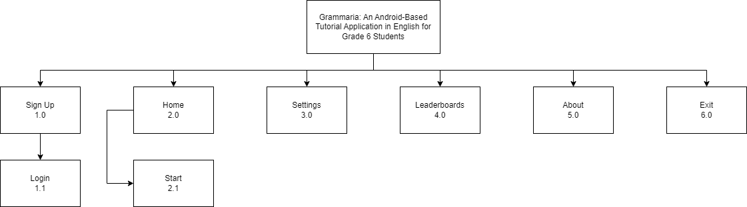

This diagram shows the process of how the users will use the application by starting the tutorial, playing the quizzes, viewing settings, leaderboards, and about.

**1.0 Sign Up**

When in Sign Up the player will input their username to create an account.

**1.1 Login**

This section is where the player input their username to enter the application.

**2.0 Home**

This module explains what the application has to offer.

**2.1 Start**

When the player selects start, they can select a topic.

**3.0 Settings**

This is where you can turn on and off the music and sounds.

**4.0 Leaderboard**

When the leaderboard is selected it will show the user the rankings of all the users.

**5.0 About**

When the about is selected it will show the names of the developers.

**6.0 Exit**

When the exit is selected it will close the application.

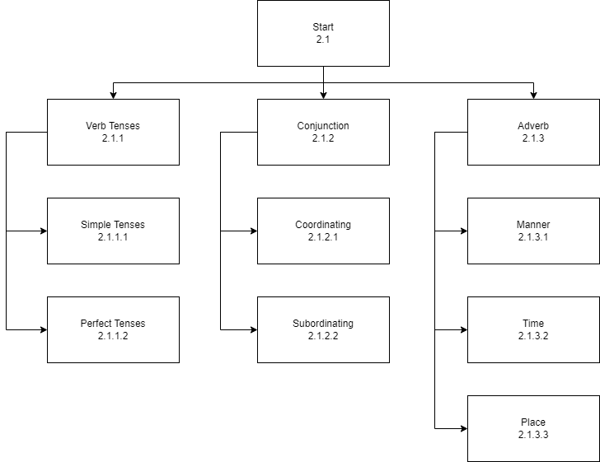Figure 2: Hierarchical Diagram of Grammaria: Tutorial Topics

This diagram shows the process of the selecting topics and sub-topics.

**2.1.1 Verb Tenses**

This section focuses on Verb Tenses which the user can choose between two sub- topics.

**2.1.1.1 Simple Tenses**

This section focuses only on the Simple Tenses.

**2.1.1.2 Perfect Tenses**

This section focuses only on the Perfect Tenses.

**2.1.2 Conjunction**

This section focuses on Conjunctions which the user can choose between two sub- topics.

**2.1.2.1 Coordinating**

This section focuses only on the Coordinating Conjunctions.

**2.1.2.2 Subordinating**

This section focuses only on the Subordinating Conjunctions.

**2.1.3 Adverb**

This section focuses on Adverbs which the user can choose between three sub- topics.

**2.1.3.1 Manner**

This section focuses only on the Adverb of Manner.

**2.1.3.2 Time**

This section focuses only on the Adverb of Time.

**2.1.3.3 Place**

This section focuses only on the Adverb of Place.

Figure 3: Block Diagram of Grammaria – Settings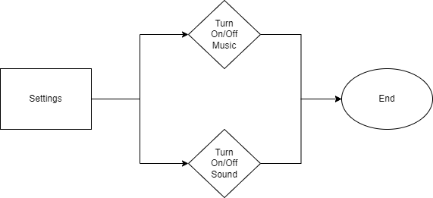

This diagram shows the function of Settings.

Figure 4: Block Diagram of Grammaria – Leaderboards



This diagram shows how the leaderboard works.

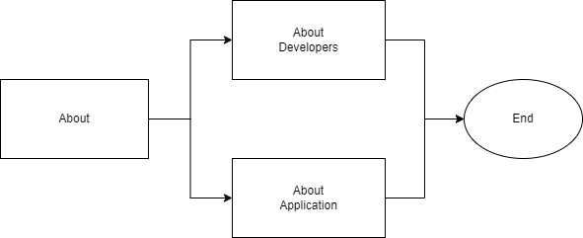Figure 5: Block Diagram of Grammaria – About

This diagram shows the process of about.

Figure 6: Block Diagram of Grammaria - Exit

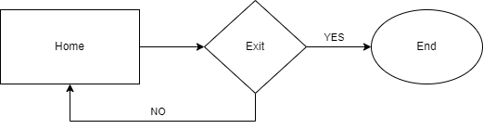

This diagram shows the process of exiting the application.

Figure 7: Storyboard of Grammaria from Main Menu to Verb Tenses Topic

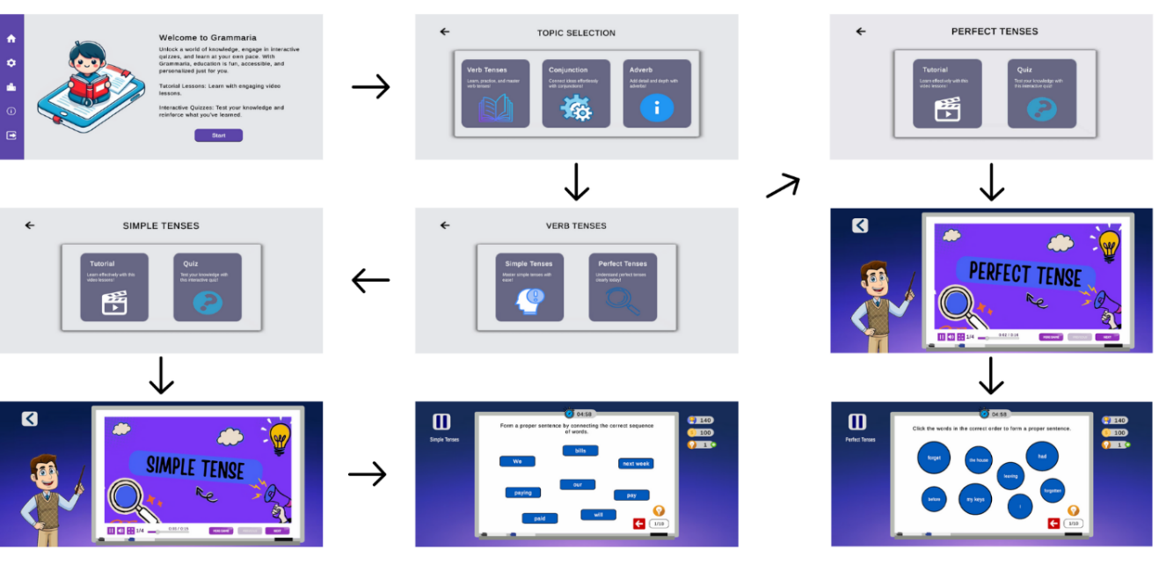

The player must choose the start button on the main menu for the app to start it process. After clicking, the app will lead to the topic’s selection. Upon choosing the verb tenses topic, the player has the option to choose between simple and perfect tenses for its subtopics. After opening, the player has two options which is the tutorial and the quiz. In tutorial, it will display teacher Mark who is teaching the verb tenses topic. In the quiz option, it will display an interactive quiz which allow the students test their knowledge about the verb tenses

Figure 8: Storyboard of Grammaria from Main Menu to Conjunction Topic

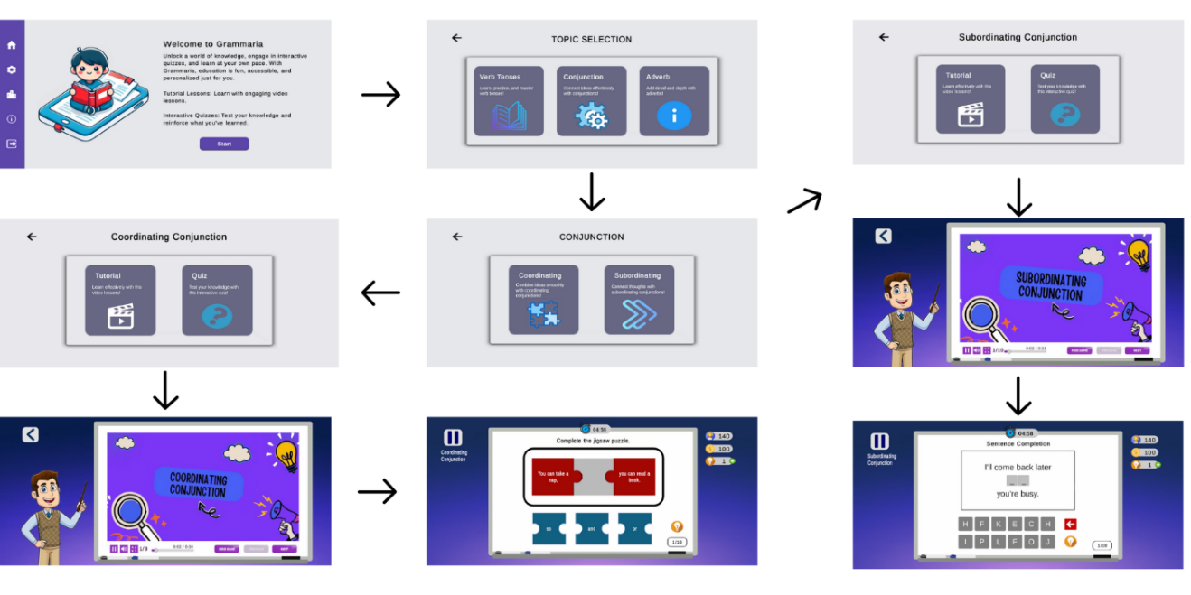

The player must choose the start button on the main menu for the app to start it process. After clicking, the app will lead to the topic’s selection. Upon choosing the conjunction topic, the player has the option to choose between coordinating and subordinating tenses for its subtopics. After opening, the player has two options which is the tutorial and the quiz. In tutorial, it will display teacher Mark who is teaching the conjunction topic. In the quiz option, it will display an interactive quiz which allow the students test their knowledge about conjunctions

Figure 9: Storyboard of Grammaria from Main Menu to Adverb Topic

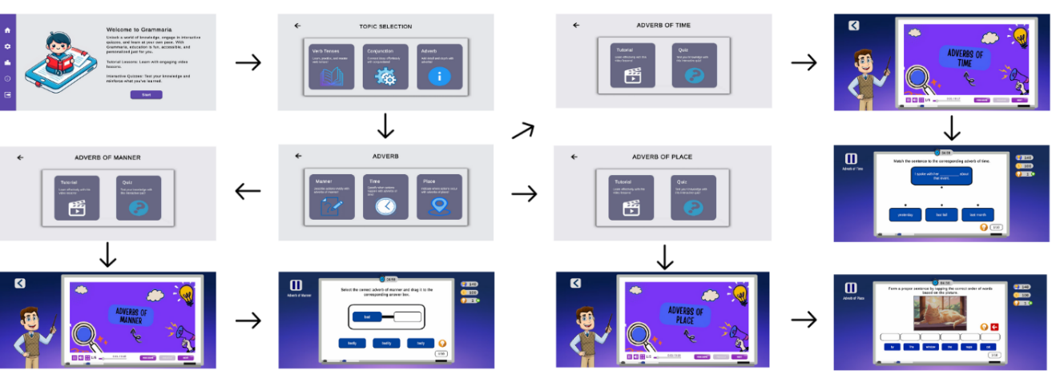

The player must choose the start button on the main menu for the app to start it process. After clicking, the app will lead to the topic’s selection. Upon choosing the adverb topic, the player has the option to choose between adverb of manner, time, and place for its subtopics. After opening, the player has two options which is the tutorial and the quiz. In tutorial, it will display teacher Mark who is teaching the adverb topic. In the quiz option, it will display an interactive quiz which allow the students test their knowledge about adverbs.

Figure 10: Storyboard of Grammaria – Main Menu Module

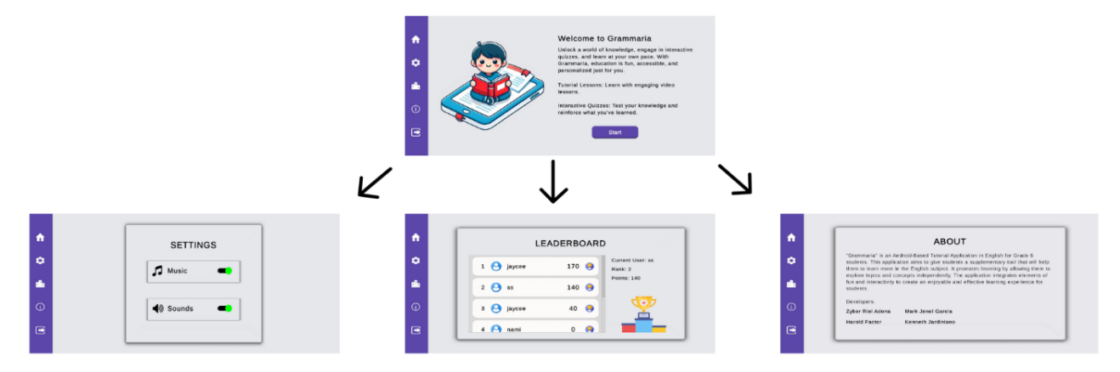

The main menu module consists of start button where it starts the app process. The settings button which allows the users to turn off or turn on the sound and music from the app. The leaderboards button that shows the ranking and scores of the users who uses the app. The about button that shows the developers of the tutorial application Grammaria.

**Design of Software, System, Product, and/or Processes**

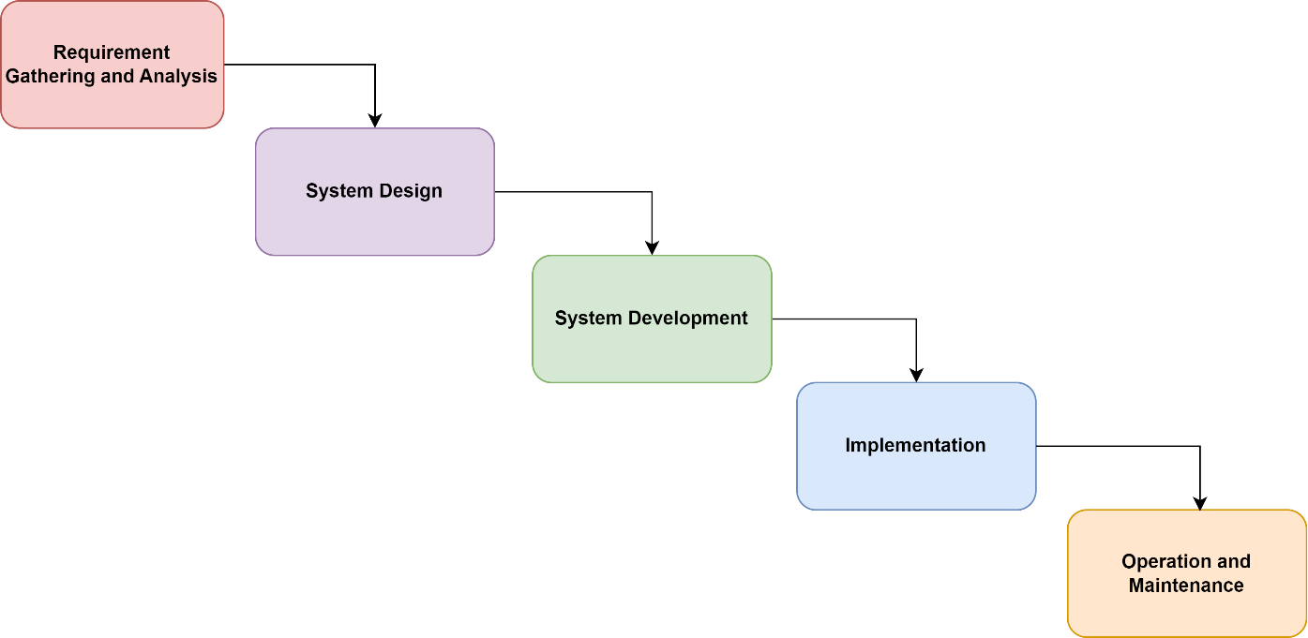Figure 11: Waterfall Model of Grammaria

According to Solanki (2021), the waterfall model, known as the linear sequential life cycle model, stands as one of the earliest and most inflexible approaches to development and testing. It adheres to a vertical, sequential progression, wherein each subsequent phase commences only after the completion of the preceding one. Due to its linear structure, there is no provision for revisiting completed phases, rendering it costly for applications necessitating frequent modifications.

The developers used the waterfall model, which consists of multiple phases such as requirement gathering and analysis, system design, system development, implementation, and operation and maintenance

**Requirements Gathering and Analysis**

In the initial phase, the developers identified the objectives of the application. This includes the subject matter, learning outcomes, and target audience. The developers gathered information from teachers and the preferences of the target audience.

**System Design**

In the second phase of development, the gathered requirements will be used to create a detailed design that will outline the quiz, the interface, topics, audio, assets, and the tools that will be needed. In this phase, the developers focused on creating a user-friendly, interactive, and appealing interface design that aligns with the curriculum standards and learning objectives.

**System Development**

In the third phase, the design created by the developers developed into a functional application. The software that will be used is Unity, along with Microsoft Visual Studio as the development environment that the developers used. The software that is used to create the tutorial video for the educational feature of the application is Canva.

**Implementation**

In the fourth phase, the tutorial content, interface, and audio will be integrated into a cohesive tutorial application. The developers performed a test to identify and debug any issues that can be found in the system.

**Operation and Maintenance**

In the final phase, the developed application is operational. The application is distributed to schools for operational use. The developers evaluated the feedback given and perform maintenance, updates, and bug fixes to improve the application.

Figure 12: Entity Relationship Diagram of Grammaria

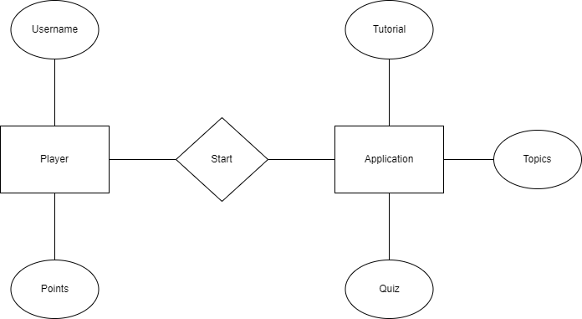

The diagram shows how the player interacts with the application. The player can set their username while using the application. The player can view tutorial and topics, they can also play the quiz.

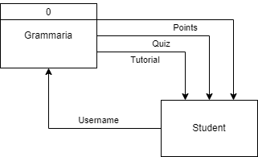Figure 13: Context Diagram of Grammaria

The diagram shows that the user of the application are students in grade 6. The students will provide their results, progress, and points to the application.

**Data Dictionary**

**Data Dictionary for Users**

Table 7: Data Dictionary: Users

|  |  |  |  |
| --- | --- | --- | --- |
| **Name:** | Users | | |
| **Description:** | This file is for storing user data such as username and total points | | |
| **Contents:** | {“username”:} | | |
|  | **Field Name** | **Data**  **Type** | **Description** |
|  | username | String | Name of User |

The table shows relevant information for storing data of users and serves as the repository for the user’s total points

**Data Dictionaries for Leaderboard**

Table 8: Data Dictionary: Leaderboards

|  |  |  |  |
| --- | --- | --- | --- |
| **Name:** | Leaderboards | | |
| **Description:** | This file is for storing leaderboards data of the application. | | |
| **Contents:** | {“username”: +, “totalpoints”: +, “rank”:} | | |
|  | **Field Name** | **Data**  **Type** | **Description** |
|  | username | String | Name of Player |
|  | totalpoints | int | Total points |
|  | rank | int | Current rank |

The table shows relevant information for storing data of the leaderboards and will be used as rankings for users based on their total points.

**Development**

The development process has been done according to the Waterfall methodology, meaning investigation, analysis, design, development, implementation, and ending with maintenance. It started with the investigation phase, which provided information on setting the functional and structural aspects of the system in order for developers to conceptualize and understand exactly what needs to be carried out within the project. Following this was the analysis phase, where the requirements had to be properly scrutinized and documented that they were well-defined and achievable. Consequently, the developers did much creation of detailed plans and storyboards in the design phase to capture the layout of the system, features, and user interface. At the development stage, coding and integration of various components of the system were carried out based on these specifications. This implementation phase, after development, contained the strict testing of the system to ensure that it worked according to the desired fashion, and met the requirement. Any bugs found were fixed on time. Finally, in the maintenance phase, the developers gave support and updates to maintain the system in working condition. In all phases, the developers have given importance to user data privacy by providing strong security and abiding by legal requirements, making sure that all the content is used with due permission and any copyright violation does not occur.

**Data Privacy**

The app does not collect or store any personal information from players. Instead, it retains the player's username, password, points, and rank, which are used in the leaderboard system and securely stored in a fire-base system.

**Anti-Copyright Infringement**

Originality was a key focus in the development of Grammaria. The developers were committed to producing unique educational content that aligned with Grade 6 English curriculum standards. To achieve this, the team created original educational materials, mini games, puzzles, scattered words and must form a proper sentence by connecting them in the correct order. Drag and drop and interactive elements, specifically designed for the application.

**Anti-Plagiarism**

The developers upheld academic integrity by ensuring that all the content that is used in the application is original and properly cited. The questions, tutorial videos, and other materials are made with extensive research of English topics for grade 6 students. All information used are properly credited to ensure that the application did not compromise ethical standards.

**Results and Discussion**

**Testing**

**Home Module Testing**

Table 9: Home Module Testing

|  |  |  |  |  |
| --- | --- | --- | --- | --- |
| Functionality | Expected Outcome | No. of times tested | Pass | Fail |
| Start | Present the three topics. | 10 | 10 | 0 |
| User Profile | Update the highest score of the player | 10 | 9 | 1 |
| Leaderboard | Accurately display the player’s score | 10 | 7 | 3 |
| About | Present information about the app and its developers | 10 | 10 | 0 |
| Exit | Terminates the app appropriately | 10 | 10 | 0 |

The table present the outcomes of unit testing conducted on the Home Module. All the functionalities under the main menu modules worked as intended. Functionalities such as the User Profile and Leaderboard have failed a few times due the flawed code.

**Signup Module Testing**

Table 10: Signup Module Testing

|  |  |  |  |  |
| --- | --- | --- | --- | --- |
| Functionality | Expected Outcome | No. of times tested | Pass | Fail |
| Username Input | Let the player input their username. | 10 | 10 | 0 |

The table presents the unit testing conducted on the sign-up module. All the functionalities are working as intended. There is no problem in inputting the player’s username.

**Start Module Testing**

Table 11: Start Module Testing

|  |  |  |  |  |
| --- | --- | --- | --- | --- |
| Functionality | Expected Outcome | No. of times tested | Pass | Fail |
| Start | Bring player to topic selection screen | 10 | 10 | 0 |
| Verb Tense | Brings the player to verb tenses sub topics | 10 | 10 | 0 |
| Conjunction | Brings the player to conjunction sub topics | 10 | 10 | 0 |
| Adverb | Brings the player to adverb sub topics | 10 | 9 | 1 |

The table presents the unit testing conducted on the start module. The functionalities are working as expected expect for adverb which failed 1 time due to code error.

**Tutorial Module Testing**

Table 12: Tutorial Module Testing

|  |  |  |  |  |
| --- | --- | --- | --- | --- |
| Functionality | Expected Outcome | No. of times tested | Pass | Fail |
| Tutorial | Display the tutorial video | 10 | 8 | 2 |
| Video pause | Stops the video from playing | 10 | 9 | 1 |
| Next button | Proceeds to the next video | 10 | 10 | 0 |
| Previous button | Go back to the previous video | 10 | 9 | 1 |
| Mini game | Display the Word Search mini game | 10 | 9 | 1 |

The table presents the unit testing conducted on the tutorial module. The functions are working as intended aside from a few fails due to coding error.

**User Profile Module Testing**

Table 13: User Profile Module Testing

|  |  |  |  |  |
| --- | --- | --- | --- | --- |
| Functionality | Expected Outcome | No. of times tested | Pass | Fail |
| Score | Player updates the score based on the highest score. | 10 | 10 | 0 |

The table present the unit testing conducted on the user profile module. The functions are working as intended, the score updates without a problem.

**Leaderboard Module Testing**

Table 14: Leaderboard Module Testing

|  |  |  |  |  |
| --- | --- | --- | --- | --- |
| Functionality | Expected Outcome | No. of times tested | Pass | Fail |
| Leaderboard | Shows the list of the watched information video | 10 | 9 | 1 |
| Back | It goes back to main menu | 10 | 10 | 0 |

The table presents the outcomes of unit testing conducted on the Leaderboards Module. All functionalities worked as intended except for one time the scores did not update due to coding issues.

**Description Prototype**

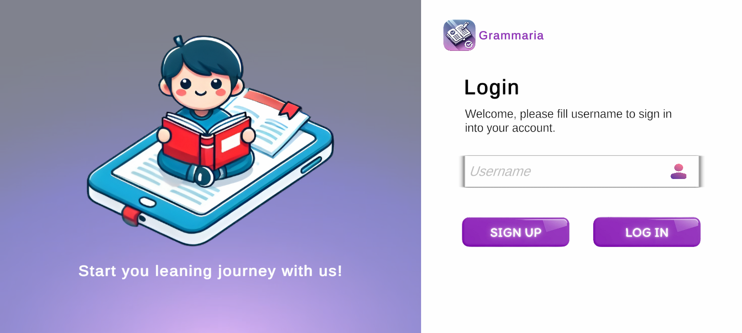Figure 14: Start Screen

Description: This shows the Login screen and a Signup button for when the player makes a new account or needs to login their existing account.

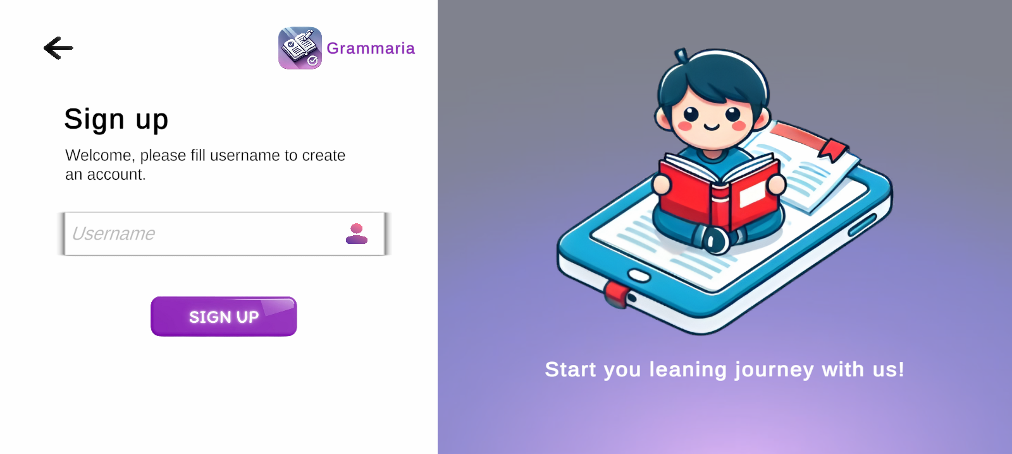Figure 15: Sign-up

Description: This is where the player inputs their username to create a new account

* **Username Input**

Allows the player to input their desired username.

Figure 16: Home

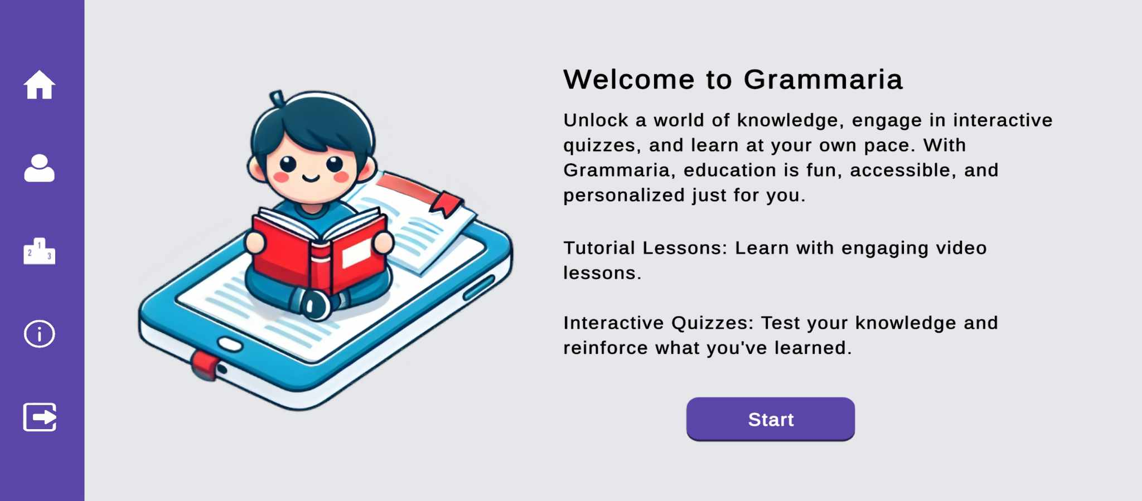

Description: This module displays the Home of the application, featuring the following options:

* **Start**

This allows the player to access the topics that contains the tutorial and quizzes.

* **User Profile**

The user profile contains the score of the player in each topic.

* **Leaderboard**

The scoreboard section showcases the highest scores achieved by players, offering a competitiveness to attain the top positions.

* **About**

The about section provides players with insights into the app and its developers, offering a glimpse into the background and details

* **Exit**

The exit option serves as a convenient button for player to exit the application.

Figure 17: Topic Selection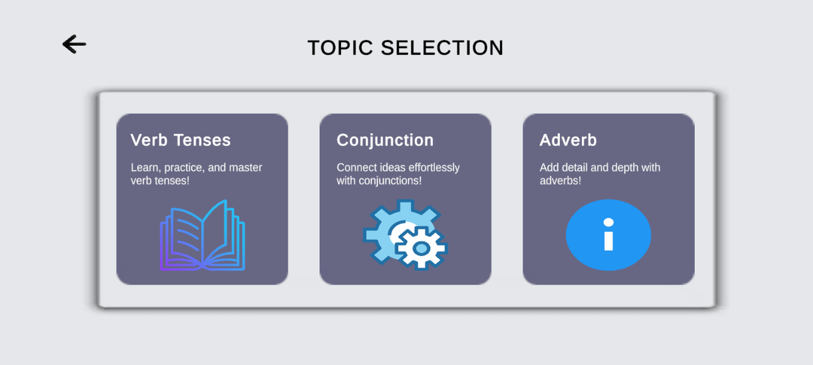

Description: This module allows the player to choose which topic they want to learn.

Figure 18: Verb Tenses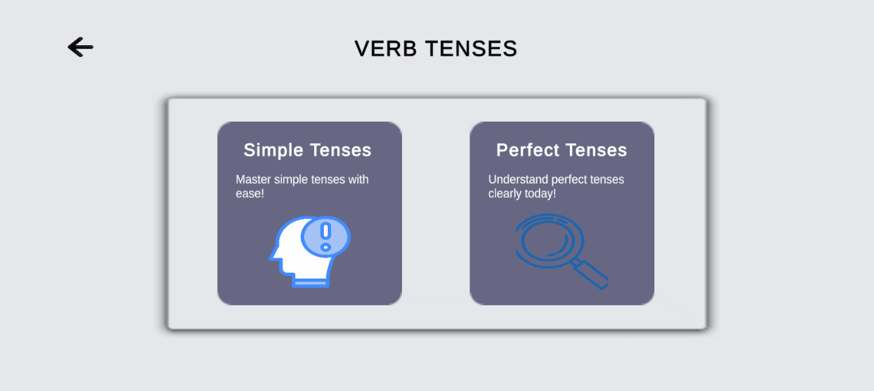

Description: In this module the player can choose the verb tenses sub-topics.

Figure 19: Activity Selection

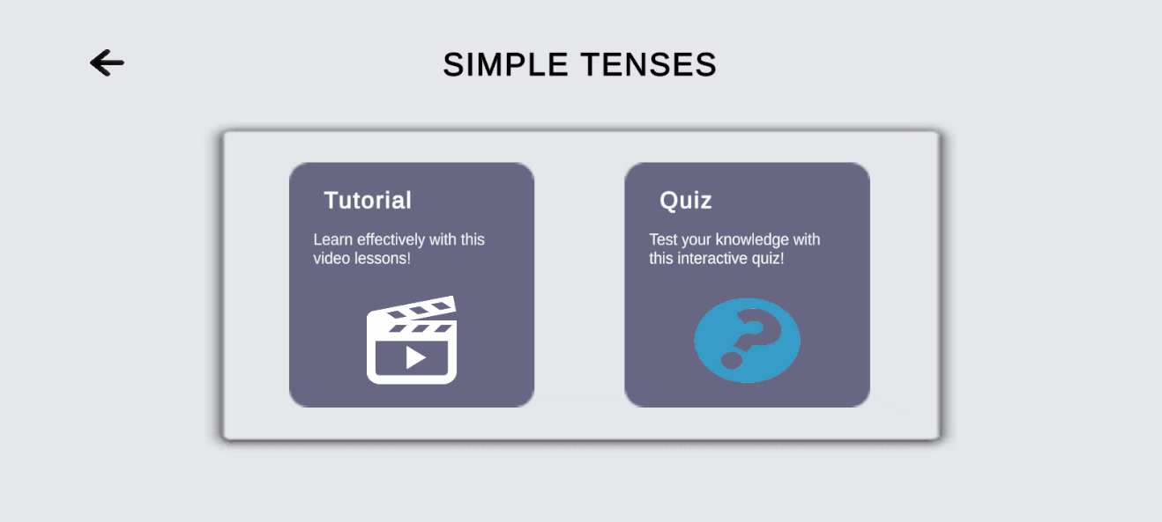

Description: This module is where the player can choose to watch the video tutorial and take a quiz

Figure 20: Verb Tense Tutorial Video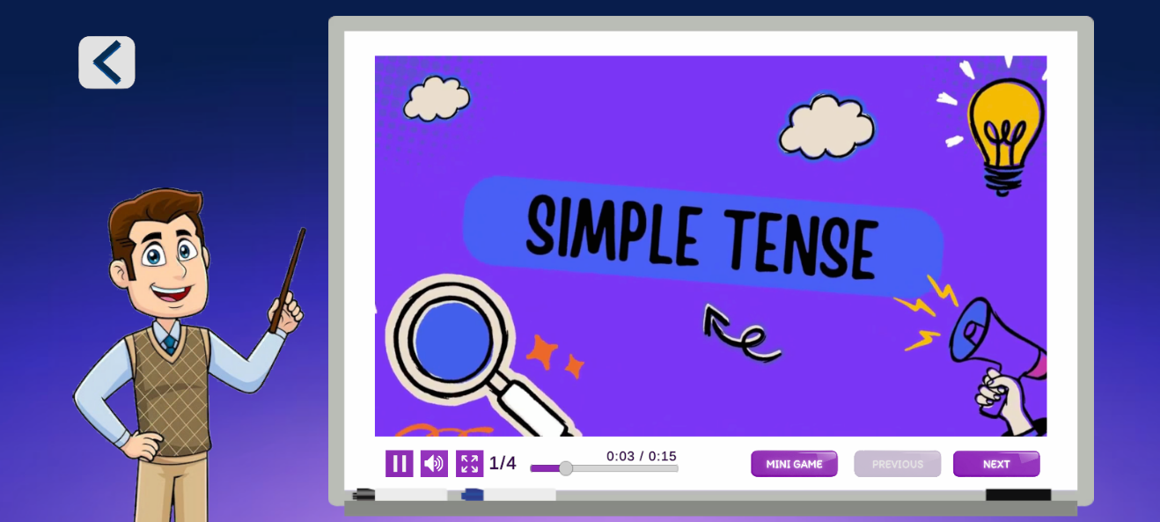

Description: This module is where the player can learn about the verb tenses.

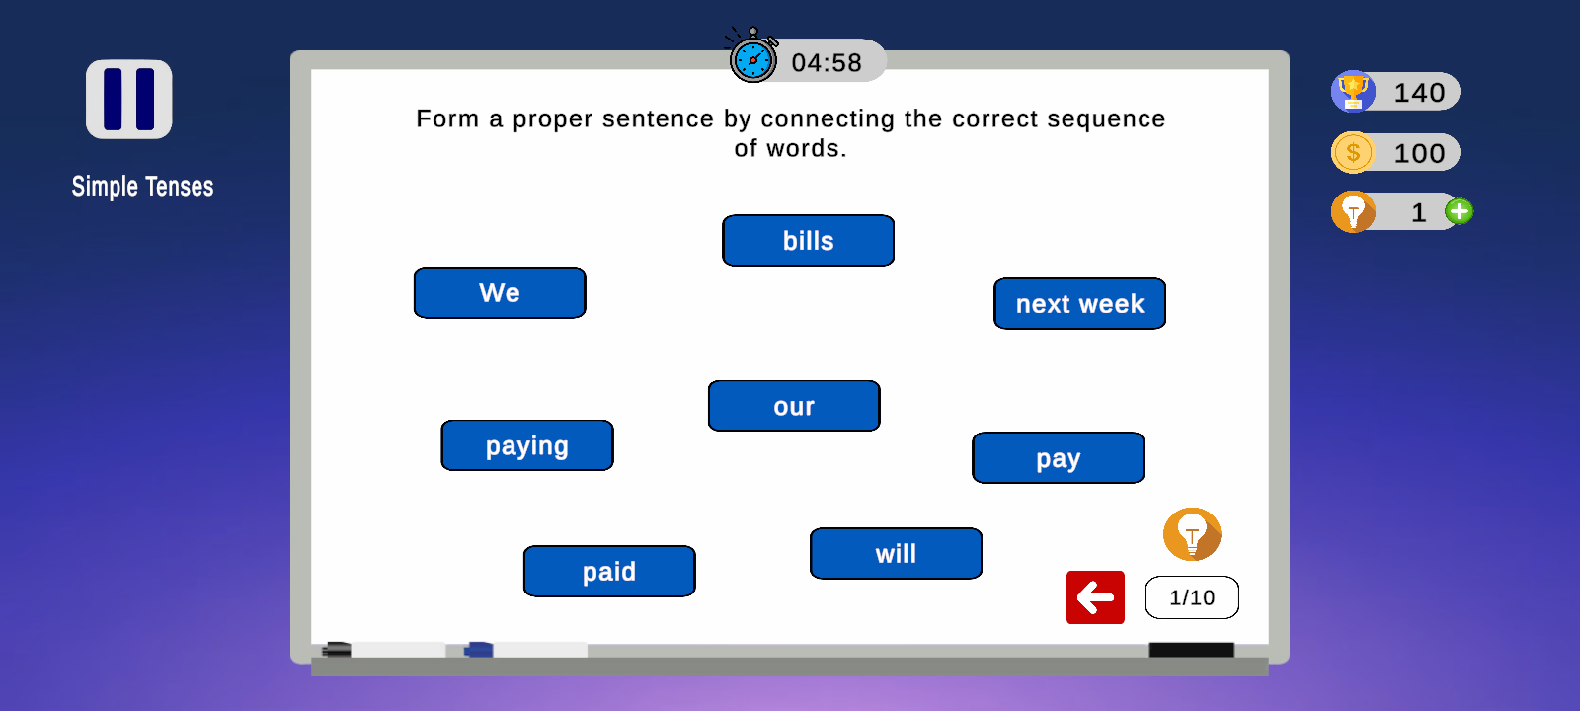Figure 21: Simple Tense Quiz

Description: This module is where the player can test their knowledge about the simple tense.

Figure 22: Perfect Tense Tutorial Video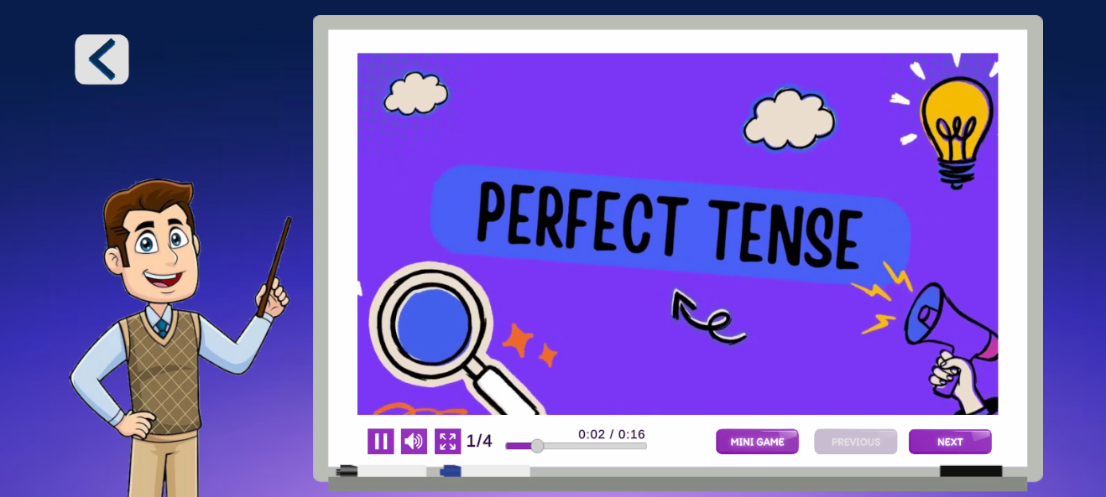

Description: This module is where the player can learn about perfect tense.

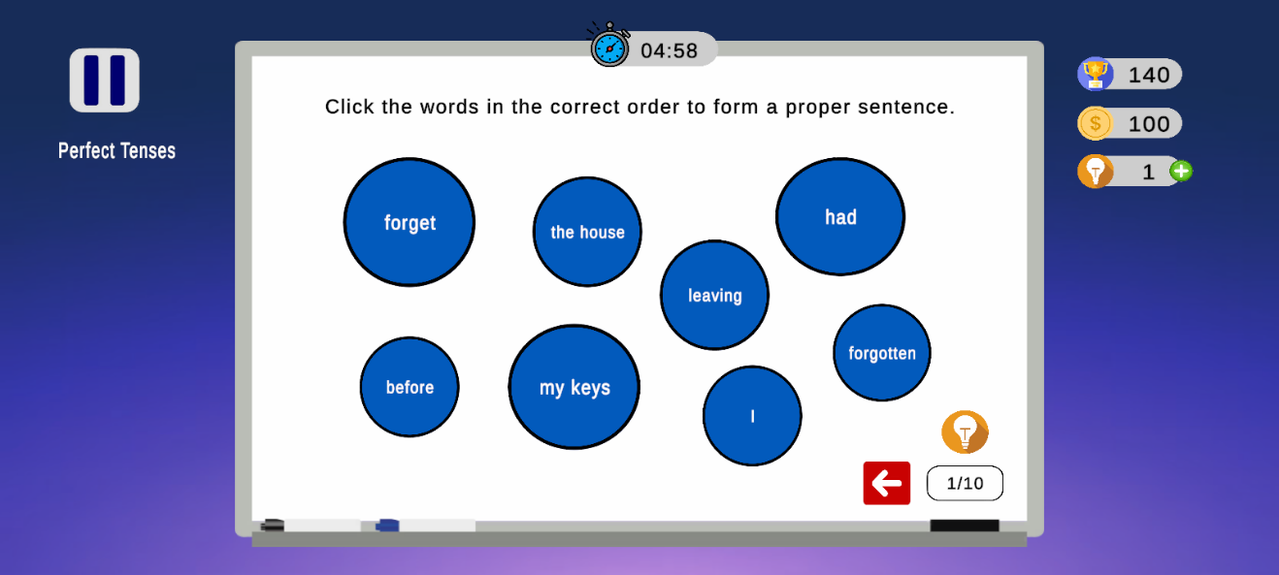Figure 23: Perfect Tense Quiz

Description: This module is where the player can test their knowledge about the perfect tense.

Figure 24: Conjunction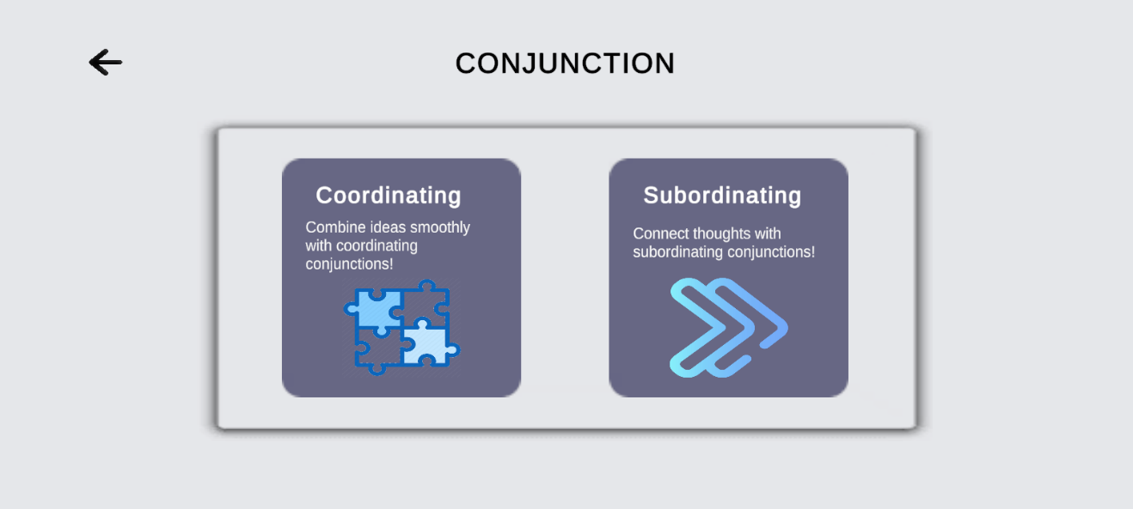

Description: In this module the player can choose the conjunction sub-topics.

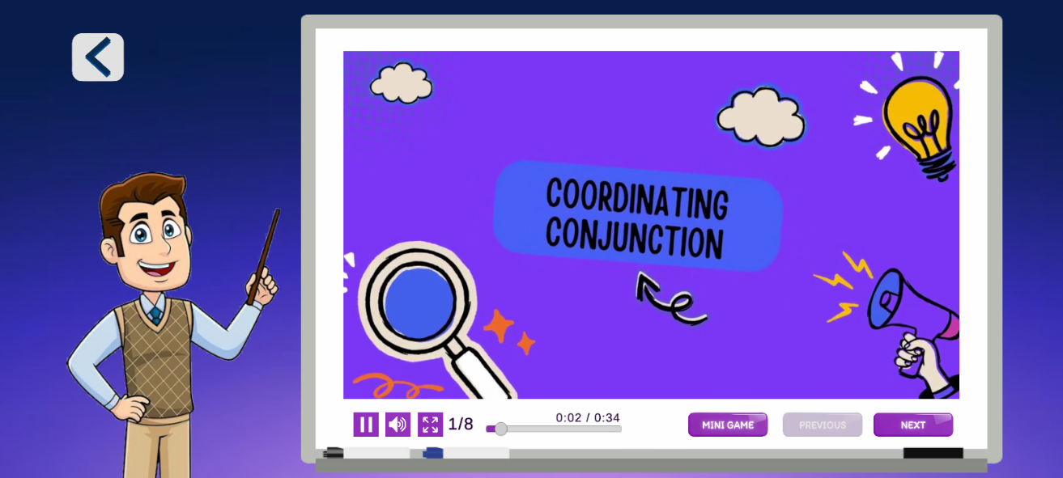Figure 25: Coordinating Conjunction Tutorial Video

Description: This module is where the player can learn about coordinating conjunction.

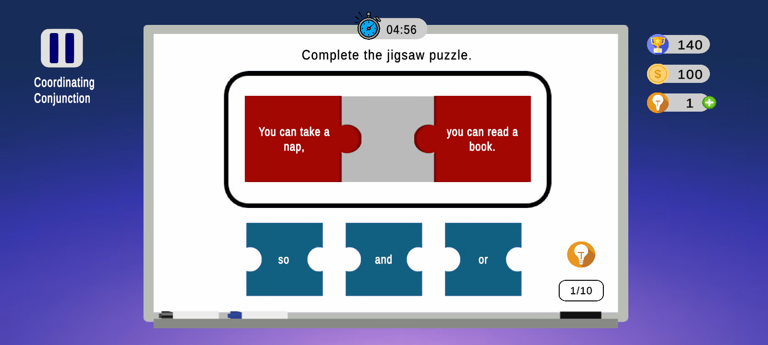Figure 26: Coordinating Conjunction Quiz

Description: This module is where the player can test their knowledge in coordinating conjunction.

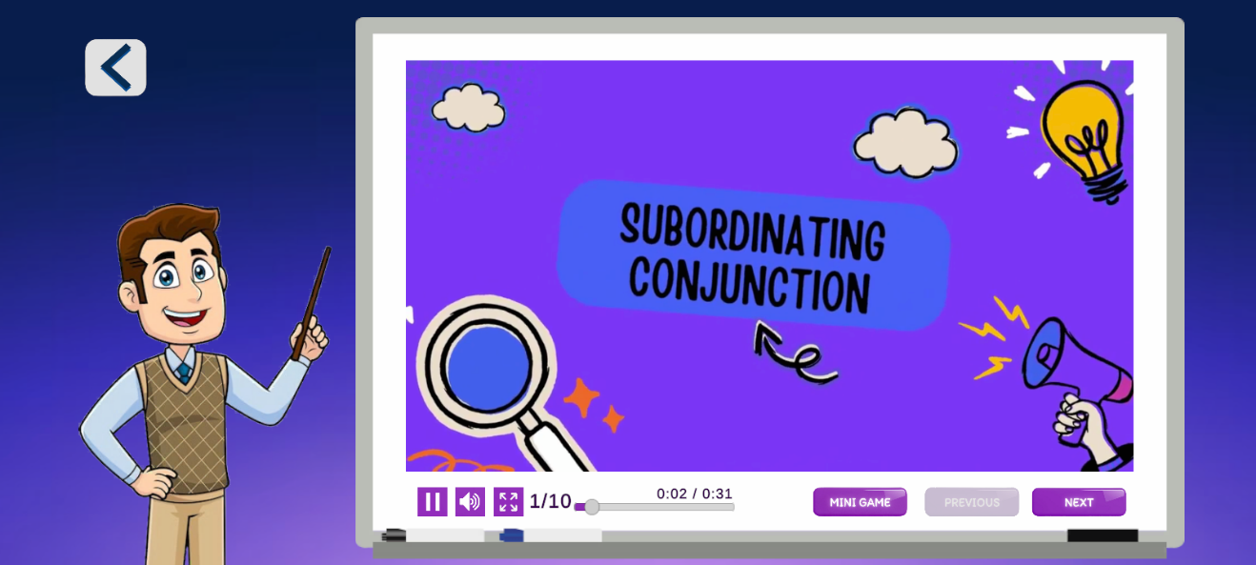Figure 27: Subordinating Conjunction Tutorial Video

Description: This module is where the player learns about subordinating conjunction.

Figure 28: Subordinating Conjunction Quiz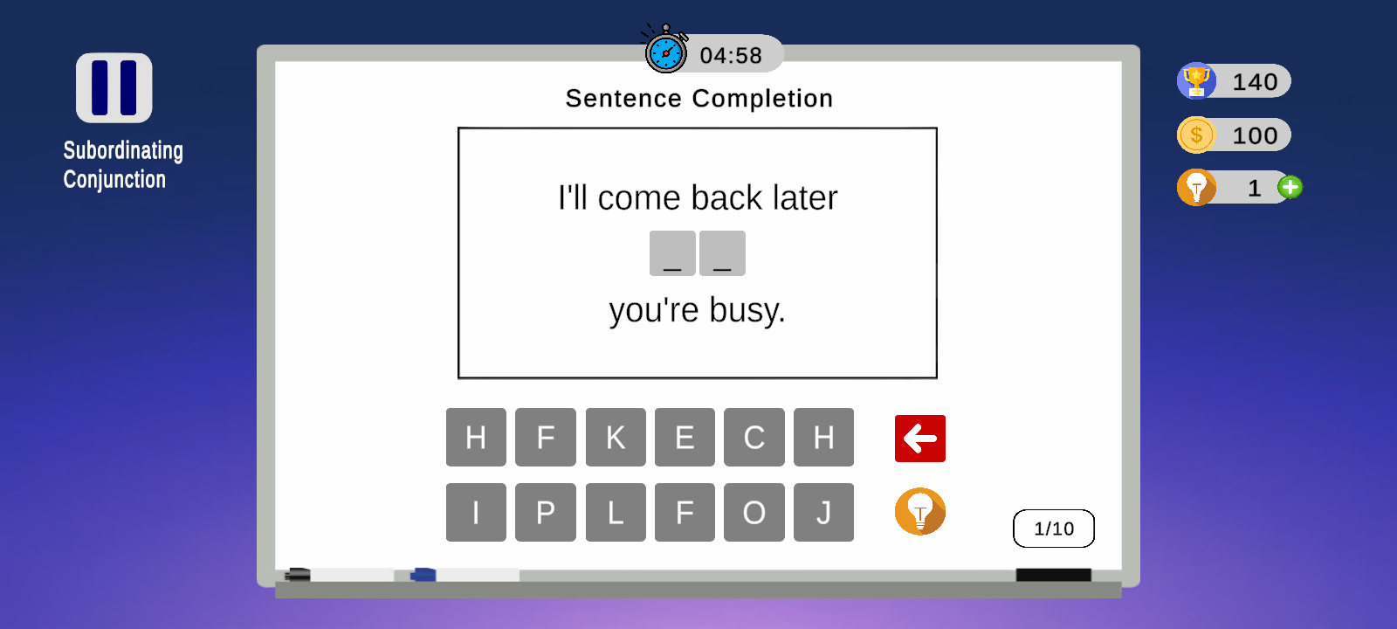

Description: This module is where the player can test their knowledge in subordinating conjunction.

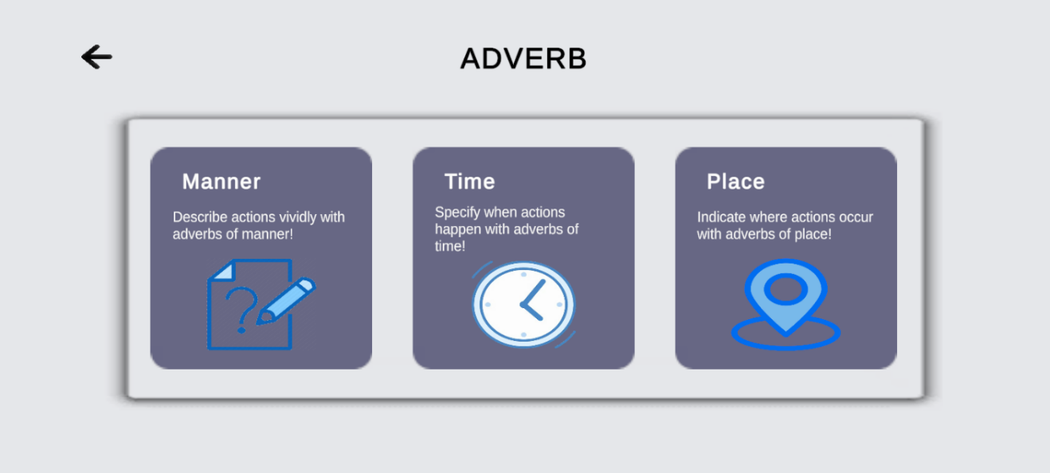Figure 29: Adverbs

Description: This module is where the player can choose adverb sub-topics.

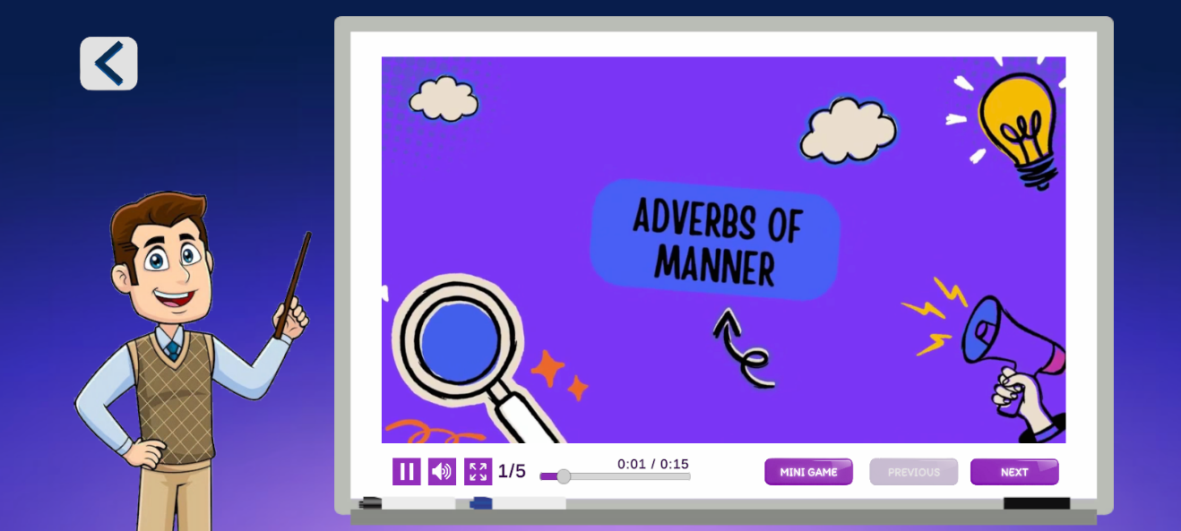Figure 30: Adverb of Manner Tutorial Video

Description: This module is where the player can learn about adverb of manner.

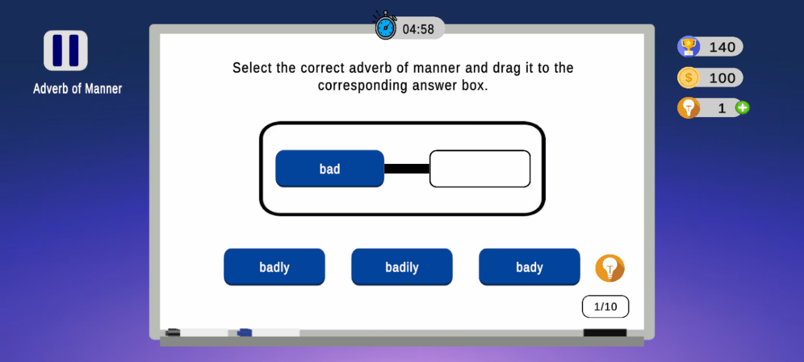Figure 31: Adverb of Manner Quiz

Description: This module is where the player can test their knowledge in adverb of manner.

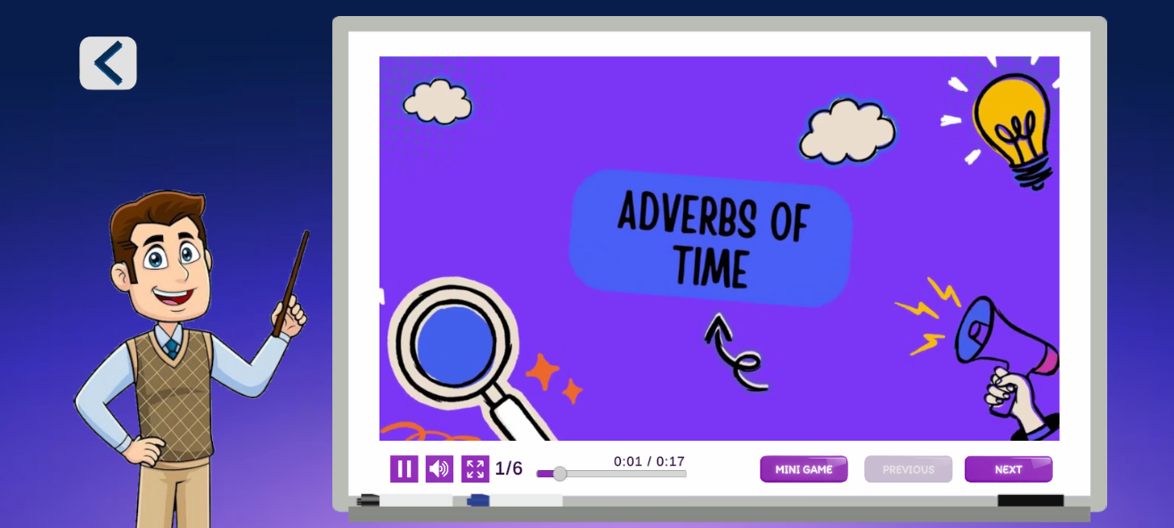Figure 32: Adverb of Time Tutorial Video

Description: This module is where the player learns about adverbs of time.

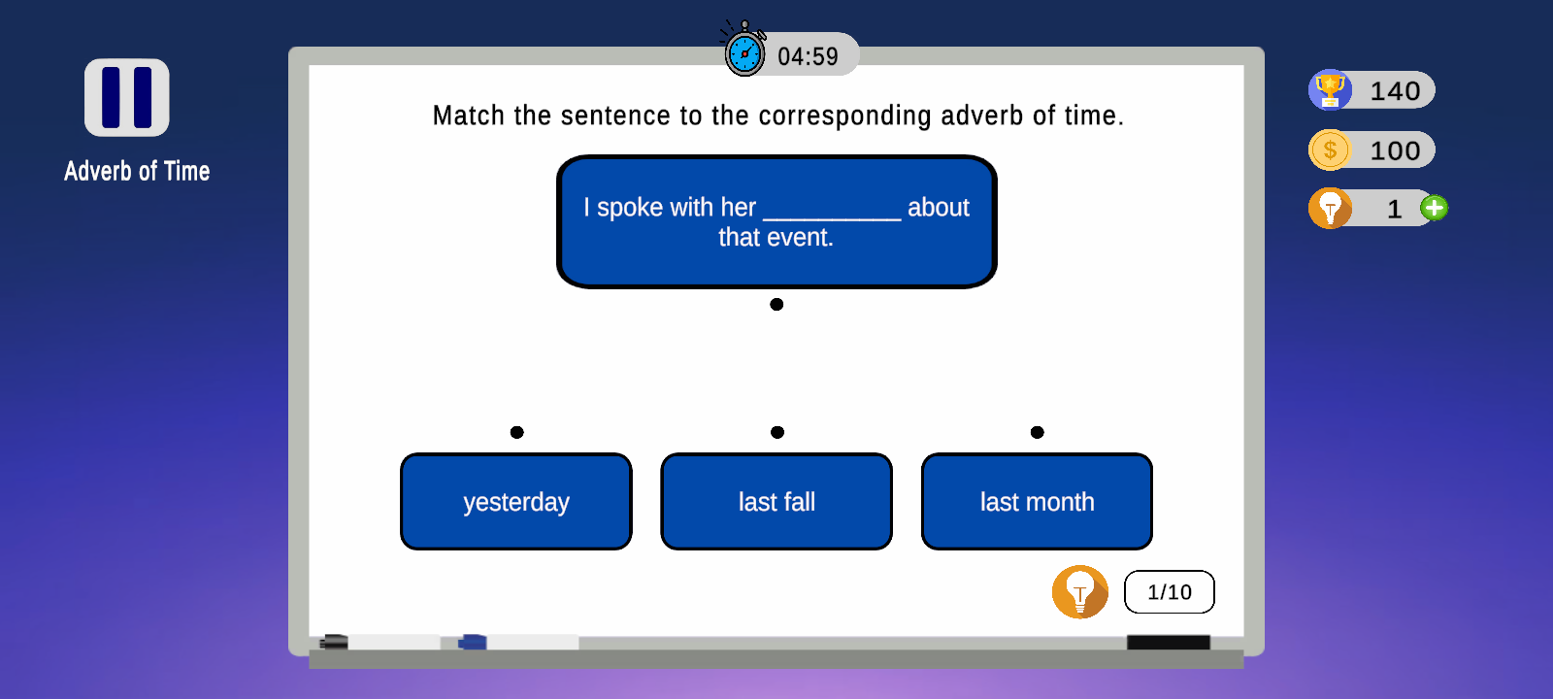Figure 33: Adverb of Time Quiz

Description: This module is where the player can test their knowledge in adverb of time.

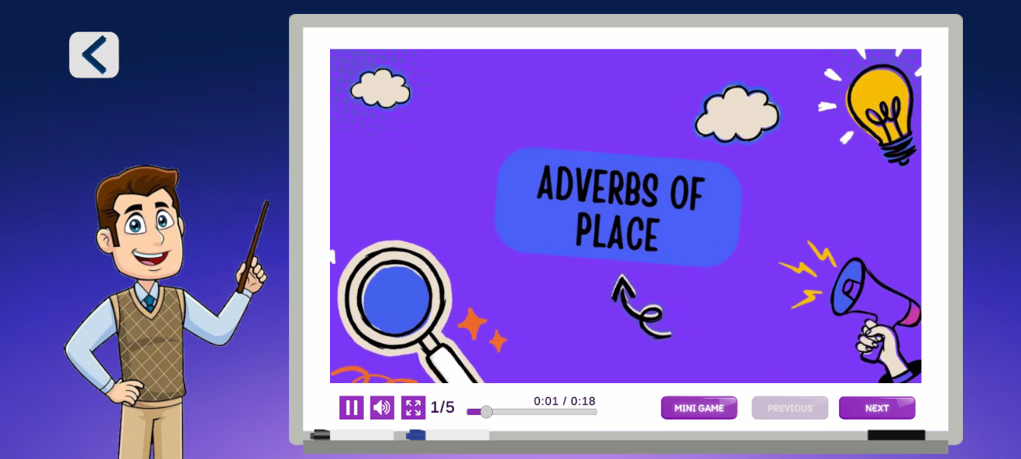Figure 34: Adverb of Place Tutorial Video

Description: This module is where the play learns about adverb of place.

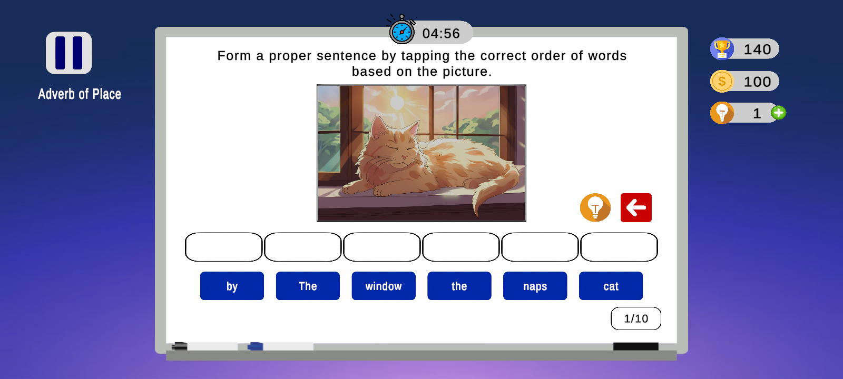Figure 35: Adverb of Place Quiz

Description: This module is where the player can test their knowledge in adverb of place.

Figure 36: User Profile

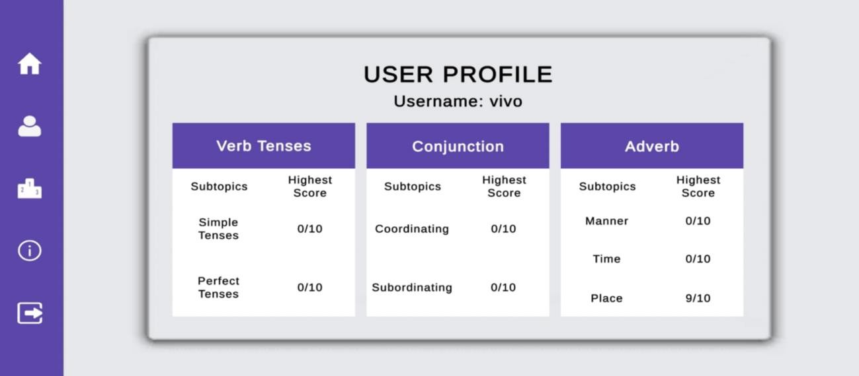

Description: This module is where the user progress and high scores stored.

Figure 37: Leaderboard

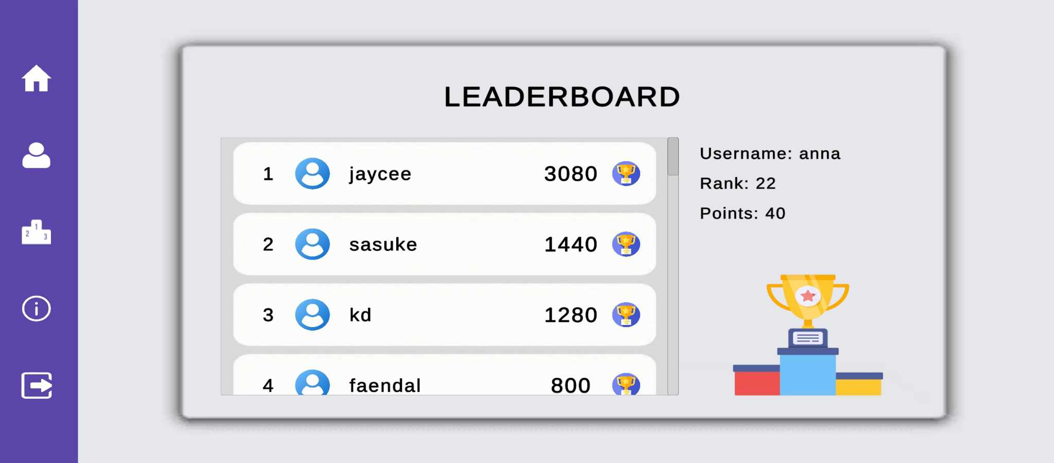

Description: This module shows the total points gained while playing the game and rank of the player.

Figure 38: About

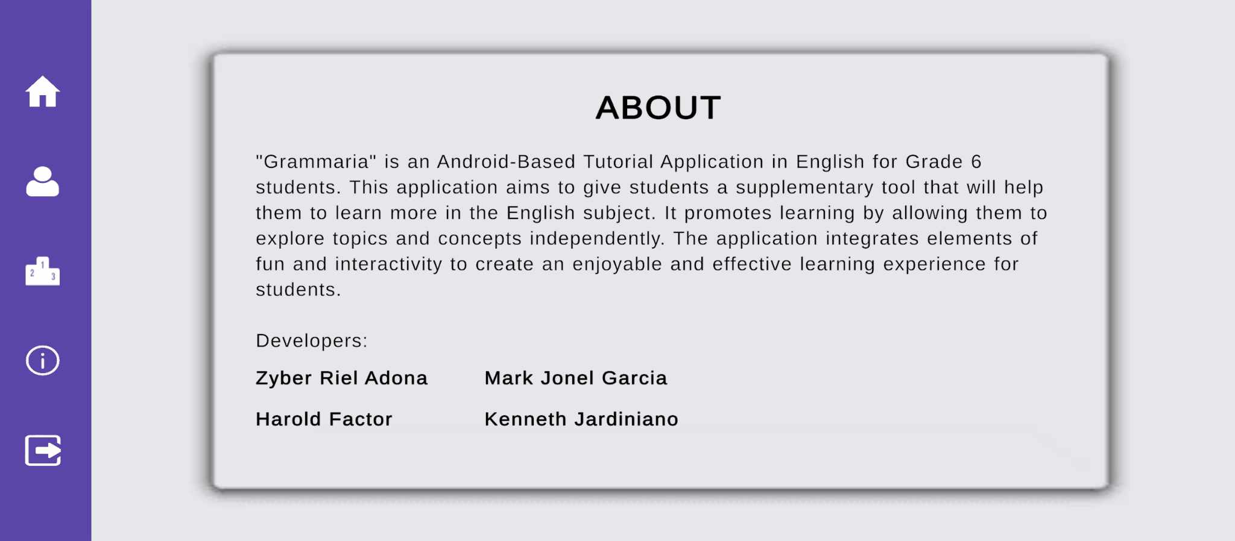

Description: This module displays the information about the developers and the app.

**Implementation Plan**

The implementation plan for Grammaria will begin with careful testing to ensure it works smoothly on Android devices. The developers will guide the Teachers on how to use Grammaria in the classroom and connect it to English lessons, making it easy to integrate into their teaching. After launching the app with a simple installation guide, students will be introduced to Grammaria to improve their grammar skills, with an exciting experience to keep them engaged. Regular feedback from students and teachers will guide future changes. This plan aims to make Grammaria a valuable learning tool for Grade 6 English students.

**Implementation Results**

The implementation of Grammaria proved successful in achieving a smooth and user-friendly experience on Android devices. Most features worked as intended, with minor exceptions. The line in the quiz is inconsistent depending on the phone size. The tutorial video is accurate and working as intended. Overall Grammaria provided consistency and an enjoyable learning experience. The tutorial application is set to deliver a reliable and improved user satisfaction in all areas of the application.

**Conclusion**

In conclusion, the implementation of Grammaria has been largely successful, providing an engaging and user-friendly tool for improving grammar skills among Grade 6 English students. The thorough testing and guidance provided to teachers enabled a smooth integration into the classroom, enhancing the learning experience. Although minor adjustments may be needed, particularly regarding quiz on different phone sizes, the overall feedback has been positive. The continued collection of feedback from both students and teachers will allow for ongoing improvements, ensuring that Grammaria remains a valuable and reliable educational tool for grammar instruction.

**References**

Published

Alindogan, J. F., Apego, M., Delleopac, R., & Lalo, J. (2022). BookKnight: An Educational Game in English Vocabulary for the Grade 6 Students. Retrieve from STI College Balayan.

Website/Online

Alcala, M. & Tamban, V. (2022). Effectiveness of Animated Video Presentation (AVP)

as Supplementary Reading Materials in Reading Comprehension of Grade 3 Learners: <https://www.academia.edu/download/87687764/IJMRAP_V4N12P12Y22.pdf>

Caballero, L., Ferrer, M. M., & Tiria, R. (2022). The Role of Gamification in the Academic Performance of Junior High School Students in Language Subject.

<https://www.researchgate.net/publication/359864945_The_Role_of_Gamification_in_the_Academic_Performance_of_Junior_High_School_Students_in_Language_Subject>

Edwards, L. (2022). What Is Canva and How Does It Work? Tips & Tricks. <https://www.techlearning.com/how-to/what-is-canva-and-how-does-it-work-for-education>

Eliyawati, et al. (2020). SmartChem: An Android application for learning multiple representations of Acid-Base chemistry: <https://eric.ed.gov/?id=EJ1267609>

Espiritu, P., Jadie, J., Ponce, A., & Cheng, C. (2023). Balarila: Deep Learning for Semantic Grammar Error Correction in Low-Resource Settings. <https://aclanthology.org/2023.sealp-1.3.pdf>

Fisher T. (2023) What is a computer mouse? (2022). <https://www.lifewire.com/what-is-a-mouse-2618156>

Garcia J. (2021) An Introduction to Aseprite: The Best Pixel Art Tool Available

<https://www.makeuseof.com/aseprite-best-pixel-art-tool/>

Guillen-Hanson, G., Jylha, H. & Hassan, L. (2021). The Role Sound Plays in Games: A Thematic Literature Study on Immersion, Inclusivity and Accessibility in Game Sound Research.

<https://www.researchgate.net/publication/354428664_The_Role_Sound_Plays_in_Games_A_Thematic_Literature_Study_on_Immersion_Inclusivity_and_Accessibility_in_Game_Sound_Research>

Kenlon S. (2023). What is Synfig Studio. <https://www.gamedesigning.org/animation/synfig/>

Kholis, A. (2021). Elsa Speak App: Automatic Speech Recognition (ASR) for supplementing English pronunciation skills: <https://doi.org/10.32332/joelt.v9i1.2723>

Kirvan P. (2023). What Is a Smartphone?

<https://www.techtarget.com/searchmobilecomputing/definition/smartphone>

Lacoma, T. (2023). What is Unity and how do you use the game engine? Android Police. <https://www.androidpolice.com/what-is-unity/>

Lagayan E. C., Borabon P. V., Long J., & Orendez O. G. (2023). PORTALOGICA: A 2D LOGIC GATE GAME-BASED LEARNING APPLICATION DEVELOPED IN UNITY GAME ENGINE. IN C#.

<https://www.researchgate.net/publication/370855134_PORTALOGICA_A_2D_LOGIC_GATE_GAME-BASED_LEARNING_APPLICATION_DEVELOPED_IN_UNITY_GAME_ENGINE_IN_C>

Moes T. (2023) What is Windows? <https://softwarelab.org/blog/what-is-windows/>

Nunns, J. (2023). What is Visual Studio? - Tech Monitor. Tech Monitor. <https://techmonitor.ai/what-is/what-is-visual-studio>

Praveen, C. K., & Srinivasan, K. (2022). Psychological Impact and Influence of Animation on Viewer's Visual Attention and Cognition.

<https://www.ncbi.nlm.nih.gov/pmc/articles/PMC9453061/>

Purgina, M., Mozgovoy, M., & Blake, J. (2019). WordBricks: Mobile Technology and Visual Grammar Formalism for Gamification of Natural Language Grammar Acquisition: <https://journals.sagepub.com/doi/full/10.1177/0735633119833010>

Saravanos, A. & Curinga, M. (2023). Simulating the Software Development Lifecycle: The Waterfall Model. <https://www.mdpi.com/2571-5577/6/6/108>

Solanki, J. (2021). The Importance of Waterfall Methodology In The Software Development Life Cycle. DEV Community. <https://dev.to/jignesh_simform/the-importance-of-waterfall-methodology-in-the-software-development-life-cycle-3o58>

Tamosevicius, R. (2022). Why Is Game-Based Learning Important? eLearning Industry. <https://elearningindustry.com/why-is-game-based-learning-important>

Taylor (2022) What is Printer. <https://ecomputertips.com/what-is-printer/>

Volle A. (2024). Laptop computer | Definition, History, & Facts. Encyclopedia Britannica. <https://www.britannica.com/technology/laptop-computer>

Appendices

APPENDIX A. RESORCE PERSON

**Resource Person**

Edna L. Ilao

[edna.ilao002@deped.gov.ph](mailto:edna.ilao002@deped.gov.ph)

0936-821-0943

English Teacher

Pook Elementary School

Jasmin S. Cabral

[jasmin.cabral001@deped.gov.ph](mailto:jasmin.cabral001@deped.gov.ph)

0905-128-6701

English Teacher

Baclaran Elementary School

Joan P. Contreras

English Teacher

[joan.contreras@deped.gov.ph](mailto:joan.contreras@deped.gov.ph)

0936-201-9693

Santol Elementary School

appendix B

Letter to the Beneficiary

appendix B -1

Letter to the Beneficiary

(Mrs. Aida S. Cudiamat - Pook Elementary School)

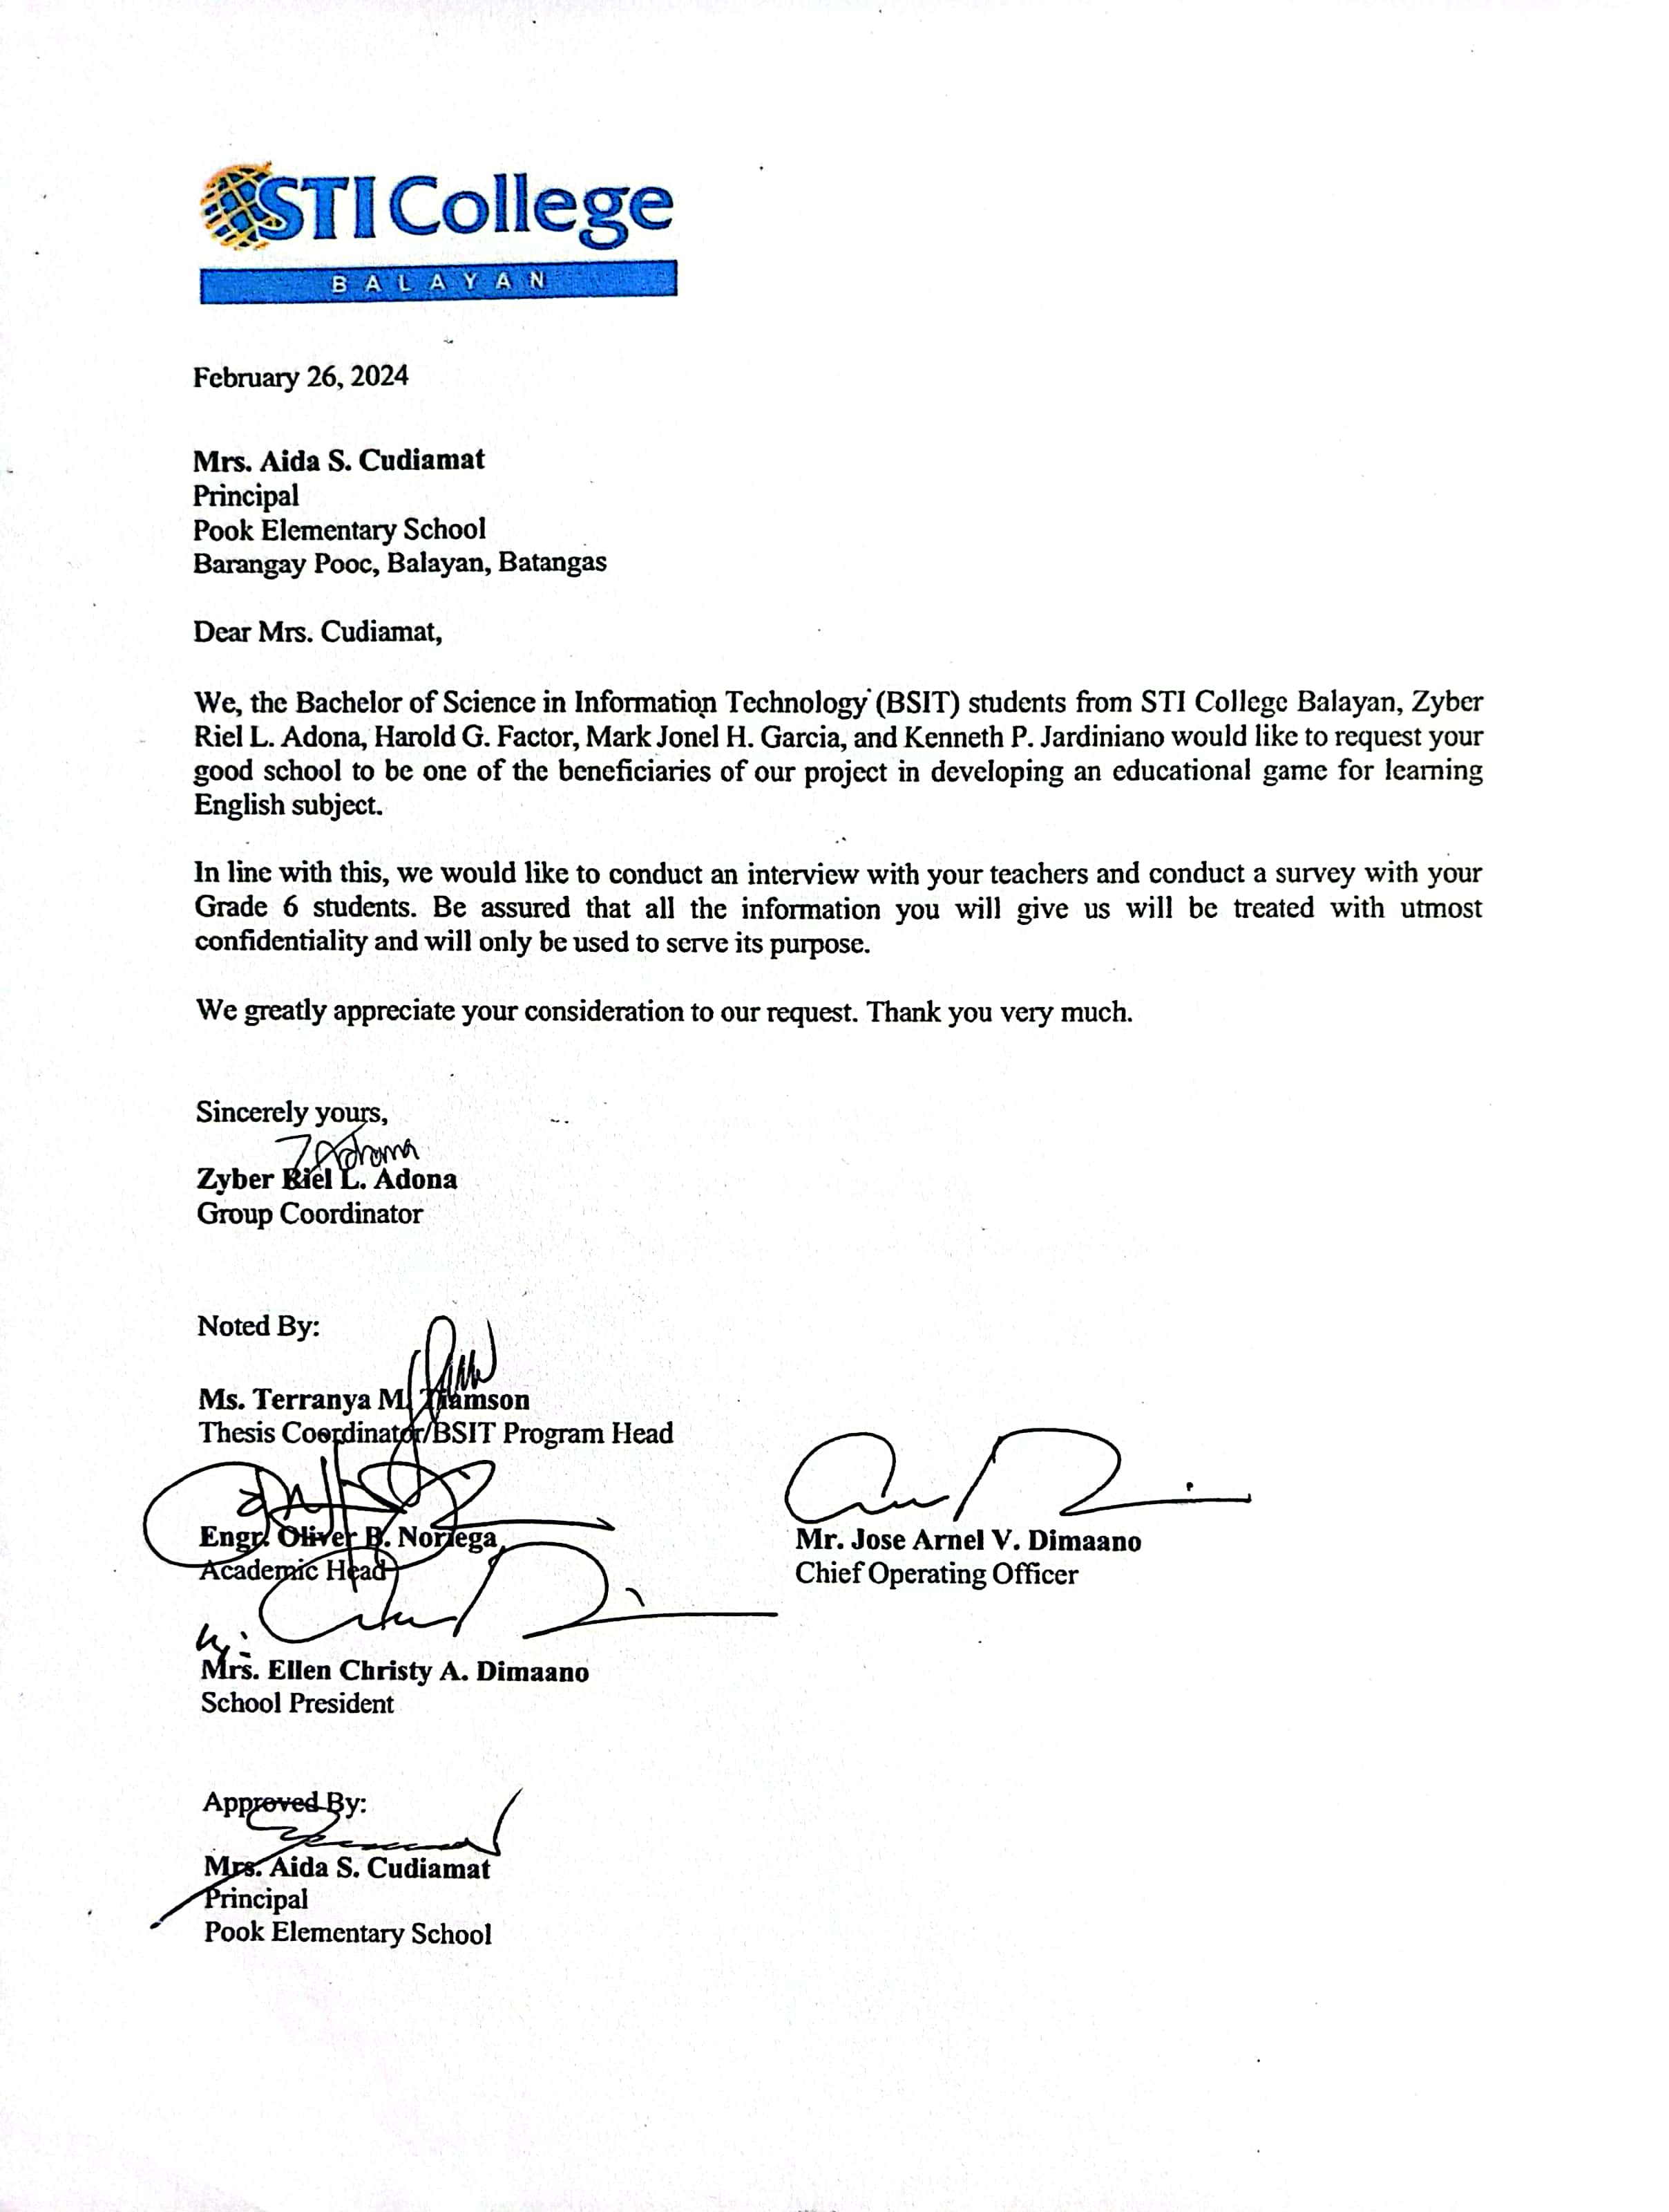

appendix B -2

Letter to the Beneficiary

(Mr. Eric B. Panganiban- Baclaran Elementary School)



appendix B -3

Letter to the Beneficiary

(Mrs. Geresa C. Alday - Santol Elementary School)

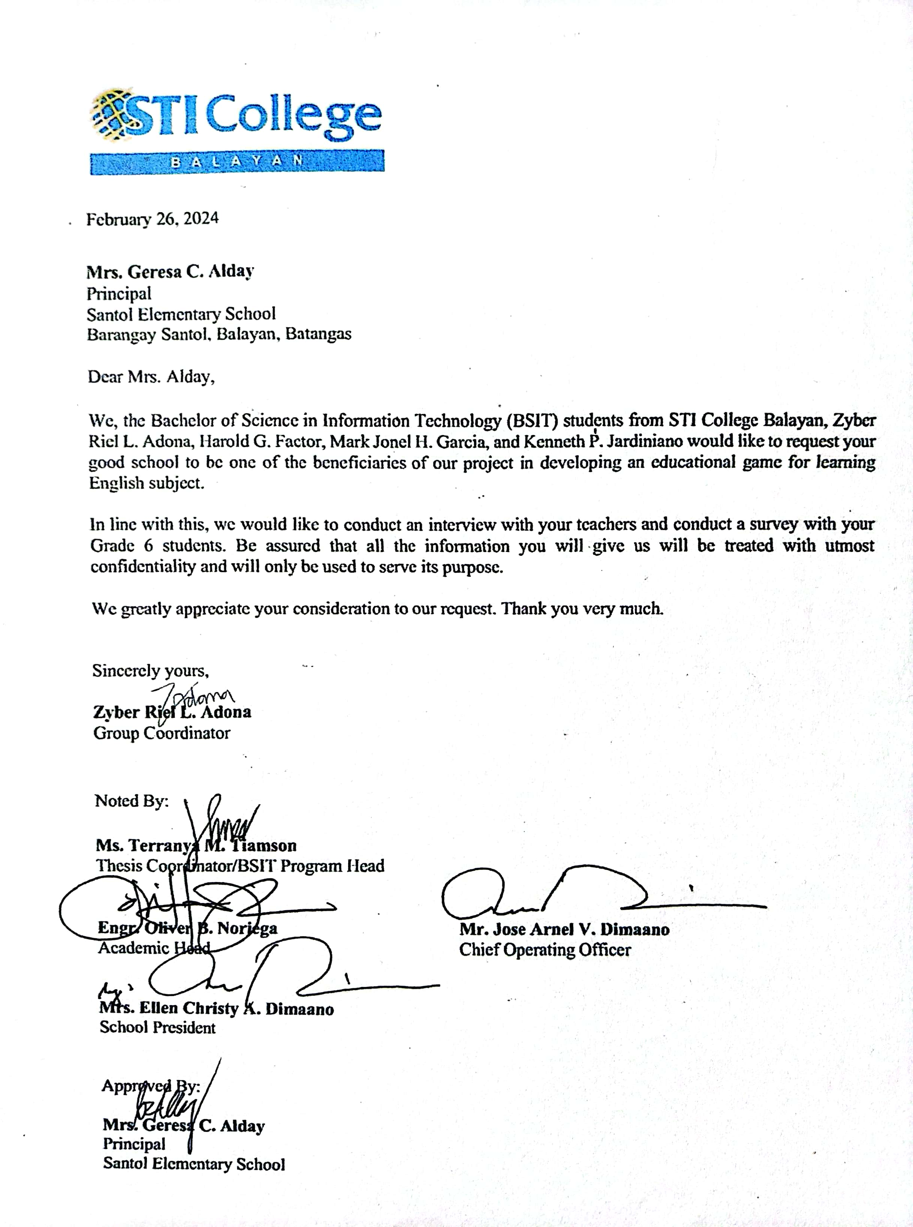

appendix c

Transcript of Interview

appendix c -1

Transcript of Interview

Pook Elementary School

Name of school: Pook Elementary School

1. What topics are being discuss in your subject?

In English, evaluating narratives and grammatical structures.

1. In what method do you deliver the topics?

Inquiry method, cooperative; depending on the subject matter. We sometimes do games.

1. What are the basic problems that students encounter in learning this subject?

Not all but mostly the focus. Maybe the factors to be considered such as interest, the level of understanding.

1. Do you think an educational game will help your students to learn these topics/lessons?

Of course. Learner’s today are the 20th Century learners.

1. If we make a game, what topic you want to focus?

More on English Grammar.

1. What do you prefer? Mobile or desktop game?

It must be desktop because it could be utilized or shred by two or three learners but since we do not have desktop, I’ll prefer mobile.

1. If desktop, does your school have computers? How many computers do you have?

That is the problem in our school since we were attacked by robbers, our access was stolen.

1. Do you prefer the game online or offline?

Both are useful but I prefer offline so that it can be used anytime I wish.

1. If online, does your school have access on internet?

Yes, we have.

1. How many Grade 6 students does your school have?

We have 50 grade 6 learners.



EDNA L. ILAO

appendix c -2

Transcript of Interview

Baclaran Elementary School

Name of school: Baclaran Elementary School

1. What topics are being discussed in your subject?

Q1

Identify real or make-believe, fact or non-fact images

Interpret the meaning suggested in visual media through a focus on visual elements, for example, line, symbols, colour, gaze, framing and social distance

Make connections between information viewed and personal experiences

Q2

Identify the purpose, key structural and

language features of various types of informational/factual text

Recognize evaluative word choices to detect biases and propaganda devices used by speakers

Compare and contrast content of materials viewed to other sources of information (print, online and broadcast)

Q3

Present a coherent, comprehensive report on differing viewpoints on an issue EN10LC-IIId-3.18

Evaluate narratives based on how the author developed the elements

Q4

Compose clear and coherent sentences using appropriate grammatical structures (verb tenses, conjunctions, adverbs)

Compose a persuasive essay on self-selected topic

1. In what method do you deliver the topics?

It depends on the component and structure of every class. Most of the activity given by teacher is more on collaborative, interactive and student-centered activity. Communicative language teaching also is delivered.

1. What are the basic problems that students encounter in learning this subject?

Lack of motivation

Cultural differences / family orientation

Limited reading and comprehension skills

Lack of confidence

Different learning Styles

Lack of learning Materials

1. Do you think an educational game will help your students to learn this topics/lesson?

YES

1. If we make a game, what topic you want us to focus?

Topics that focus on comprehension, vocabulary and reading skills of the learners.

1. What do you prefer? Mobile or desktop game?

Both.

1. If desktop, does your school have computers? How many computers do you have?

Every teacher has its own personal laptop only.

1. Do you prefer the game online or offline?

Both

1. If online, does your school have access on internet?

Yes

1. How many Grade 6 students does your school have?

52 pupils



JASMIN S. CABRAL

English 6 Teacher

appendix c -3

Transcript of Interview

Santol Elementary School

Name of school: Santol Elementary School

1. What topics are being discuss in your subject?

See attached bow for Semesters

1. In what method do you deliver the topics?

Discussion, Groupings

1. What are the basic problems that students encounter in learning this subject?

Medium – Language itself

1. Do you think an educational game will help your students to learn these topics/lessons?

Offline Game

1. If we make a game, what topic you want to focus?

Grammar

1. What do you prefer? Mobile or desktop game?

Mobile

1. If desktop, does your school have computers? How many computers do you have?

None

1. Do you prefer the game online or offline?

Yes, Offline

1. If online, does your school have access on internet?

Yes

1. How many Grade 6 students does your school have?

Total of 56 grade 6 pupils



JOAN P. CONTRERAS

English 6 Teacher

appendix D

Sample Survey Questionnaire

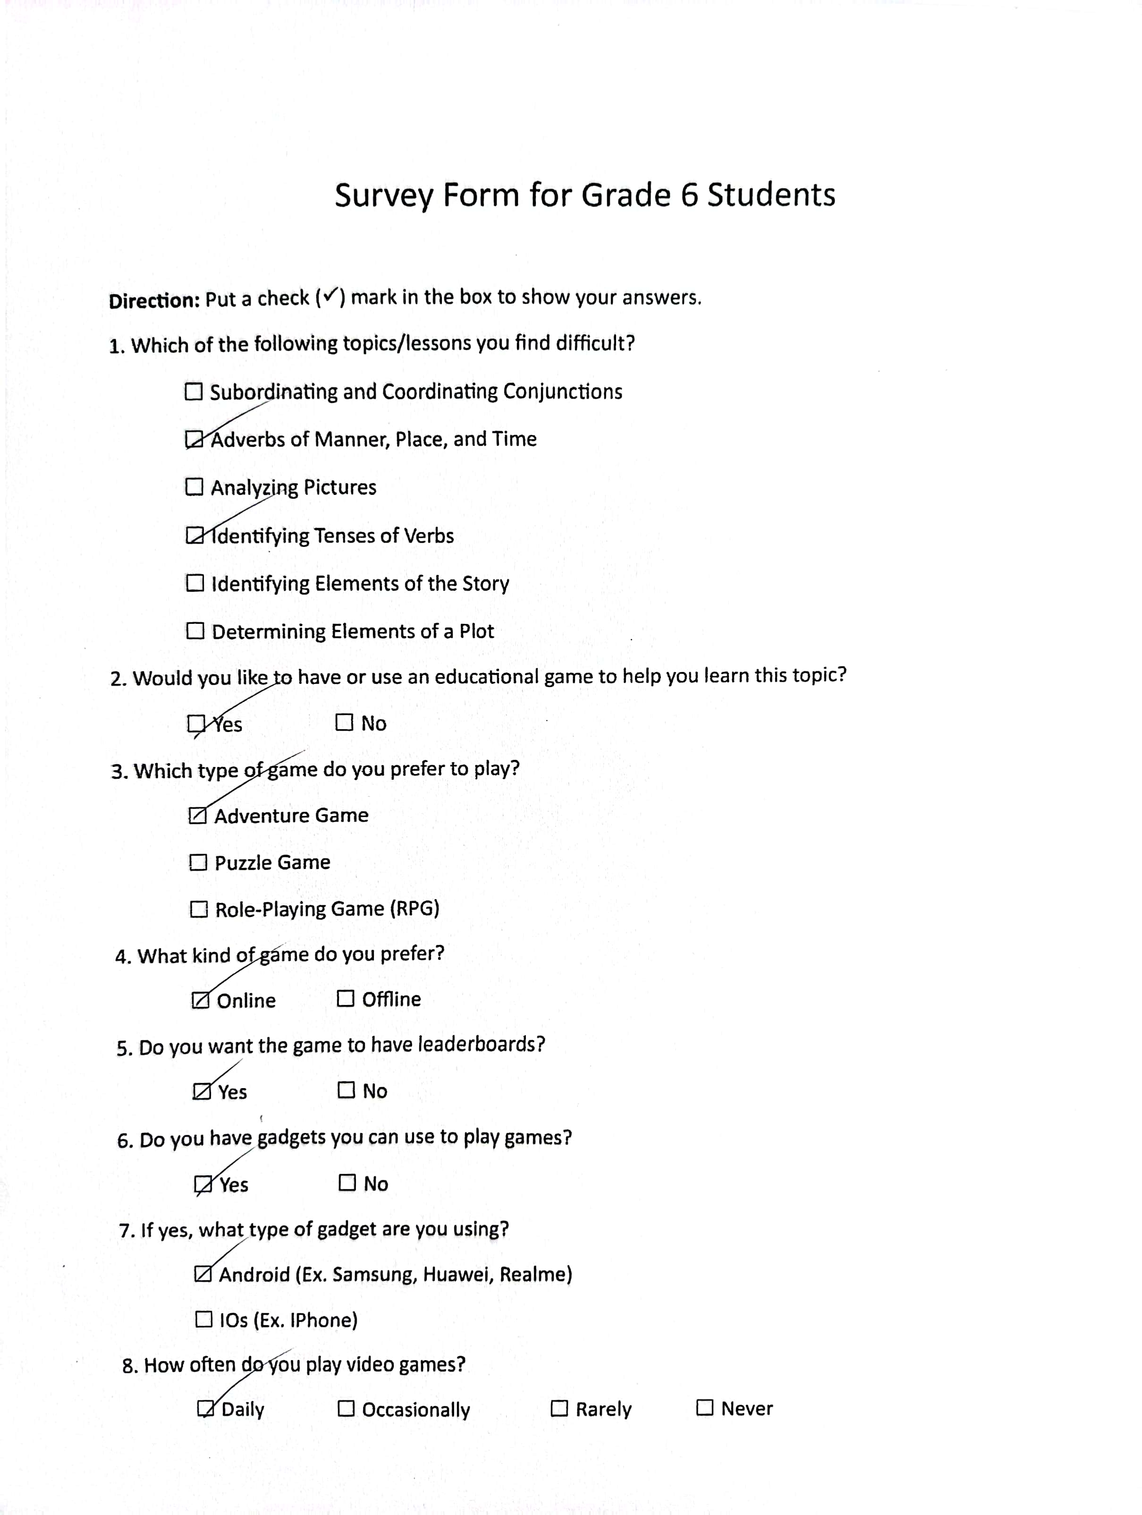

appendix e

Survey Summary

appendix e - 1

Survey Result (Baclaran Elementary School)



Slovin’s Formula (Baclaran Elementary School)

Given:

$$n= \frac{N}{1+{Ne}^{2}}$$

$$n= \frac{52}{1+{52(0.05)}^{2}}$$

$$n= \frac{52}{1+52(0.025)}$$

$$n= \frac{52}{1+0.13}$$

$$n= \frac{52}{1.13}$$

$$n=46.018$$

**Appendix D - 1 Survey Result (Baclaran Elementary School)**

Q1. Which of the following topics/lessons you find difficult?

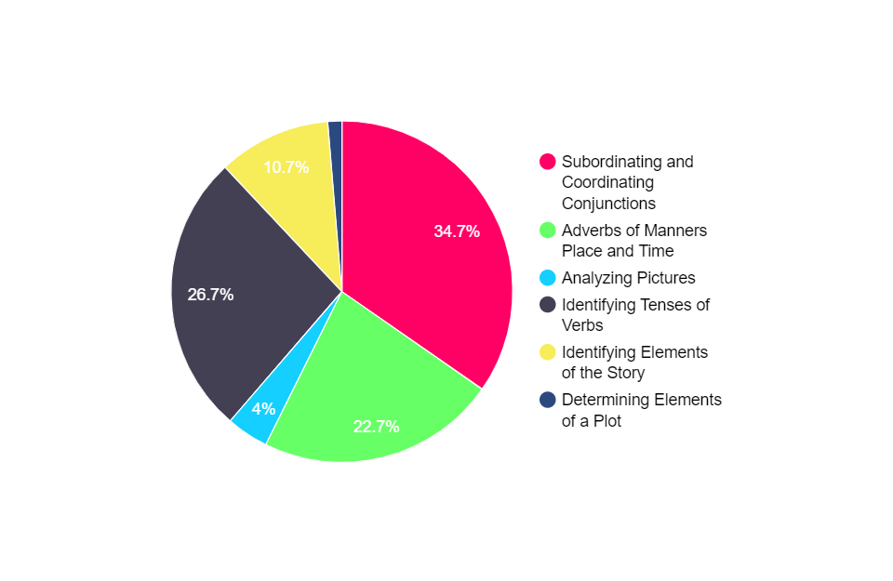

|  |  |
| --- | --- |
| Subordinating and Coordinating Conjunctions | 34.7% (26 students) |
| Adverbs of Manners, Place, and Time | 22.7% (17 students) |
| Analyzing Pictures | 4% (3 students) |
| Identifying Tenses of Verbs | 26.7% (20 students) |
| Identifying Elements of the Story | 10.7% (8 students) |
| Determining Elements of a Plot | 1.2% (1 student) |

The figure provides the percentage breakdown for survey question number 1. Among the 46 students, the result shows that 34.7% of the respondents answered “Subordinating and Coordinating Conjunctions”, 26.7% of them answered “Identifying Tenses of Verbs”, and 22.7% answered “Adverbs of Manners, Place, and Time”, indicating that these topics are the most difficult for them.

Q2. Would you like to have or use an educational game to help you learn this topic?

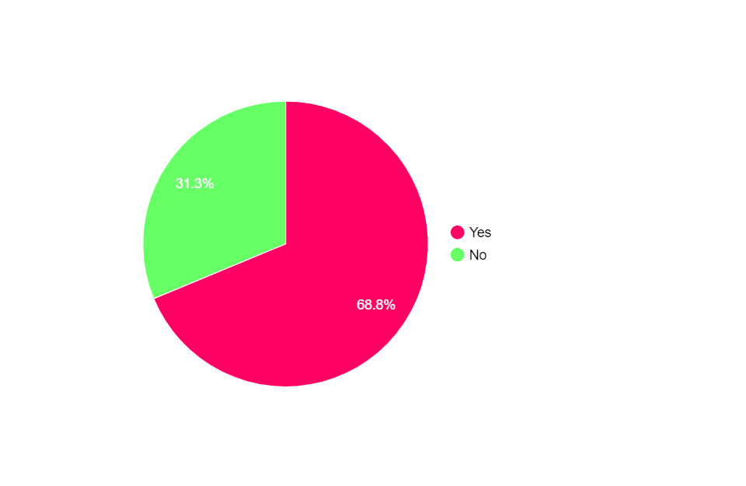

|  |  |
| --- | --- |
| Yes | 68.8% (32 students) |
| No | 31.3% (14 students) |

The figure provides the percentage breakdown for survey question num 2. Among the 46 students, the result shows that 68.8% of the respondents answered “Yes”, indicating that they are in favor of using educational game to help them learn their topics. The remaining 31.3% respondents answered “No”, indicating that they do not agree to use educational game for their learning.

Q3. Which type of game do you prefer to play?

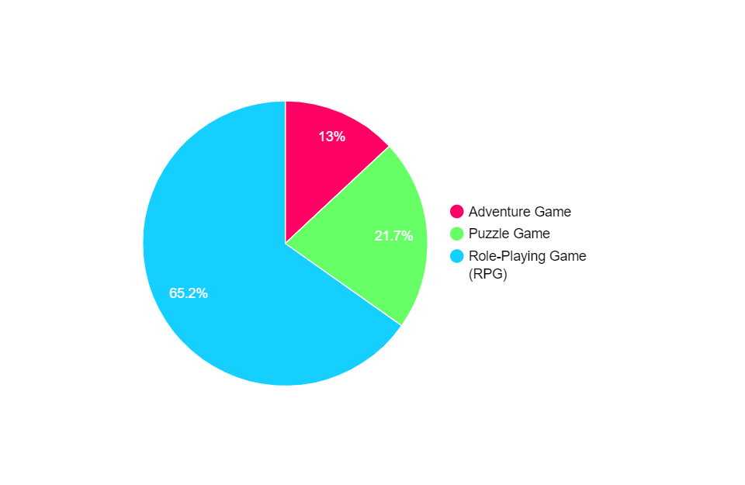

|  |  |
| --- | --- |
| Adventure Game | 13% (6 students) |
| Puzzle Game | 21.7% (10 students) |
| Role-Playing Game (RPG) | 65.2% (30 students) |

The figure provides the percentage breakdown for survey question number 3. Among the 46 students, the result shows that 65.2% of the respondents answered “Role-Playing Game (RPG)”, indicating that they prefer to play this type of game.

Q4. What kind of game do you prefer?

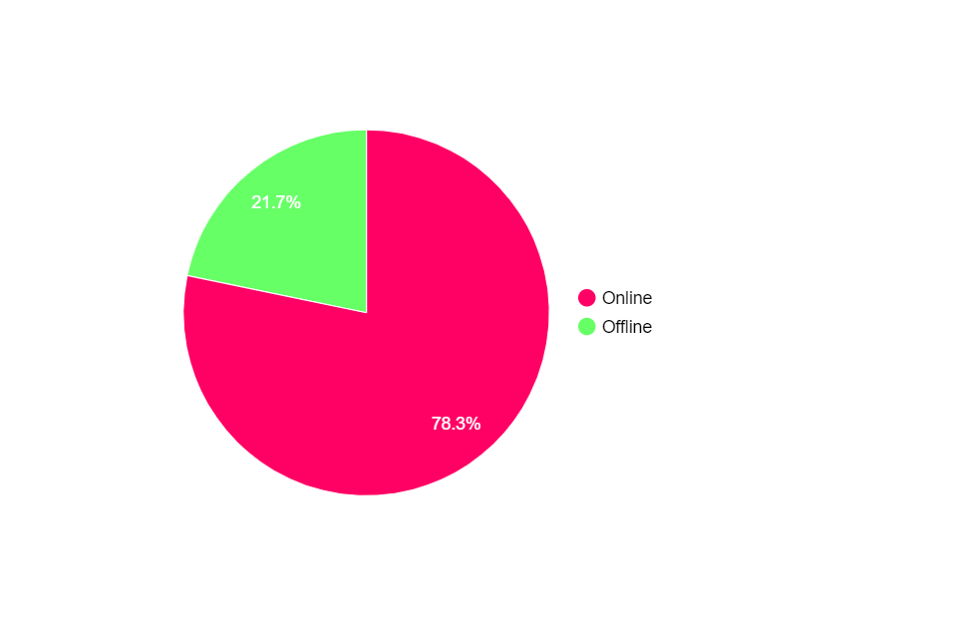

|  |  |
| --- | --- |
| Online | 78.3% (36 students) |
| Offline | 21.7% (10 students) |

The figure provides the percentage breakdown for survey question number 4. Among the 46 students, the result shows that 78.3% of the respondents answered “Online”, indicating that they prefer an online game. The remaining 21.7% respondents answered “Offline”, indicating that they prefer an offline game.

Q5. Do you want the game to have leaderboards?

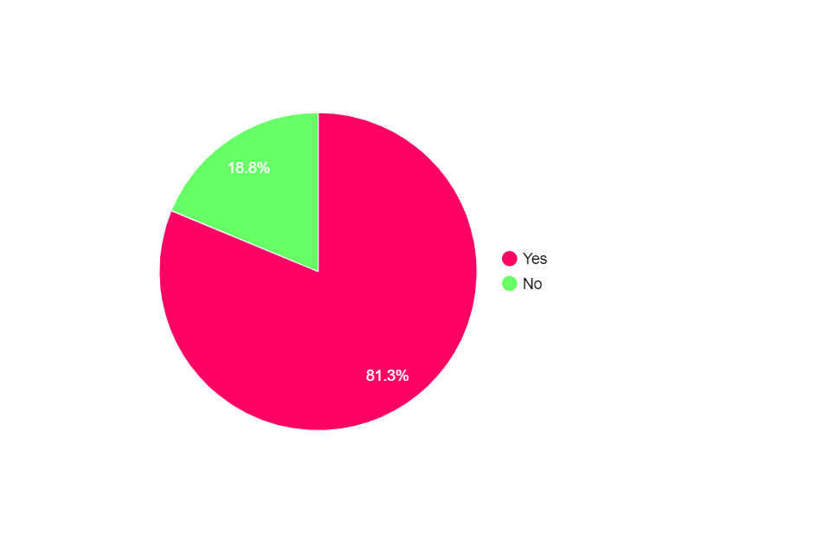

|  |  |
| --- | --- |
| Yes | 81.3% (38 students) |
| No | 18.8% (8 students) |

The figure provides the percentage breakdown for survey question number 5. Among the 46 students, the result shows that 81.3% of the respondents answered “Yes”, indicating that they want a game with leaderboards to track their progress. The remaining 18.8% respondents answered “No”, indicating that they want a game with no leaderboards.

Q6. Do you have gadgets you can use to play games?

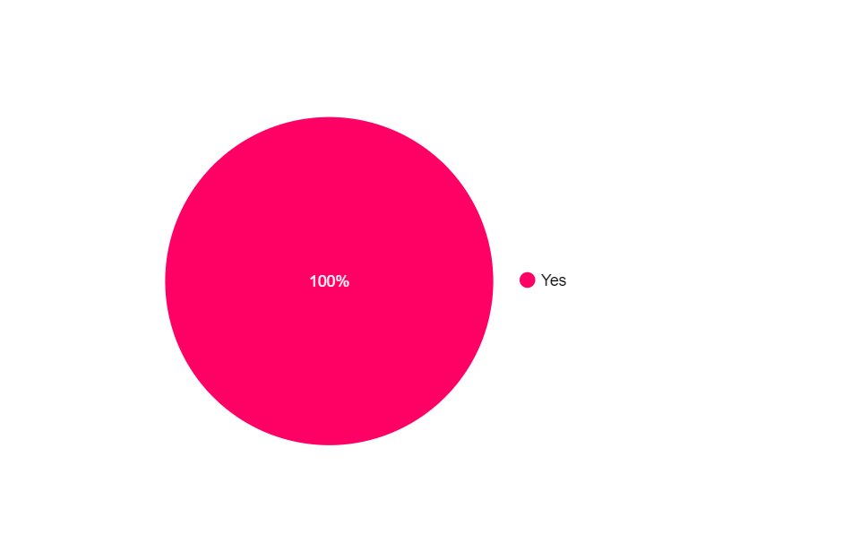

|  |  |
| --- | --- |
| Yes | 100% (46 students) |
| No | 0% (0 student) |

The figure provides the percentage breakdown for survey question number 6. Among the 46 students, the result shows that 100% of the respondents answered “Yes”, indicating that they have gadgets to play games.

Q7. If yes, what type of gadget are you using?

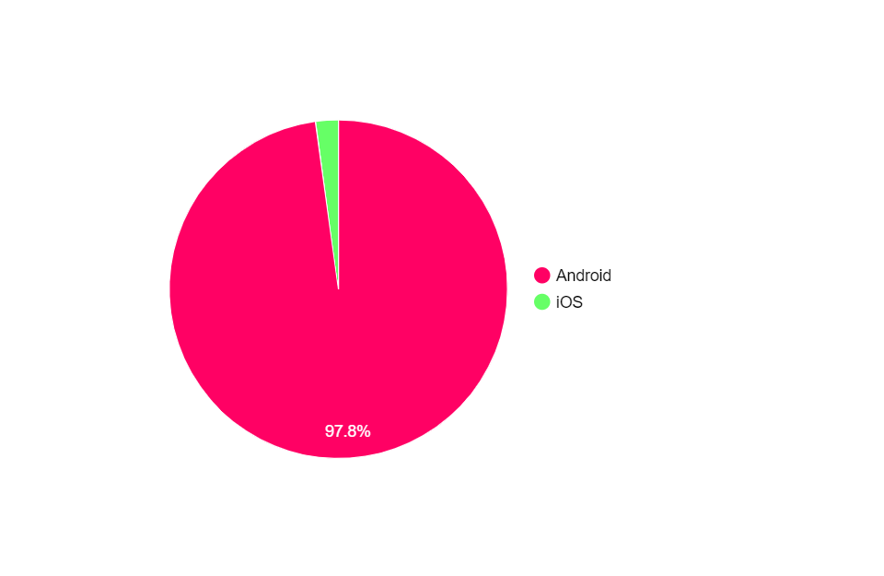

|  |  |
| --- | --- |
| Android | 97.8% (45 students) |
| iOS | 2.2% (1 student) |

The figure provides the percentage breakdown for survey question number 7. Among the 46 students, the result shows that 97.8% of the respondents answered “Android”, indicating that they use android type of gadget such as Samsung, Huawei, and Realme. The remaining 2.2% respondents answered “iOS”, indicating that they use iOS type of gadget.

Q8. How often do you play video games?

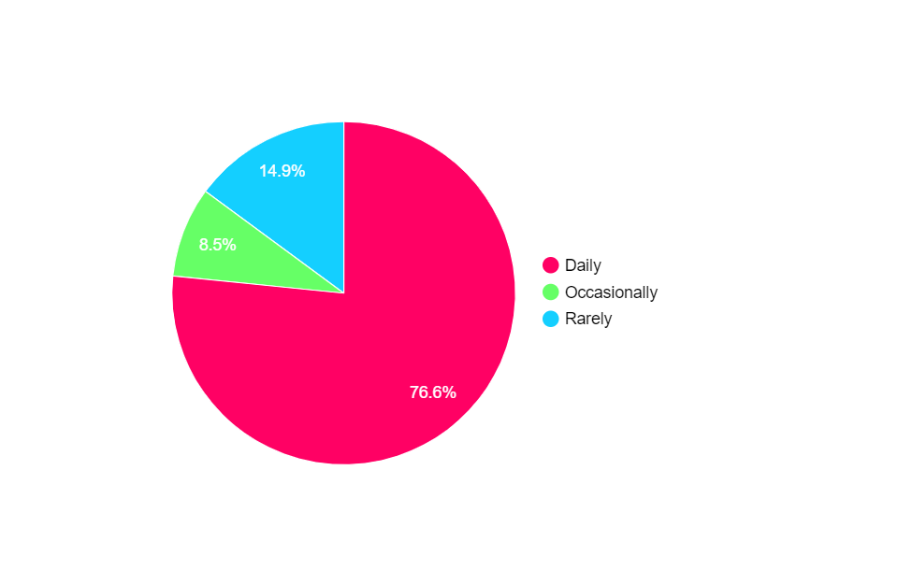

|  |  |
| --- | --- |
| Daily | 76.6% (35 students) |
| Occasionally | 8.5% (4 students) |
| Rarely | 14.9% (7 students) |
| Never | 0% (0 student) |

The figure provides the percentage breakdown for survey question number 8. Among the 46 students, the result shows that 76.6% of the respondents answered “Daily”, indicating that they play video games daily. Additionally, 14.9% percents of the respondents answered “Rarely”, indicating that they play video games once in a while. The remaining 8.5% respondents occasionally play games and 0% of them never play

appendix e - 2

Survey Result (Pook Elementary School)



Slovin’s Formula (Pook Elementary School)

Given:

$$n= \frac{N}{1+{Ne}^{2}}$$

$$n= \frac{50}{1+{50(0.05)}^{2}}$$

$$n= \frac{50}{1+50(0.025)}$$

$$n= \frac{50}{1+0.125}$$

$$n= \frac{52}{1.125}$$

$$n=44.444$$

**Appendix D - 2 Survey Result (Pook Elementary School)**

Q1. Which of the following topics/lessons you find difficult?

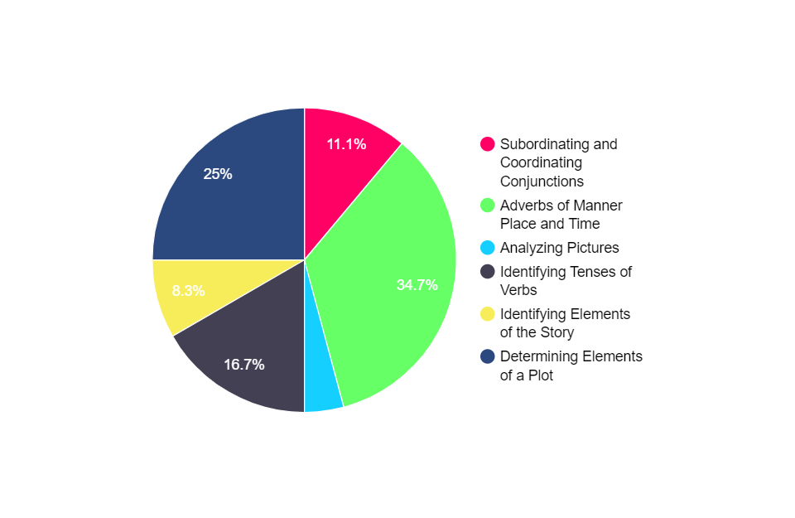

|  |  |
| --- | --- |
| Subordinating and Coordinating Conjunctions | 11.1% (8 students) |
| Adverbs of Manner, Place, and Time | 34.7% (25 students) |
| Analyzing Pictures | 5.5% (3 students) |
| Identifying Tenses of Verbs | 16.7% (12 students) |
| Identifying Elements of the Story | 8.3% (6 students) |
| Determining Elements of a Plot | 25% (18 students) |

The figure provides the percentage breakdown for survey question number 1. Among the 44 students, the result shows that 34.7% of the respondents answered “Adverbs of Manner, Place, and Time”, 25% of them answered “Determining Elements of a Plot”, and 16.7% answered “Identifying Tenses of Verbs”, indicating that these topics are the most difficult for them.

Q2. Would you like to have or use an educational game to help you learn this topic?

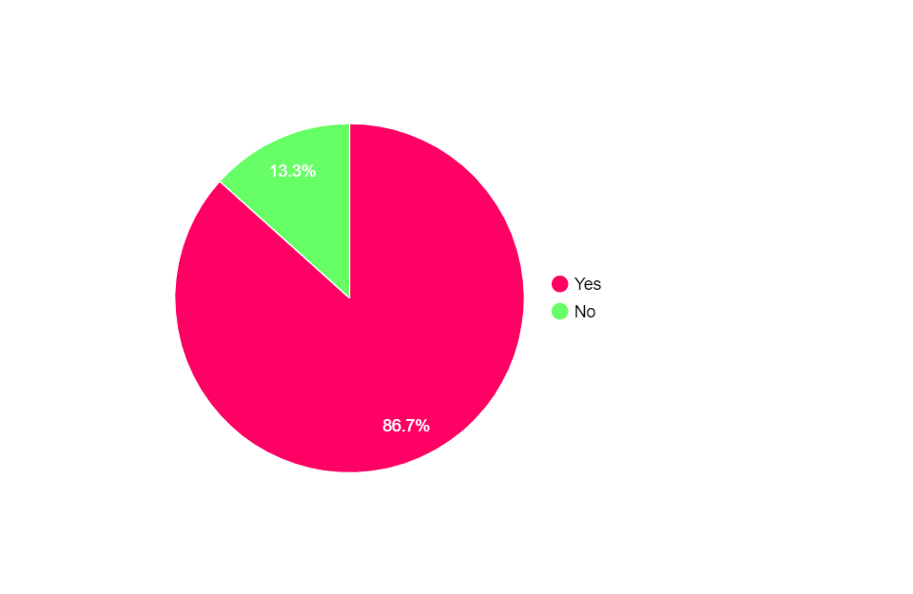

|  |  |
| --- | --- |
| Yes | 86.7% (38 students) |
| No | 13.3% (6 students) |

The figure provides the percentage breakdown for survey question num 2. Among the 44 students, the result shows that 86.7% of the respondents answered “Yes”, indicating that they are in favor of using educational game to help them learn their topics. The remaining 13.3% respondents answered “No”, indicating that they do not agree to use educational game for their learning.

Q3. Which type of game do you prefer to play?

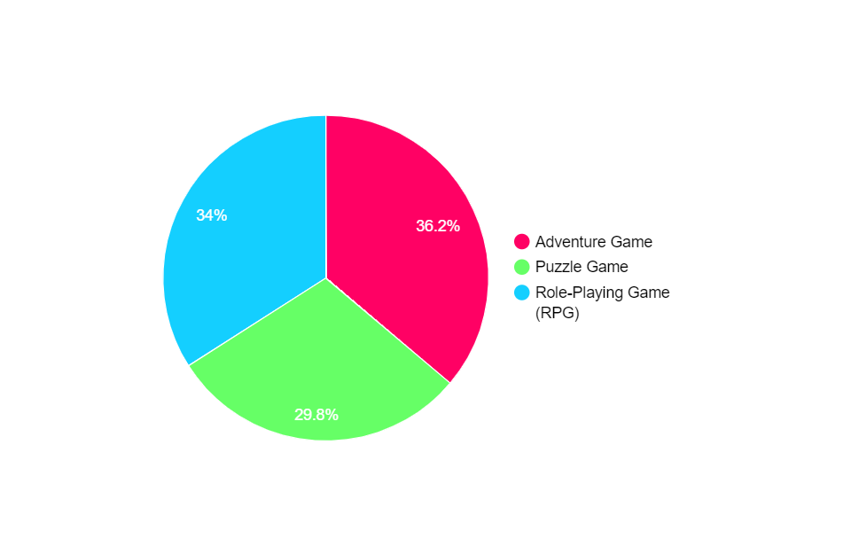

|  |  |
| --- | --- |
| Adventure Game | 36.2% (16 students) |
| Puzzle Game | 29.8% (13 students) |
| Role-Playing Game (RPG) | 34% (15 students) |

The figure provides the percentage breakdown for survey question number 3. Among the 44 students, the result shows that 36.2% of the respondents answered “Adventure Game”, indicating that they prefer to play this type of game.

Q4. What kind of game do you prefer?

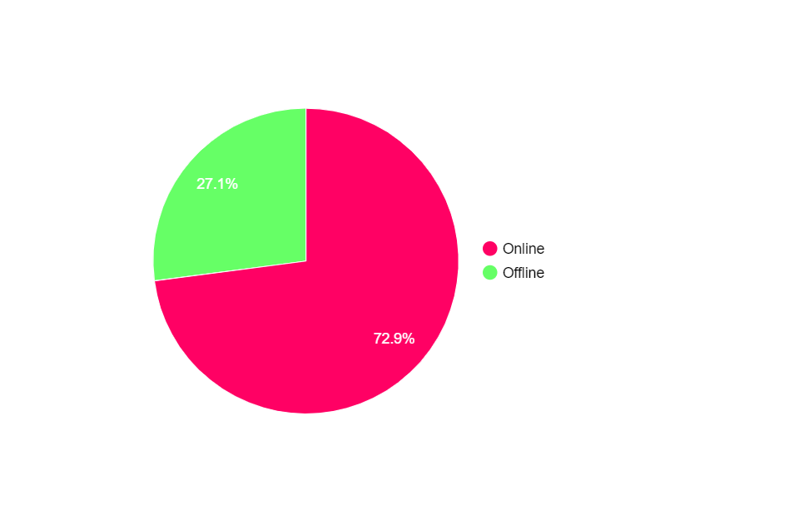

|  |  |
| --- | --- |
| Online | 72.9% (33 students) |
| Offline | 27.1% (11 students) |

The figure provides the percentage breakdown for survey question number 4. Among the 44 students, the result shows that 72.9% of the respondents answered “Online”, indicating that they prefer an online game. The remaining 27.1% respondents answered “Offline”, indicating that they prefer an offline game.

Q5. Do you want the game to have leaderboards?

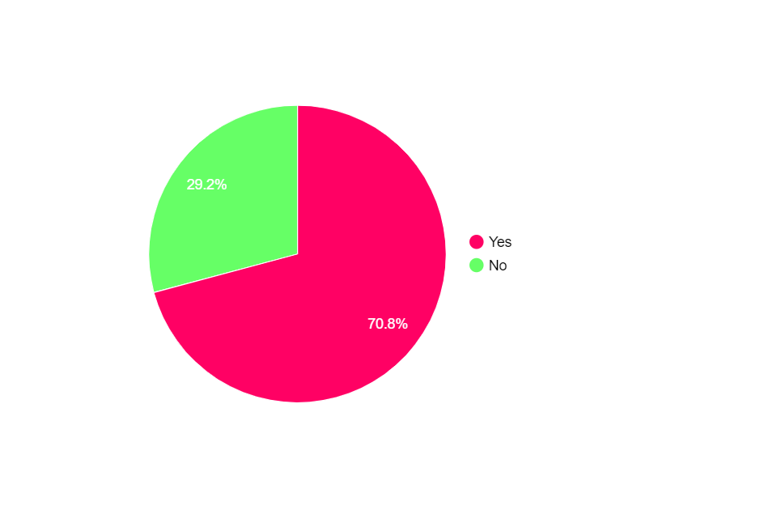

|  |  |
| --- | --- |
| Yes | 70.8% (32 students) |
| No | 29.2% (12 students) |

The figure provides the percentage breakdown for survey question number 5. Among the 44 students, the result shows that 70.8% of the respondents answered “Yes”, indicating that they want a game with leaderboards to track their progress. The remaining 29.2% respondents answered “No”, indicating that they want a game with no leaderboards.

Q6. Do you have gadgets you can use to play games?

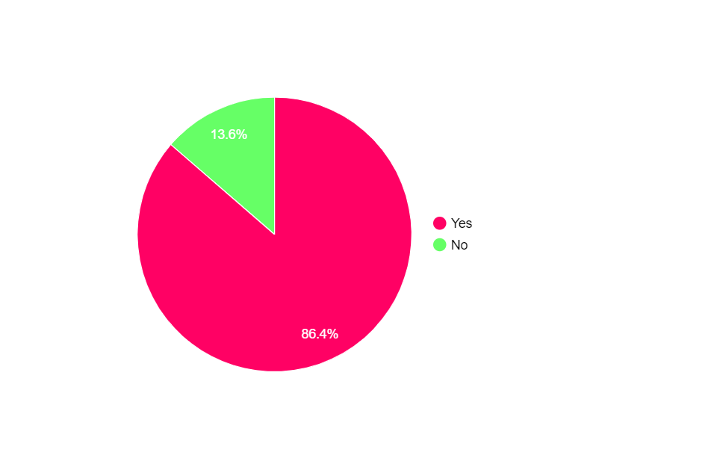

|  |  |
| --- | --- |
| Yes | 86.4% (38 students) |
| No | 13.6% (6 students) |

The figure provides the percentage breakdown for survey question number 6. Among the 44 students, the result shows that 86.4% of the respondents answered “Yes”, indicating that they have gadgets to play games. The remaining 13.6% respondents answered “No”, indicating that they do not have gadgets.

Q7. If yes, what type of gadget are you using?

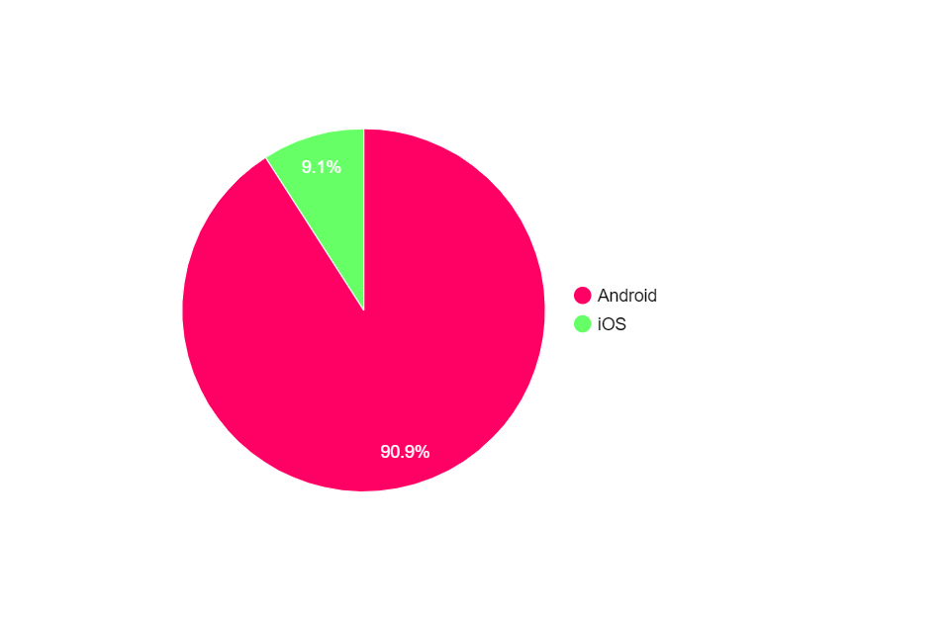

|  |  |
| --- | --- |
| Android | 90.9% (40 students) |
| iOS | 9.1% (4 students) |

The figure provides the percentage breakdown for survey question number 7. Among the 44 students, the result shows that 90.9% of the respondents answered “Android”, indicating that they use android type of gadget such as Samsung, Huawei, and Realme. The remaining 9.1% respondents answered “iOS”, indicating that they use iOS type of gadget.

Q8. How often do you play video games?

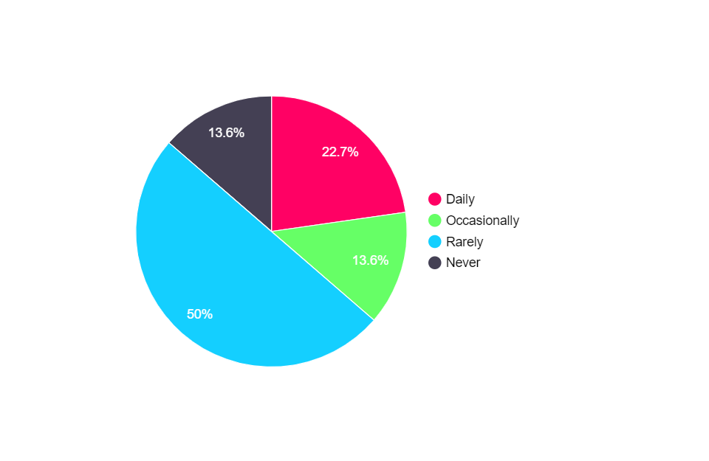

|  |  |
| --- | --- |
| Daily | 22.7% (10 students) |
| Occasionally | 13.6% (6 students) |
| Rarely | 50% (22 students) |
| Never | 13.6% (6 students) |

The figure provides the percentage breakdown for survey question number 8. Among the 44 students, the result shows that 50% of the respondents answered “Rarely”, indicating that they play video games once in a while. Additionally, 22.7% percents of the respondents answered “Daily”, indicating that they play video games daily. The remaining respondents occasionally play games and some of them never play.

appendix e - 3

Survey Result (Santol Elementary School)



Slovin’s Formula (Santol Elementary School)

Given:

$$n= \frac{N}{1+{Ne}^{2}}$$

$$n= \frac{56}{1+{56(0.05)}^{2}}$$

$$n= \frac{56}{1+56(0.025)}$$

$$n= \frac{56}{1+0.14}$$

$$n= \frac{52}{1.14}$$

$$n=49.123$$

**Appendix D - 3 Survey Result (Santol Elementary School)**

Q1. Which of the following topics/lessons you find difficult?

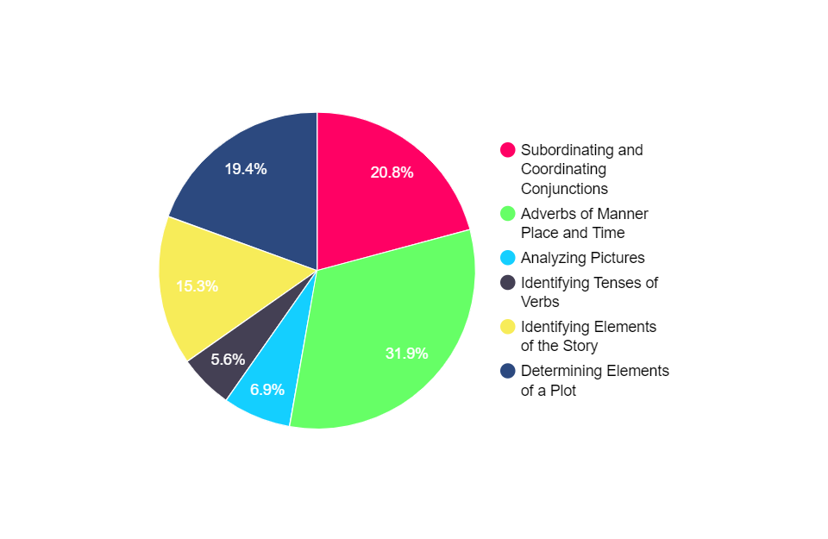

|  |  |
| --- | --- |
| Subordinating and Coordinating Conjunctions | 20.8% (15 students) |
| Adverbs of Manner, Place, and Time | 31.9% (23 students) |
| Analyzing Pictures | 6.9% (5 students) |
| Identifying Tenses of Verbs | 5.6% (4 students) |
| Identifying Elements of the Story | 15.3% (11 students) |
| Determining Elements of a Plot | 19.4% (14 students) |

The figure provides the percentage breakdown for survey question number 1. Among the 49 students, the result shows that 31.9% of the respondents answered “Adverbs of Manner, Place, and Time”, 19.4% of them answered “Determining Elements of a Plot”, and 16.7% answered “Subordinating and Coordinating Conjunctions”, indicating that these topics are the most difficult for them.

Q2. Would you like to have or use an educational game to help you learn this topic?

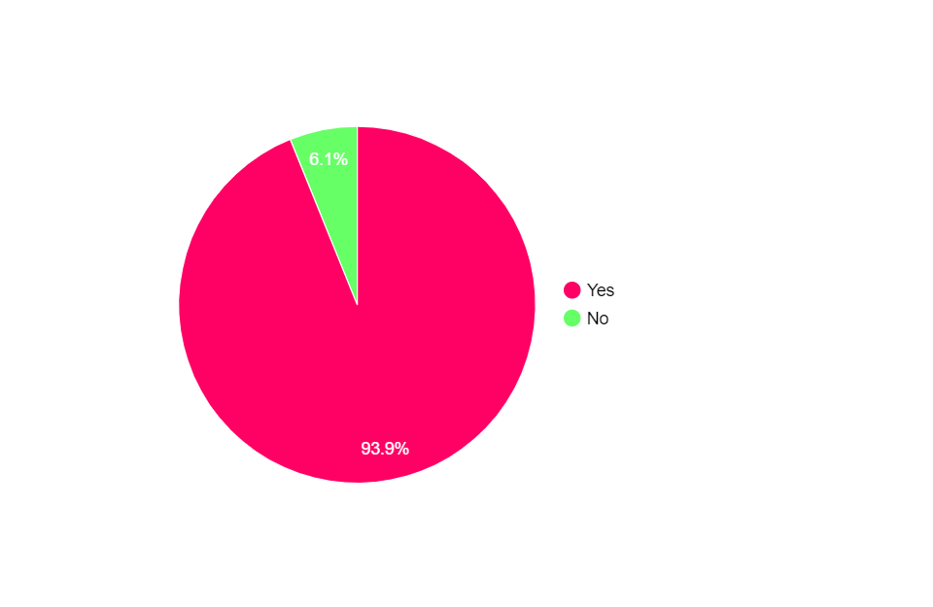

|  |  |
| --- | --- |
| Yes | 93.9% (46 students) |
| No | 6.1% (3 students) |

The figure provides the percentage breakdown for survey question num 2. Among the 49 students, the result shows that 93.9% of the respondents answered “Yes”, indicating that they are in favor of using educational game to help them learn their topics. The remaining 6.1% respondents answered “No”, indicating that they do not agree to use educational game for their learning.

Q3. Which type of game do you prefer to play?

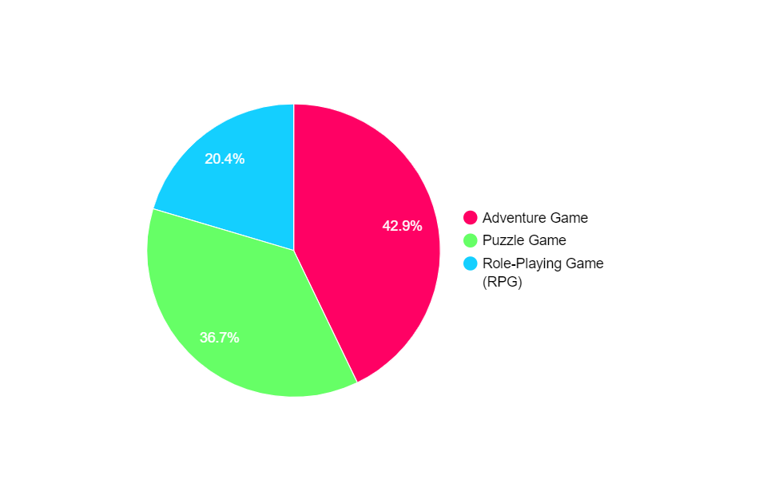

|  |  |
| --- | --- |
| Adventure Game | 42.9% (21 students) |
| Puzzle Game | 36.7% (18 students) |
| Role-Playing Game (RPG) | 20.4% (10 students) |

The figure provides the percentage breakdown for survey question number 3. Among the 49 students, the result shows that 42.9% of the respondents answered “Adventure Game”, indicating that they prefer to play this type of game.

Q4. What kind of game do you prefer?

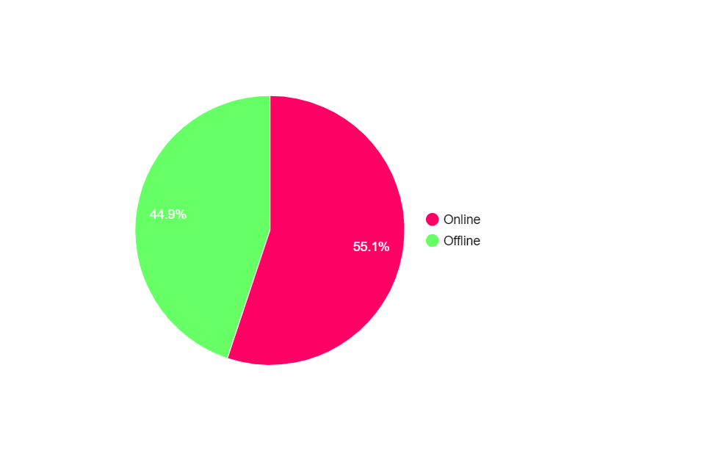

|  |  |
| --- | --- |
| Online | 55.1% (27 students) |
| Offline | 44.9% (22 students) |

The figure provides the percentage breakdown for survey question number 4. Among the 49 students, the result shows that 55.1% of the respondents answered “Online”, indicating that they prefer an online game. The remaining 44.9% respondents answered “Offline”, indicating that they prefer an offline game.

Q5. Do you want the game to have leaderboards?

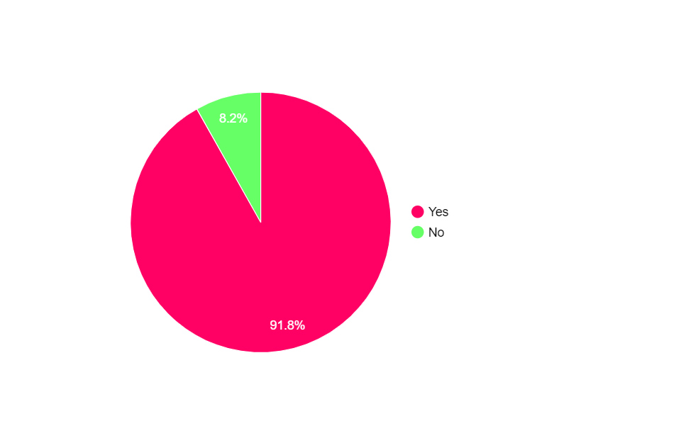

|  |  |
| --- | --- |
| Yes | 91.8% (45 students) |
| No | 8.2% (4 students) |

The figure provides the percentage breakdown for survey question number 5. Among the 49 students, the result shows that 91.8% of the respondents answered “Yes”, indicating that they want a game with leaderboards to track their progress. The remaining 8.2% respondents answered “No”, indicating that they want a game with no leaderboards.

Q6. Do you have gadgets you can use to play games?



|  |  |
| --- | --- |
| Yes | 93.9% (46 students) |
| No | 6.1% (3 students) |

The figure provides the percentage breakdown for survey question number 6. Among the 49 students, the result shows that 93.9% of the respondents answered “Yes”, indicating that they have gadgets to play games. The remaining 6.1% respondents answered “No”, indicating that they do not have gadgets.

Q7. If yes, what type of gadget are you using?

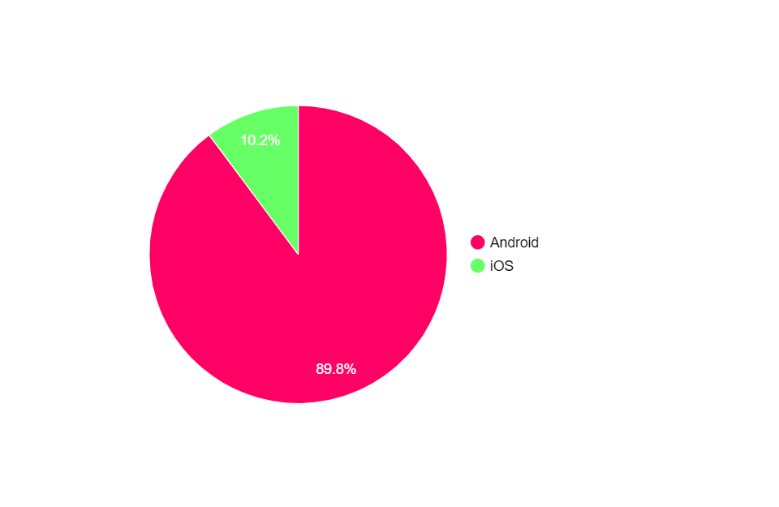

|  |  |
| --- | --- |
| Android | 89.8% (44 students) |
| iOS | 10.2% (5 students) |

The figure provides the percentage breakdown for survey question number 7. Among the 49 students, the result shows that 89.8% of the respondents answered “Android”, indicating that they use android type of gadget such as Samsung, Huawei, and Realme. The remaining 10.2% respondents answered “iOS”, indicating that they use iOS type of gadget.

Q8. How often do you play video games?

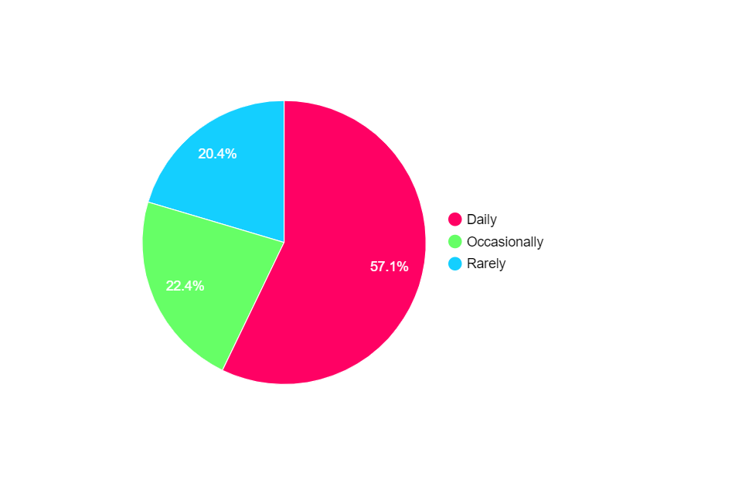

|  |  |
| --- | --- |
| Daily | 57.1% (28 students) |
| Occasionally | 22.4% (11 students) |
| Rarely | 20.4% (10 students) |
| Never | 0% (0 student) |

The figure provides the percentage breakdown for survey question number 8. Among the 49 students, the result shows that 57.1% of the respondents answered “Daily”, indicating that they play video games daily. Additionally, 22.4% percents of the respondents answered “Occasionally”, indicating that they play video games often. The remaining 20.4% respondents rarely play games.

appendix F

Subject Content

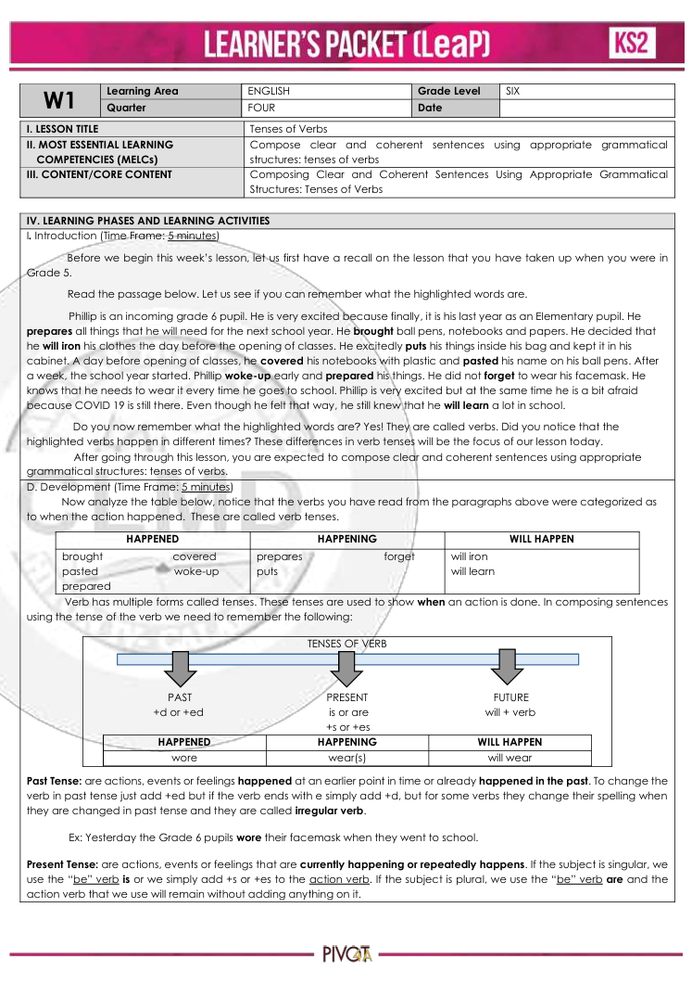

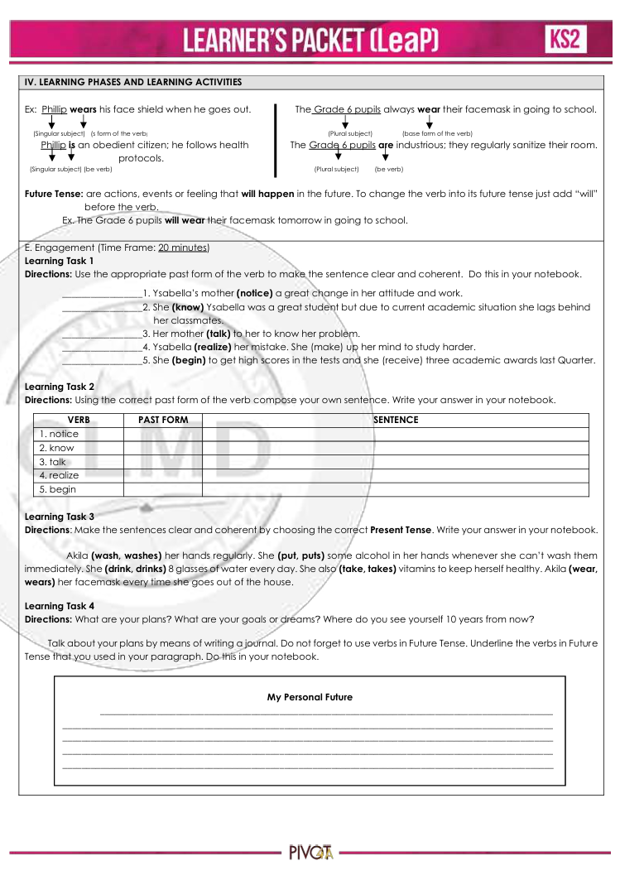

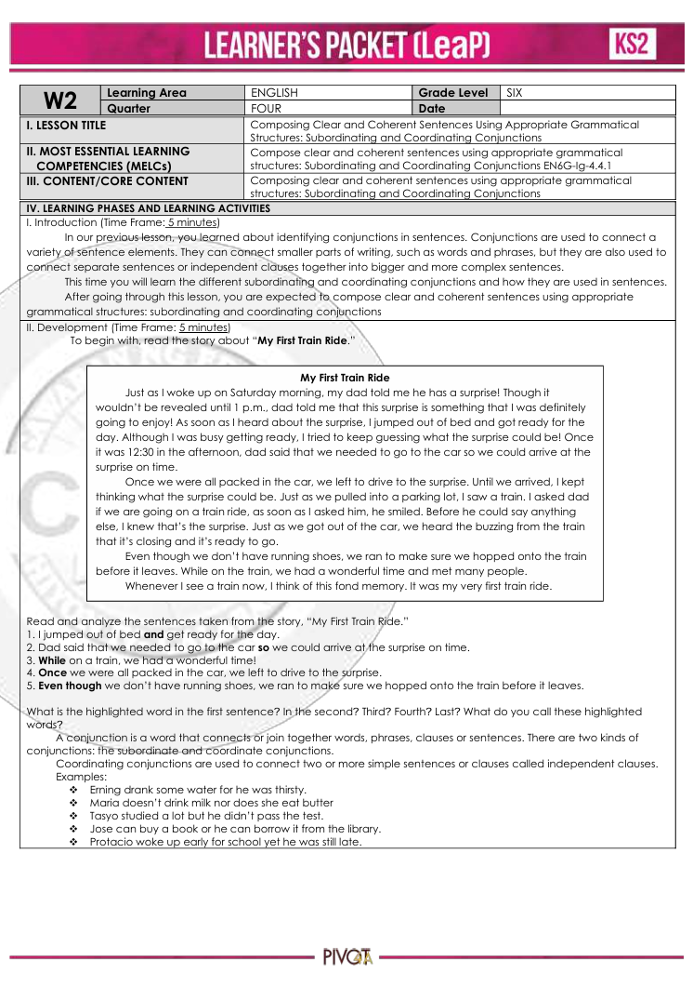

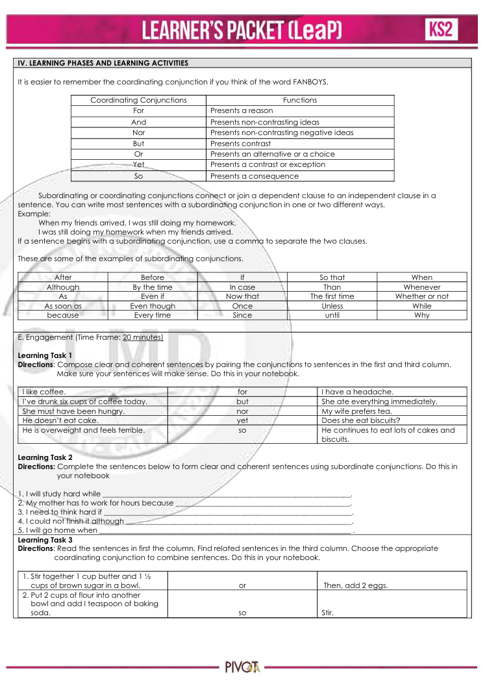

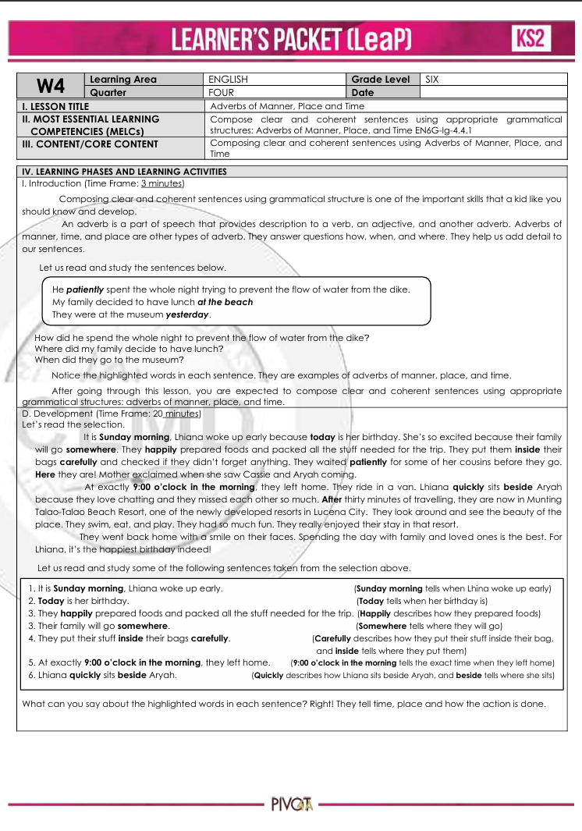

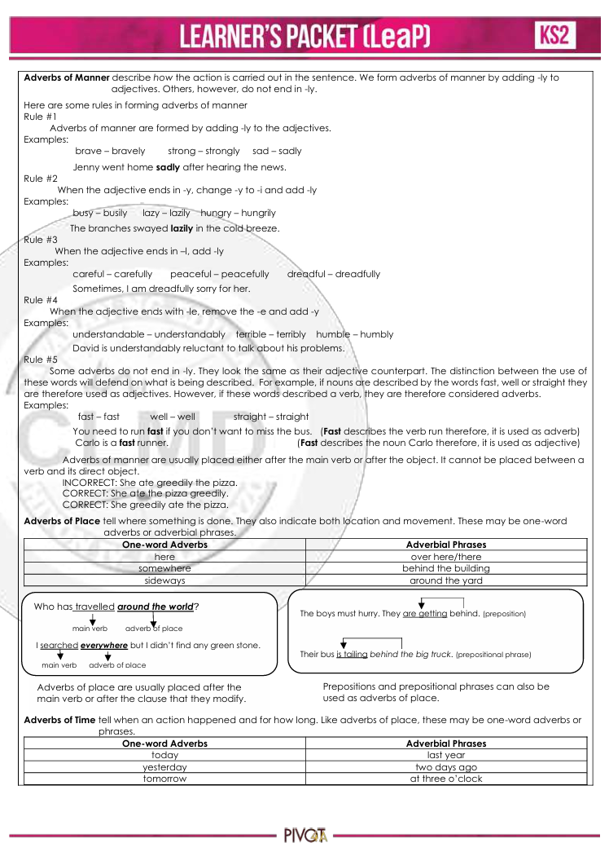

appendix G

Letter of Approval

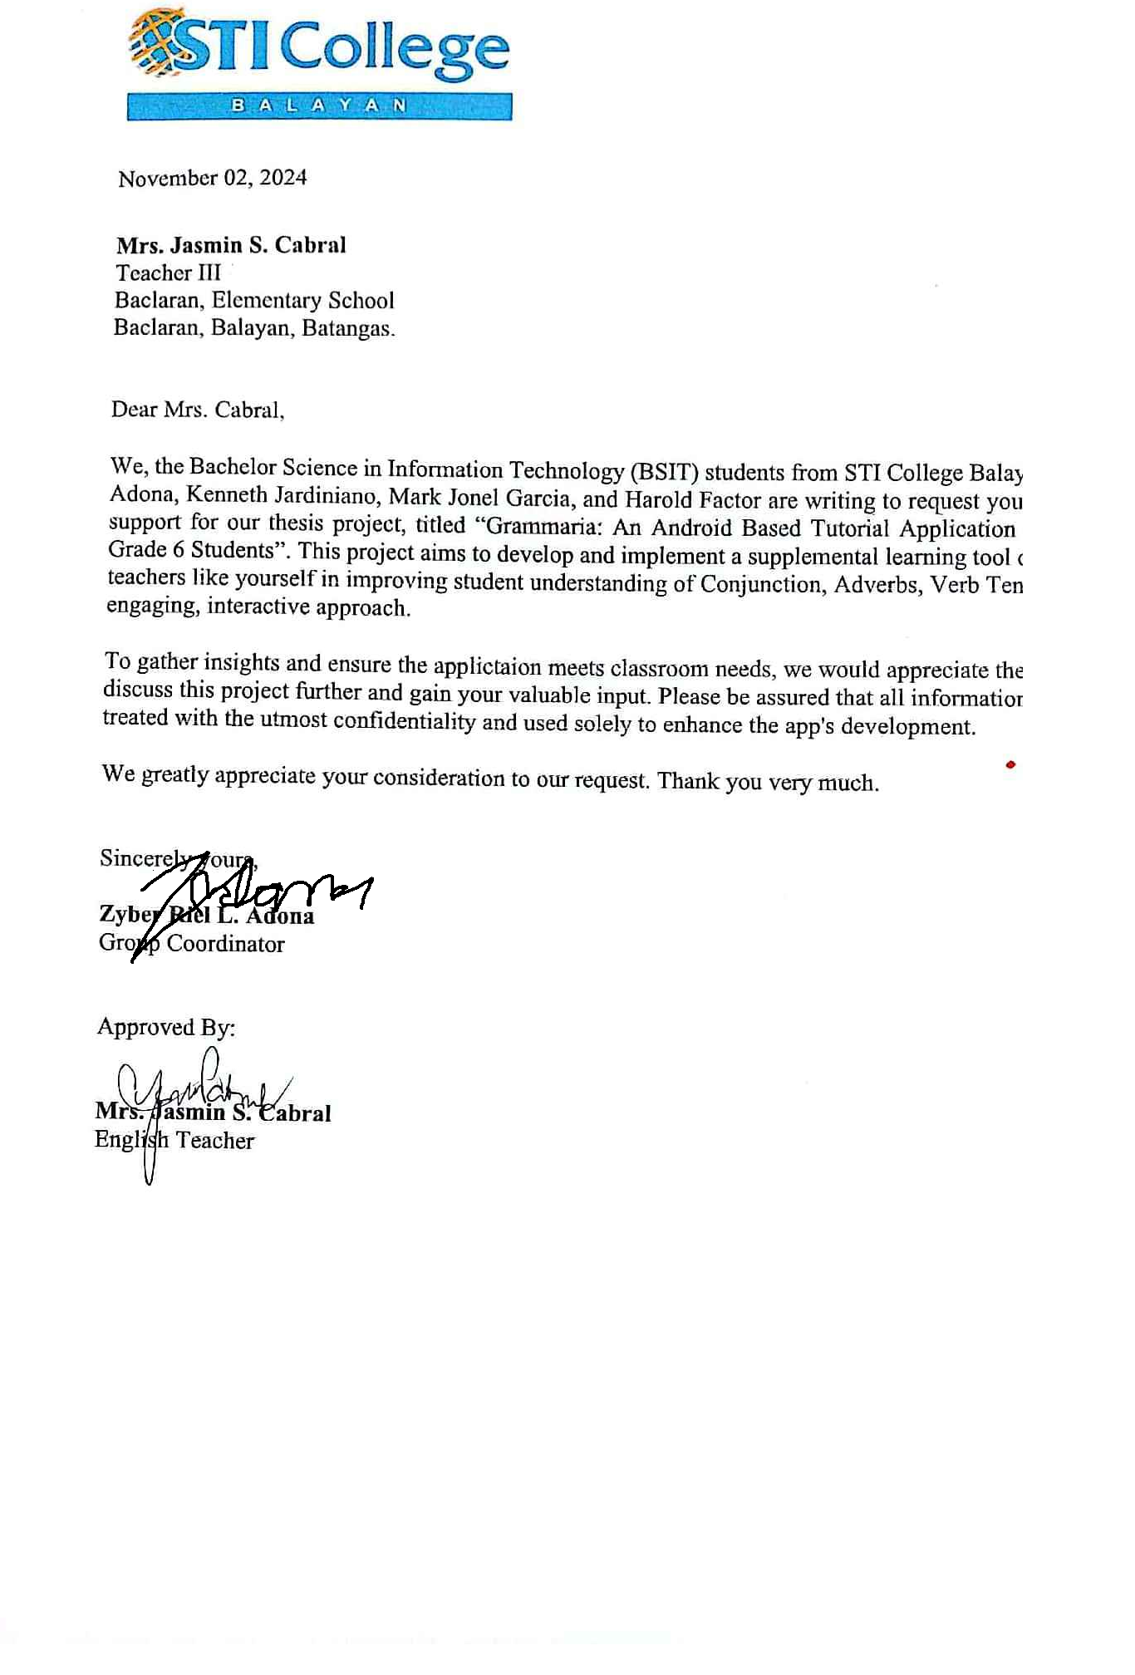

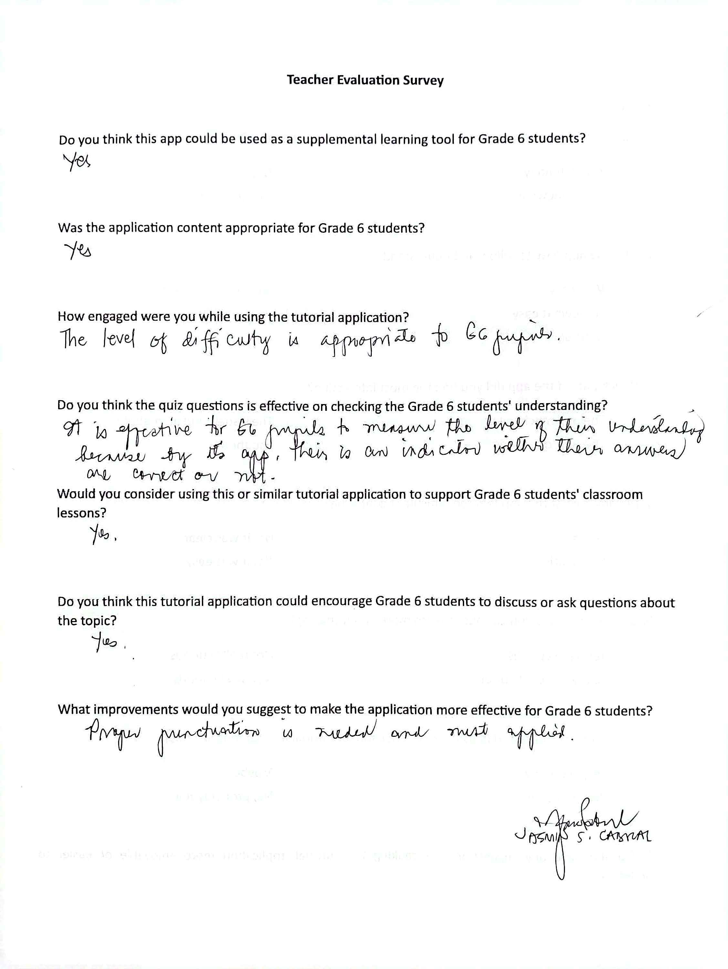

appendix H

Relevant Source Code

**Login Module**

public class LogIn : MonoBehaviour

{

[SerializeField] private TMP_InputField usernameInputFieldForLogin;

[SerializeField] private TMP_InputField usernameInputFieldForSignup;

[SerializeField] public TMP_Text invalidTextOfLogin;

[SerializeField] public TMP_Text invalidTextOfSignup;

private UserManager userManager;

private void Start()

{

userManager = FindAnyObjectByType<UserManager>();

}

public void OnSignUp()

{

string username = usernameInputFieldForSignup.text;

if (string.IsNullOrEmpty(username))

{

invalidTextOfSignup.text = "Username cannot be empty.";

invalidTextOfSignup.color = Color.red;

return;

}

bool signUpSuccessful = userManager.SignUp(username);

if (signUpSuccessful)

{

usernameInputFieldForSignup.text = "";

SceneManager.LoadScene("MainMenu");

UIManager uiManager = FindAnyObjectByType<UIManager>();

if (uiManager != null)

{

uiManager.UpdateUI();

}

invalidTextOfSignup.text = "User signed up successfully.";

invalidTextOfSignup.color = Color.green;

Debug.Log("User signed up successfully.");

}

else

{

usernameInputFieldForSignup.text = "";

invalidTextOfSignup.text = "Username already exists.";

invalidTextOfSignup.color = Color.red;

}

}

public void OnLogin()

{

string username = usernameInputFieldForLogin.text;

bool loginSuccessful = userManager.Login(username);

if (loginSuccessful)

{

SceneManager.LoadScene("MainMenu");

UIManager uiManager = FindAnyObjectByType<UIManager>();

if (uiManager != null)

{

uiManager.UpdateUI();

}

invalidTextOfLogin.text = "Login successful!";

invalidTextOfLogin.color = Color.green;

}

else

{

invalidTextOfLogin.text = "Invalid username!";

invalidTextOfLogin.color = Color.red;

}

}

}

**Leaderboard Manager**

public class LeaderboardManager : MonoBehaviour

{

public GameObject leaderboardEntryPrefab;

public Transform leaderboardContent;

public TMP_Text currentUserRankText;

public TMP_Text currentUserPointsText;

public TMP_Text currentUserUsernameText;

private DatabaseReference leaderboardRef;

public TMP_Text noInternet;

private void Start()

{

FirebaseApp.CheckAndFixDependenciesAsync().ContinueWithOnMainThread(task =>

{

FirebaseApp app = FirebaseApp.DefaultInstance;

leaderboardRef = FirebaseDatabase.DefaultInstance.RootReference.Child("leaderboard");

// Attempt to display online leaderboard first

DisplayOnlineLeaderboard();

});

noInternet.gameObject.SetActive(false);

}

public void DisplayOnlineLeaderboard()

{

ClearLeaderboardUI();

if (Application.internetReachability != NetworkReachability.NotReachable)

{

leaderboardRef.OrderByChild("points").GetValueAsync().ContinueWithOnMainThread(task =>

{

if (task.IsCompleted)

{

DataSnapshot snapshot = task.Result;

if (snapshot.Exists)

{

Debug.Log("Data snapshot retrieved successfully.");

LoadLeaderboardEntries(snapshot);

noInternet.gameObject.SetActive(false);

}

else

{

Debug.LogWarning("No data found in leaderboard.");

}

}

else

{

Debug.LogError("Failed to retrieve data from Firebase.");

}

});

}

else

{

DisplayOfflineUserRank();

Debug.Log("No internet connection.");

noInternet.gameObject.SetActive(true);

}

}

private void LoadLeaderboardEntries(DataSnapshot snapshot)

{

List<(string username, int point)> leaderboardEntries = new List<(string, int)>();

foreach (DataSnapshot userSnapshot in snapshot.Children)

{

string username = userSnapshot.Child("username").Value.ToString();

int point = int.Parse(userSnapshot.Child("points").Value.ToString());

leaderboardEntries.Add((username, point));

}

leaderboardEntries.Sort((a, b) => b.point.CompareTo(a.point));

for (int i = 0; i < leaderboardEntries.Count; i++)

{

CreateLeaderboardEntry(i + 1, leaderboardEntries[i].username, leaderboardEntries[i].point);

}

DisplayCurrentUserRank(leaderboardEntries);

}

private void DisplayCurrentUserRank(List<(string username, int point)> leaderboardEntries)

{

User currentUser = UserManager.instance.GetCurrentUser();

if (currentUser == null)

{

Debug.LogWarning("No current user found.");

return;

}

int currentUserRank = -1;

for (int i = 0; i < leaderboardEntries.Count; i++)

{

if (leaderboardEntries[i].username == currentUser.username)

{

currentUserRank = i + 1;

break;

}

}

if (currentUserRank > 0)

{

currentUserRankText.text = $"Rank: {currentUserRank}";

currentUserPointsText.text = $"Points: {currentUser.point}";

currentUserUsernameText.text = $"Username: {currentUser.username}";

}

else

{

currentUserRankText.text = "Rank: N/A";

currentUserPointsText.text = $"Points: {currentUser.point}";

currentUserUsernameText.text = $"Username: {currentUser.username}";

}

}

private void DisplayOfflineUserRank()

{

User curentUser = UserManager.instance.GetCurrentUser();

currentUserUsernameText.text = $"Username: {curentUser.username}";

currentUserRankText.text = "Rank: N/A";

currentUserPointsText.text = $"Points: {curentUser.point}";

}

private void CreateLeaderboardEntry(int rank, string username, int point)

{

GameObject entry = Instantiate(leaderboardEntryPrefab, leaderboardContent);

TMP_Text rankText = entry.transform.Find("RankText").GetComponent<TMP_Text>();

TMP_Text usernameText = entry.transform.Find("UsernameText").GetComponent<TMP_Text>();

TMP_Text pointText = entry.transform.Find("PointText").GetComponent<TMP_Text>();

rankText.text = rank.ToString();

usernameText.text = username;

pointText.text = point.ToString();

}

private void ClearLeaderboardUI()

{

foreach (Transform child in leaderboardContent)

{

Destroy(child.gameObject);

}

UserManager.instance.SyncLocalDataToFirebase(); // Optional: sync local data

}

// Helper class to hold the list of users

[System.Serializable]

private class UserList

{

public List<User> users;

}

}

**Tutorial Video**

public class VideoPlayBack : MonoBehaviour

{

[SerializeField] private RectTransform videoScreen; // The green video screen object

[SerializeField] private RectTransform whiteboard; // The green video screen object

[SerializeField] private RectTransform leftButtons; // The green video screen object

[SerializeField] private RectTransform rightButtons; // The green video screen object

[SerializeField] private Button MiniGameButton;

[SerializeField] private Button BackButton;

[SerializeField] private GameObject Teacher;

public VideoClip[] videoClip;

private VideoPlayer videoplayer;

private int videoClipIndex;

private bool isMuted = false;

private void Awake()

{

videoplayer = GetComponent<VideoPlayer>();

}

private void Start()

{

videoplayer.clip = videoClip[0];

UpdateClipNumber();

UpdateButtonStates();

UpdateProgressBar(); // Initialize the progress bar

// Add listener for slider

// progressBar.onValueChanged.AddListener(OnSliderValueChanged); // Add listener for slider

fullScreenButton.onClick.AddListener(ToggleFullscreen);

PlayCircleButton.onClick.AddListener(playPause);

playPauseButton.onClick.AddListener(playPause);

muteButton.onClick.AddListener(ToggleMute);

nextButton.onClick.AddListener(playNext);

previousButton.onClick.AddListener(playPrevious);

videoplayer.loopPointReached += OnVideoFinished; // Add event listener for video end

}

private void Update()

{

if (videoplayer.isPlaying)

{

UpdateProgressBar(); // Continuously update progress bar and time display

}

}

// Event handler when the video finishes

private void OnVideoFinished(VideoPlayer vp)

{

string tutorialName = videoplayer.clip.name;

UserManager.instance.MarkTutorialAsCompleted(tutorialName);

PlayCircleButton.gameObject.SetActive(true);

playPauseButton.image.sprite = play; // Change the button image to "play" when video finishes

}

// Toggle mute and unmute

private void ToggleMute()

{

isMuted = !isMuted; // Toggle the mute state

videoplayer.SetDirectAudioMute(0, isMuted); // Mute/unmute audio on track 0

if (isMuted)

{

muteButton.image.sprite = muteImage; // Show muted icon

}

else

{

muteButton.image.sprite = unmuteImage; // Show unmuted icon

}

}

private IEnumerator PlayPreparedVideo()

{

videoplayer.Prepare();

while (!videoplayer.isPrepared)

{

yield return null; // Wait until the video is prepared

}

videoplayer.Play();

PlayCircleButton.gameObject.SetActive(false);

playPauseButton.image.sprite = pause;

}

private void playNext()

{

videoClipIndex++;

if (videoClipIndex >= videoClip.Length)

{

videoClipIndex = 0;

}

videoplayer.clip = videoClip[videoClipIndex];

UpdateClipNumber();

UpdateButtonStates();

ResetProgressBar();

StartCoroutine(PlayPreparedVideo()); // Play only when the video is prepared

}

private void playPrevious()

{

videoClipIndex--;

if (videoClipIndex < 0)

{

videoClipIndex = videoClip.Length - 1;

}

videoplayer.clip = videoClip[videoClipIndex];

UpdateClipNumber();

UpdateButtonStates();

ResetProgressBar();

StartCoroutine(PlayPreparedVideo()); // Play only when the video is prepared

}

**}**

**Simple Tenses Quiz**

public class QuestionManagerForSimpleTenses : MonoBehaviour

{

[SerializeField] private QuizDataForSimpleTenses questionDataScriptable;

[SerializeField] private List<TMP_Text> wordTexts; // List to hold the words

[SerializeField] public List<GameObject> wordItems; // List of word GameObjects

private int currentQuestionIndex = 0;

private QuestionForSimpleTenses currentQuestion;

private List<QuestionForSimpleTenses> selectedQuestions; // List to store selected questions for the current game

[SerializeField] private TMP_Text timerText;

private float timeRemaining = 300f;

private bool isPaused = false;

[SerializeField] private GameObject checkIcon;

[SerializeField] private GameObject xIcon;

[SerializeField] private AudioSource src;

[SerializeField] private AudioClip correct, wrong, click_sound;

public Button hintButton;

public Button buyHintButton; // Button to buy hints

public Button resetButton;

public GameObject QuizPanel;

public GameObject ResultPanel;

public TMP_Text ScoreText;

public TMP_Text resultText;

public TMP_Text PointsText;

public TMP_Text bonusCoinsText;

public TMP_Text NumberText;

public Button pauseButton;

public Button resumeButton;

public int Score;

public int Points;

public int Coins;

UIManager uiManager;

User currentUser;

private void Start()

{

selectedQuestions = SelectRandomQuestions(questionDataScriptable.questions, 10);

SetQuestion();

StartCoroutine(TimerCoroutine());

pauseButton.onClick.AddListener(PauseTimer);

resumeButton.onClick.AddListener(OnResumeButtonClick);

hintButton.onClick.AddListener(ShowHint);

resetButton.onClick.AddListener(ResetSelectedWords);

buyHintButton.onClick.AddListener(BuyHint);

uiManager = FindAnyObjectByType<UIManager>();

currentUser = UserManager.instance.GetCurrentUser();

}

private void UpdateTimerDisplay()

{

TimeSpan timeSpan = TimeSpan.FromSeconds(timeRemaining);

timerText.text = timeSpan.ToString(@"mm\:ss");

}

private IEnumerator TimerCoroutine()

{

while (timeRemaining > 0)

{

while (isPaused)

{

yield return null;

}

yield return new WaitForSeconds(1);

timeRemaining--;

UpdateTimerDisplay();

}

if (timeRemaining <= 0)

{

GameOver();

}

}

public void PauseTimer()

{

isPaused = true;

}

public void OnResumeButtonClick()

{

isPaused = false;

}

public void ShowHint()

{

if (currentUser.hint > 0)

{

foreach (var word in wordItems)

{

var wordComponent = word.GetComponent<CorrectWords>();

if (wordComponent != null)

{

wordComponent.ShowHint();

break; // Only show the hint for one word

}

}

currentUser.hint -= 1;

UserManager.instance.SaveUsers(); // Save the updated user data

// Update UI to reflect the new coins and hint count

if (uiManager != null)

{

uiManager.UpdateUI(); // Update hint count

}

hintButton.interactable = false;

}

else

{

Debug.Log("No hints available");

}

}

public void BuyHint()

{

if (currentUser != null)

{

if (currentUser.coin >= 100)

{

currentUser.coin -= 100; // Deduct 100 coins for purchasing a hint

currentUser.hint += 1; // Add 1 hint to the user's hint count

UserManager.instance.SaveUsers(); // Save the updated user data

// Update UI to reflect the new coins and hint count

if (uiManager != null)

{

uiManager.UpdateUI(); // Update hint count

}

Debug.Log("Hint purchased. Current coins: " + currentUser.coin + " Hints: " + currentUser.hint);

}

else

{

Debug.Log("Not enough coins to purchase a hint.");

}

}

}

private void GameOver()

{

QuizPanel.SetActive(false);

ResultPanel.SetActive(true);

ScoreText.text = Score + "/10";

PointsText.text = Points.ToString();

if (Score >= 8)

{

resultText.text = "Passed";

resultText.color = new Color(0f, 0.4113207f, 0.01012429f); // dark green

}

else

{

resultText.text = "Failed";

resultText.color = Color.red; // Change the color to red for "Failed"

}

if (Score == 10)

{

Coins = 100;

}

else if (Score == 9)

{

Coins = 80;

}

else if (Score == 8)

{

Coins = 50;

}

else

{

Coins = 0;

}

bonusCoinsText.text = Coins.ToString();

// Update the current user's points and coins in the UserManager

UpdateUserProgress(Points, Coins);

// Get the UIManager instance and update points and coins

uiManager.UpdateUI();

}

**Perfect Tenses Quiz**

public class QuestionManagerForPerfectTenses : MonoBehaviour

{

public static QuestionManagerForPerfectTenses instance;

[SerializeField] private QuizDataForPerfectTenses questionDataScriptable;

[SerializeField] private CorrectSequence[] optionsWordList;

[SerializeField] private TMP_Text timerText;

private float timeRemaining = 300f;

[SerializeField] private Button hintButton;

[SerializeField] private GameObject checkIcon;

[SerializeField] private GameObject xIcon;

[SerializeField] private AudioSource src;

[SerializeField] private AudioClip correct, wrong, click_sound;

public int currentQuestionIndex = 0;

public List<QuestionDataForPerfectTenses> selectedQuestions; // List to store selected questions for the current game

private List<string> selectedWords = new List<string>(); // List to keep track of selected words

public Button buyHintButton;

public GameObject QuizPanel;

public GameObject ResultPanel;

public TMP_Text ScoreText;

public TMP_Text resultText;

public TMP_Text PointsText;

public TMP_Text bonusCoinsText;

public TMP_Text NumberText;

public Button pauseButton;

public Button resumeButton;

public int Score;

public int Points;

public int Coins;

private bool isPaused = false;

UIManager uiManager;

User currentUser;

private void Awake()

{

if (instance == null)

instance = this;

else

Destroy(this.gameObject);

}

void Start()

{

// Shuffle and select questions at the start

selectedQuestions = SelectRandomQuestions(questionDataScriptable.questions, 10);

SetQuestion();

StartCoroutine(TimerCoroutine()); // Start the timer

pauseButton.onClick.AddListener(PauseTimer);

resumeButton.onClick.AddListener(OnResumeButtonClick);

hintButton.onClick.AddListener(ShowHint); // Assign the ShowHint method to the button click event

buyHintButton.onClick.AddListener(BuyHint);

uiManager = FindAnyObjectByType<UIManager>();

currentUser = UserManager.instance.GetCurrentUser();

}

void UpdateTimerDisplay()

{

TimeSpan timeSpan = TimeSpan.FromSeconds(timeRemaining);

timerText.text = timeSpan.ToString(@"mm\:ss"); // Format time as minutes and seconds

}

IEnumerator TimerCoroutine()

{

while (timeRemaining > 0)

{

while (isPaused)

{

yield return null; // Wait here until isPaused is false

}

yield return new WaitForSeconds(1);

timeRemaining--;

UpdateTimerDisplay();

}

// Time's up!

if (timeRemaining == 0)

{

GameOver();

}

}

public void PauseTimer()

{

isPaused = true;

}

public void OnResumeButtonClick()

{

isPaused = false;

}

public void ShowHint()

{

if (currentUser.hint > 0)

{

QuestionDataForPerfectTenses currentQuestion = selectedQuestions[currentQuestionIndex];

string correctWord = currentQuestion.correctSentenceWords[CorrectSequence.currentAnswerIndex];

// Hide the correct word option from the options list

foreach (var wordOption in optionsWordList)

{

if (wordOption.wordValue == correctWord && wordOption.gameObject.activeInHierarchy)

{

// Simulate the word being selected by invoking the button click programmatically

wordOption.GetComponent<Image>().color = Color.blue;

break;

}

}

AudioManager.instance.PlaySoundEffect(click_sound);

currentUser.hint -= 1;

UserManager.instance.SaveUsers(); // Save the updated user data

// Update UI to reflect the new coins and hint count

if (uiManager != null)

{

uiManager.UpdateUI(); // Update hint count

}

hintButton.interactable = false;

}

else

{

Debug.Log("No hints available");

}

}

public void BuyHint()

{

if (currentUser != null)

{

if (currentUser.coin >= 100)

{

currentUser.coin -= 100; // Deduct 100 coins for purchasing a hint

currentUser.hint += 1; // Add 1 hint to the user's hint count

UserManager.instance.SaveUsers(); // Save the updated user data

// Update UI to reflect the new coins and hint count

if (uiManager != null)

{

uiManager.UpdateUI(); // Update hint count

}

Debug.Log("Hint purchased. Current coins: " + currentUser.coin + " Hints: " + currentUser.hint);

}

else

{

Debug.Log("Not enough coins to purchase a hint.");

}

}

}

void GameOver()

{

QuizPanel.SetActive(false);

ResultPanel.SetActive(true);

ScoreText.text = Score + "/10";

PointsText.text = Points.ToString();

if (Score >= 8)

{

resultText.text = "Passed";

resultText.color = new Color(0f, 0.4113207f, 0.01012429f); // dark green

}

else

{

resultText.text = "Failed";

resultText.color = Color.red; // Change the color to red for "Failed"

}

if (Score == 10)

{

Coins = 100;

}

else if (Score == 9)

{

Coins = 80;

}

else if (Score == 8)

{

Coins = 50;

}

else

{

Coins = 0;

}

bonusCoinsText.text = Coins.ToString();

// Update the current user's points and coins in the UserManager

UpdateUserProgress(Points, Coins);

// Get the UIManager instance and update points and coins

UIManager uiManager = FindAnyObjectByType<UIManager>();

if (uiManager != null)

{

uiManager.UpdateUI();

}

}

**Coordinating Conjunction Quiz**

public class QuestionManagerForCoordinating : MonoBehaviour

{

[SerializeField] private QuizDataForCoordinating questionDataScriptable;

[SerializeField] private TMP_Text questionText1;

[SerializeField] private TMP_Text questionText2;

[SerializeField] private List<DraggableScriptForCoordinating> answers; // List of draggable answers

[SerializeField] private AnswerBox answerBox; // Single answer box

private int currentQuestionIndex = 0;

private QuestionDataForCoordinating currentQuestion;

private List<QuestionDataForCoordinating> selectedQuestions; // List to store selected questions for the current game

[SerializeField] private TMP_Text timerText;

private float timeRemaining = 300f;

private bool isPaused = false;

[SerializeField] private GameObject checkIcon; // GameObject to display check icon

[SerializeField] private GameObject xIcon;

[SerializeField] private AudioSource src;

[SerializeField] private AudioClip correct, wrong;

public Button hintButton;

public Button buyHintButton;

public GameObject QuizPanel;

public GameObject ResultPanel;

public TMP_Text ScoreText;

public TMP_Text resultText;

public TMP_Text PointsText;

public TMP_Text bonusCoinsText;

public TMP_Text NumberText;

public Button pauseButton;

public Button resumeButton;

public int Score;

public int Points;

public int Coins;

UIManager uiManager;

User currentUser;

private void Start()

{

selectedQuestions = SelectRandomQuestions(questionDataScriptable.questionsForCoordinating, 10);

SetQuestion();

StartCoroutine(TimerCoroutine()); // Start the timer

pauseButton.onClick.AddListener(PauseTimer);

resumeButton.onClick.AddListener(OnResumeButtonClick);

hintButton.onClick.AddListener(ShowHint);

buyHintButton.onClick.AddListener(BuyHint);

uiManager = FindAnyObjectByType<UIManager>();

currentUser = UserManager.instance.GetCurrentUser();

}

void UpdateTimerDisplay()

{

TimeSpan timeSpan = TimeSpan.FromSeconds(timeRemaining);

timerText.text = timeSpan.ToString(@"mm\:ss"); // Format time as minutes and seconds

}

IEnumerator TimerCoroutine()

{

while (timeRemaining > 0)

{

while (isPaused)

{

yield return null; // Wait here until isPaused is false

}

yield return new WaitForSeconds(1);

timeRemaining--;

UpdateTimerDisplay();

}

// Time's up!

if (timeRemaining == 0)

{

GameOver();

}

}

public void PauseTimer()

{

isPaused = true;

}

public void OnResumeButtonClick()

{

isPaused = false;

}

private void ShowHint()

{

if (currentUser.hint > 0)

{

// Find all incorrect answers

List<DraggableScriptForCoordinating> incorrectAnswers = answers.Where(a =>

!a.isCorrectAnswer).ToList();

if (incorrectAnswers.Count > 0)

{

// Randomly select one incorrect answer to remove

DraggableScriptForCoordinating answerToRemove = incorrectAnswers[UnityEngine.Random.Range(0, incorrectAnswers.Count)];

answerToRemove.gameObject.SetActive(false); // Hide the answer

currentUser.hint -= 1;

UserManager.instance.SaveUsers(); // Save the updated user data

// Update UI to reflect the new coins and hint count

if (uiManager != null)

{

uiManager.UpdateUI(); // Update hint count

}

hintButton.interactable = false; // Disable the hint button after use

}

}

else

{

Debug.Log("No hints available");

}

}

public void BuyHint()

{

if (currentUser != null)

{

if (currentUser.coin >= 100)

{

currentUser.coin -= 100; // Deduct 100 coins for purchasing a hint

currentUser.hint += 1; // Add 1 hint to the user's hint count

UserManager.instance.SaveUsers(); // Save the updated user data

// Update UI to reflect the new coins and hint count

if (uiManager != null)

{

uiManager.UpdateUI(); // Update hint count

}

Debug.Log("Hint purchased. Current coins: " + currentUser.coin + " Hints: " + currentUser.hint);

}

else

{

Debug.Log("Not enough coins to purchase a hint.");

}

}

}

void GameOver()

{

QuizPanel.SetActive(false);

ResultPanel.SetActive(true);

ScoreText.text = Score + "/10";

PointsText.text = Points.ToString();

if (Score >= 8)

{

resultText.text = "Passed";

resultText.color = new Color(0f, 0.4113207f, 0.01012429f); // dark green

}

else

{

resultText.text = "Failed";

resultText.color = Color.red; // Change the color to red for "Failed"

}

if (Score == 10)

{

Coins = 100;

}

else if (Score == 9)

{

Coins = 80;

}

else if (Score == 8)

{

Coins = 50;

}

else

{

Coins = 0;

}

bonusCoinsText.text = Coins.ToString(); ;

// Update the current user's points and coins in the UserManager

UpdateUserProgress(Points, Coins);

// Get the UIManager instance and update points and coins

UIManager uiManager = FindAnyObjectByType<UIManager>();

if (uiManager != null)

{

uiManager.UpdateUI();

}

}

**Subordinating Conjunction Quiz**

public class QuizManagerForSubordinating : MonoBehaviour

{

public static QuizManagerForSubordinating instance;

[SerializeField] private QuizDataScriptable questionDataScriptable;

[SerializeField] private TMP_Text questionText1;

[SerializeField] private TMP_Text questionText2;

[SerializeField] private WordData[] answerWordList;

[SerializeField] private WordData[] optionsWordList;

[SerializeField] private TMP_Text timerText;

private float timeRemaining = 300f003B

[SerializeField] private Button hintButton;

[SerializeField] private GameObject checkIcon; // GameObject to display check icon

[SerializeField] private GameObject xIcon;

[SerializeField] private AudioSource src;

[SerializeField] private AudioClip correct, wrong, click_sound;

private char[] wordsArray = new char[12];

private List<int> selectedWordsIndex;

private int currentAnswerIndex = 0, currentQuestionIndex = 0;

private bool correctAnswer = true;

private string answerWord;

private bool isPaused = false;

public Button buyHintButton;

public GameObject QuizPanel;

public GameObject ResultPanel;

public TMP_Text ScoreText;

public TMP_Text resultText;

public TMP_Text PointsText;

public TMP_Text bonusCoinsText;

public TMP_Text NumberText;

public Button pauseButton;

public Button resumeButton;

private List<QuestionData> selectedQuestions; // List to store selected questions for the current game

private int totalQuestion = 10; // Number of questions per game

public int Score;

public int Points;

public int Coins;

UIManager uiManager;

User currentUser;

private void Awake()

{

if (instance == null)

instance = this;

else

Destroy(this.gameObject);

}

void Start()

{

// Shuffle and select 10 questions at the start

selectedQuestions = SelectRandomQuestions(questionDataScriptable.questions, totalQuestion);

ResultPanel.SetActive(false);

selectedWordsIndex = new List<int>();

checkIcon.SetActive(false); // Initially hide the check icon

xIcon.SetActive(false);

SetQuestion();

StartCoroutine(TimerCoroutine()); // Start the timer

pauseButton.onClick.AddListener(PauseTimer);

resumeButton.onClick.AddListener(OnResumeButtonClick);

hintButton.onClick.AddListener(ShowHint); // Assign the ShowHint method to the button click event

buyHintButton.onClick.AddListener(BuyHint);

uiManager = FindAnyObjectByType<UIManager>();

currentUser = UserManager.instance.GetCurrentUser();

}

void UpdateTimerDisplay()

{

TimeSpan timeSpan = TimeSpan.FromSeconds(timeRemaining);

timerText.text = timeSpan.ToString(@"mm\:ss"); // Format time as minutes and seconds

}

IEnumerator TimerCoroutine()

{

while (timeRemaining > 0)

{

while (isPaused)

{

yield return null; // Wait here until isPaused is false

}

yield return new WaitForSeconds(1);

timeRemaining--;

UpdateTimerDisplay();

}

// Time's up!

if (timeRemaining == 0)

{

GameOver();

}

}

public void PauseTimer()

{

isPaused = true;

}

public void OnResumeButtonClick()

{

isPaused = false;

}

public void ShowHint()

{

if (currentUser.hint > 0)

{

if (answerWord.Length > 0)

{

answerWordList[currentAnswerIndex].SetWord(char.ToUpper(answerWord[currentAnswerIndex]));

hintButton.interactable = false; // Optionally disable the hint button after use

AudioManager.instance.PlaySoundEffect(click_sound);

}

currentUser.hint -= 1;

UserManager.instance.SaveUsers(); // Save the updated user data

// Update UI to reflect the new coins and hint count

if (uiManager != null)

{

uiManager.UpdateUI(); // Update hint count

}

hintButton.interactable = false;

}

else

{

Debug.Log("No hints available");

}

}

public void BuyHint()

{

if (currentUser != null)

{

if (currentUser.coin >= 100)

{

currentUser.coin -= 100; // Deduct 100 coins for purchasing a hint

currentUser.hint += 1; // Add 1 hint to the user's hint count

UserManager.instance.SaveUsers(); // Save the updated user data

// Update UI to reflect the new coins and hint count

if (uiManager != null)

{

uiManager.UpdateUI(); // Update hint count

}

Debug.Log("Hint purchased. Current coins: " + currentUser.coin + " Hints: " + currentUser.hint);

}

else

{

Debug.Log("Not enough coins to purchase a hint.");

}

}

}

void GameOver()

{

QuizPanel.SetActive(false);

ResultPanel.SetActive(true);

ScoreText.text = Score + "/" + totalQuestion;

PointsText.text = Points.ToString();

if (Score >= 8)

{

resultText.text = "Passed";

resultText.color = new Color(0f, 0.4113207f, 0.01012429f); // dark green

}

else

{

resultText.text = "Failed";

resultText.color = Color.red; // Change the color to red for "Failed"

}

if (Score == 10)

{

Coins = 100;

}

else if (Score == 9)

{

Coins = 80;

}

else if (Score == 8)

{

Coins = 50;

}

else

{

Coins = 0;

}

bonusCoinsText.text = Coins.ToString();;

// Update the current user's points and coins in the UserManager

UpdateUserProgress(Points, Coins);

// Get the UIManager instance and update points and coins

UIManager uiManager = FindAnyObjectByType<UIManager>();

if (uiManager != null)

{

uiManager.UpdateUI();

}

}

**Adverb Quiz**

public class QuestionManagerForManner : MonoBehaviour

{

[SerializeField] private QuizDataForManner questionDataScriptable;

[SerializeField] private TMP_Text questionText1;

[SerializeField] private List<DraggableScriptForManner> answers; // List of draggable answers

[SerializeField] private AnswerBox answerBox; // Single answer box

private int currentQuestionIndex = 0;

private Question currentQuestion;

private List<Question> selectedQuestions; // List to store selected questions for the current game

[SerializeField] private TMP_Text timerText;

private float timeRemaining = 300f;

private bool isPaused = false;

[SerializeField] private GameObject checkIcon; // GameObject to display check icon

[SerializeField] private GameObject xIcon;

[SerializeField] private AudioSource src;

[SerializeField] private AudioClip correct, wrong, click_sound;

public Button hintButton;

public Button buyHintButton;

public GameObject QuizPanel;

public GameObject ResultPanel;

public TMP_Text ScoreText;

public TMP_Text resultText;

public TMP_Text PointsText;

public TMP_Text bonusCoinsText;

public TMP_Text NumberText;

public Button pauseButton;

public Button resumeButton;

public int Score;

public int Points;

public int Coins;

UIManager uiManager;

User currentUser;

private void Start()

{

selectedQuestions = SelectRandomQuestions(questionDataScriptable.questions, 10);

SetQuestion();

StartCoroutine(TimerCoroutine()); // Start the timer

pauseButton.onClick.AddListener(PauseTimer);

resumeButton.onClick.AddListener(OnResumeButtonClick);

buyHintButton.onClick.AddListener(BuyHint);

hintButton.onClick.AddListener(ShowHint);

uiManager = FindAnyObjectByType<UIManager>();

currentUser = UserManager.instance.GetCurrentUser();

}

void UpdateTimerDisplay()

{

TimeSpan timeSpan = TimeSpan.FromSeconds(timeRemaining);

timerText.text = timeSpan.ToString(@"mm\:ss"); // Format time as minutes and seconds

}

IEnumerator TimerCoroutine()

{

while (timeRemaining > 0)

{

while (isPaused)

{

yield return null; // Wait here until isPaused is false

}

yield return new WaitForSeconds(1);

timeRemaining--;

UpdateTimerDisplay();

}

// Time's up!

if (timeRemaining == 0)

{

GameOver();

}

}

public void PauseTimer()

{

isPaused = true;

}

public void OnResumeButtonClick()

{

isPaused = false;

}

private void ShowHint()

{

if (currentUser.hint > 0)

{

// Find all incorrect answers

List<DraggableScriptForManner> incorrectAnswers = answers.Where(a => !a.isCorrectAnswer).ToList();

if (incorrectAnswers.Count > 0)

{

// Randomly select one incorrect answer to remove

DraggableScriptForManner answerToRemove = incorrectAnswers[UnityEngine.Random.Range(0, incorrectAnswers.Count)];

answerToRemove.gameObject.SetActive(false); // Hide the answer

hintButton.interactable = false; // Disable the hint button after use

}

AudioManager.instance.PlaySoundEffect(click_sound);

currentUser.hint -= 1;

UserManager.instance.SaveUsers(); // Save the updated user data

// Update UI to reflect the new coins and hint count

if (uiManager != null)

{

uiManager.UpdateUI(); // Update hint count

}

}

else

{

Debug.Log("No hints available");

}

}

public void BuyHint()

{

if (currentUser != null)

{

if (currentUser.coin >= 100)

{

currentUser.coin -= 100; // Deduct 100 coins for purchasing a hint

currentUser.hint += 1; // Add 1 hint to the user's hint count

UserManager.instance.SaveUsers(); // Save the updated user data

// Update UI to reflect the new coins and hint count

if (uiManager != null)

{

uiManager.UpdateUI(); // Update hint count

}

Debug.Log("Hint purchased. Current coins: " + currentUser.coin + " Hints: " + currentUser.hint);

}

else

{

Debug.Log("Not enough coins to purchase a hint.");

}

}

}

void GameOver()

{

QuizPanel.SetActive(false);

ResultPanel.SetActive(true);

ScoreText.text = Score + "/10";

PointsText.text = Points.ToString();

if (Score >= 8)

{

resultText.text = "Passed";

resultText.color = new Color(0f, 0.4113207f, 0.01012429f); // dark green

}

else

{

resultText.text = "Failed";

resultText.color = Color.red; // Change the color to red for "Failed"

}

if (Score == 10)

{

Coins = 100;

}

else if (Score == 9)

{

Coins = 80;

}

else if (Score == 8)

{

Coins = 50;

}

else

{

Coins = 0;

}

bonusCoinsText.text = Coins.ToString(); ;

// Update the current user's points and coins in the UserManager

UpdateUserProgress(Points, Coins);

// Get the UIManager instance and update points and coins

UIManager uiManager = FindAnyObjectByType<UIManager>();

if (uiManager != null)

{

uiManager.UpdateUI();

}

}

**Adverb Quiz**

public class QuestionManagerForTime : MonoBehaviour

{

[SerializeField] private QuizDataForTime questionDataScriptable;

[SerializeField] private TMP_Text questionTexts; // List to hold the texts

[SerializeField] private List<TMP_Text> optionTexts; // List to hold the 3 option texts

[SerializeField] private GameObject questions; // List of answer options (GameObjects)

[SerializeField] private List<GameObject> answerOptions; // List of answer options (GameObjects)

private int currentQuestionIndex = 0;

private QuestionForTime currentQuestion;

private List<QuestionForTime> selectedQuestions; // List to store selected questions for the current game

[SerializeField] private TMP_Text timerText;

private float timeRemaining = 300f;

private bool isPaused = false;

[SerializeField] private GameObject checkIcon; // GameObject to display check icon

[SerializeField] private GameObject xIcon;

[SerializeField] private AudioSource src;

[SerializeField] private AudioClip correct, wrong, click_sound;

public Button hintButton;

public Button buyHintButton;

public GameObject QuizPanel;

public GameObject ResultPanel;

public TMP_Text ScoreText;

public TMP_Text resultText;

public TMP_Text PointsText;

public TMP_Text bonusCoinsText;

public TMP_Text NumberText;

public Button pauseButton;

public Button resumeButton;

public int Score;

public int Points;

public int Coins;

UIManager uiManager;

User currentUser;

private void Start()

{

selectedQuestions = SelectRandomQuestions(questionDataScriptable.questions, 10);

SetQuestion();

StartCoroutine(TimerCoroutine()); // Start the timer

pauseButton.onClick.AddListener(PauseTimer);

resumeButton.onClick.AddListener(OnResumeButtonClick);

hintButton.onClick.AddListener(ShowHint);

buyHintButton.onClick.AddListener(BuyHint);

uiManager = FindAnyObjectByType<UIManager>();

currentUser = UserManager.instance.GetCurrentUser();

}

void UpdateTimerDisplay()

{

TimeSpan timeSpan = TimeSpan.FromSeconds(timeRemaining);

timerText.text = timeSpan.ToString(@"mm\:ss"); // Format time as minutes and seconds

}

IEnumerator TimerCoroutine()

{

while (timeRemaining > 0)

{

while (isPaused)

{

yield return null; // Wait here until isPaused is false

}

yield return new WaitForSeconds(1);

timeRemaining--;

UpdateTimerDisplay();

}

// Time's up!

if (timeRemaining <= 0)

{

GameOver();

}

}

public void PauseTimer()

{

isPaused = true;

}

public void OnResumeButtonClick()

{

isPaused = false;

}

private void ShowHint()

{

if (currentUser.hint > 0)

{

// Find the next unmatched question in Column 1

for (int i = 0; i < optionTexts.Count; i++)

{

var questionItem = questions.GetComponent<MatchItem>();

// Check if this question is active and has not been matched yet

if (questionItem != null && questionItem.gameObject.activeSelf)

{

GameObject correctTarget = questionItem.GetCorrectTarget();

if (correctTarget != null)

{

// Highlight the question in Column 1

Image questionImage = questionItem.GetComponent<Image>();

if (questionImage != null)

{

questionImage.color = Color.red; // Highlight question in Column 1

}

// Highlight the correct answer option in Column 2

Image targetImage = correctTarget.GetComponent<Image>();

if (targetImage != null)

{

targetImage.color = Color.red; // Highlight correct answer in Column 2

}

break; // Exit the loop after highlighting one pair

}

}

}

AudioManager.instance.PlaySoundEffect(click_sound);

hintButton.interactable = false;

// Update UI to reflect the new coins and hint count

if (uiManager != null)

{

uiManager.UpdateUI(); // Update hint count

}

}

else

{

Debug.Log("No hints available");

}

}

public void BuyHint()

{

if (currentUser != null)

{

if (currentUser.coin >= 100)

{

currentUser.coin -= 100; // Deduct 100 coins for purchasing a hint

currentUser.hint += 1; // Add 1 hint to the user's hint count

UserManager.instance.SaveUsers(); // Save the updated user data

// Update UI to reflect the new coins and hint count

if (uiManager != null)

{

uiManager.UpdateUI(); // Update hint count

}

Debug.Log("Hint purchased. Current coins: " + currentUser.coin + " Hints: " + currentUser.hint);

}

else

{

Debug.Log("Not enough coins to purchase a hint.");

}

}

}

void GameOver()

{

QuizPanel.SetActive(false);

ResultPanel.SetActive(true);

ScoreText.text = Score + "/15";

PointsText.text = Points.ToString();

if (Score >= 11)

{

resultText.text = "Passed";

resultText.color = new Color(0f, 0.4113207f, 0.01012429f); // dark green

}

else

{

resultText.text = "Failed";

resultText.color = Color.red; // Change the color to red for "Failed"

}

if (Score >= 15)

{

Coins = 100;

}

else if (Score >= 13)

{

Coins = 80;

}

else if (Score >= 11)

{

Coins = 50;

}

else

{

Coins = 0;

}

bonusCoinsText.text = Coins.ToString();

// Update the current user's points and coins in the UserManager

UpdateUserProgress(Points, Coins);

// Get the UIManager instance and update points and coins

UIManager uiManager = FindAnyObjectByType<UIManager>();

if (uiManager != null)

{

uiManager.UpdateUI();

}

}

appendix I

Evaluation Tool or Test Documents

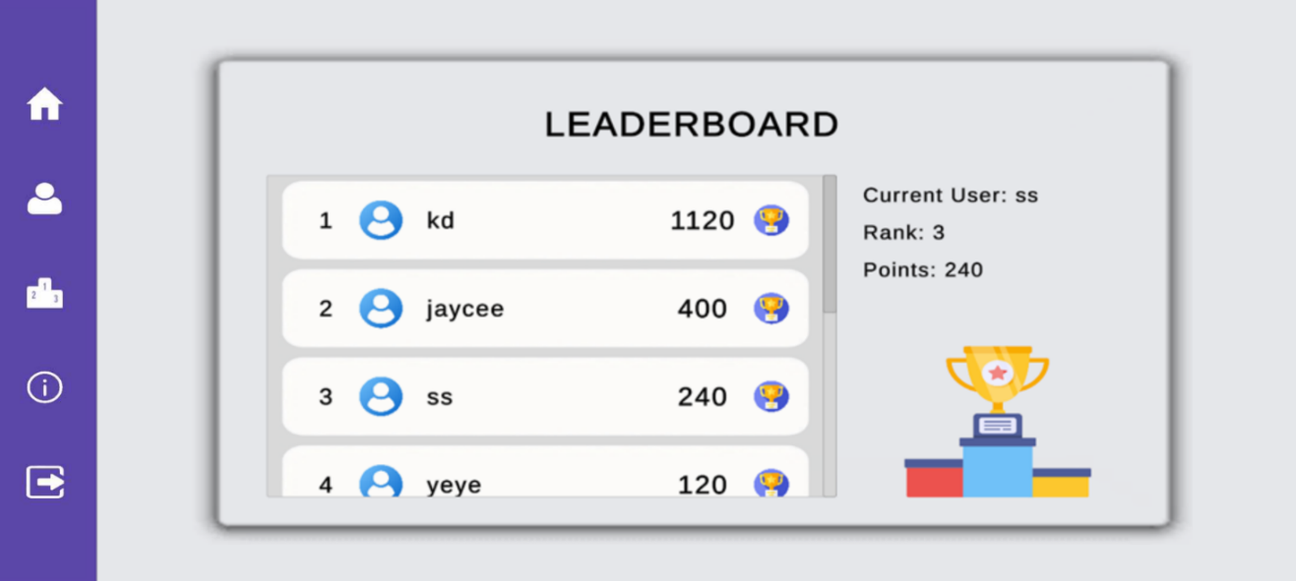

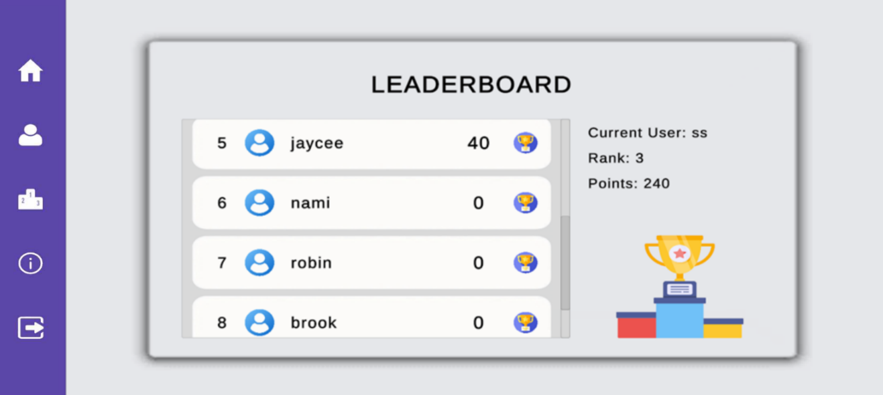

This shows the data used for testing the tutorial application’s leaderboard that consist of Rank, Username and points.

appendix J

User’s Manual

**How to Download:**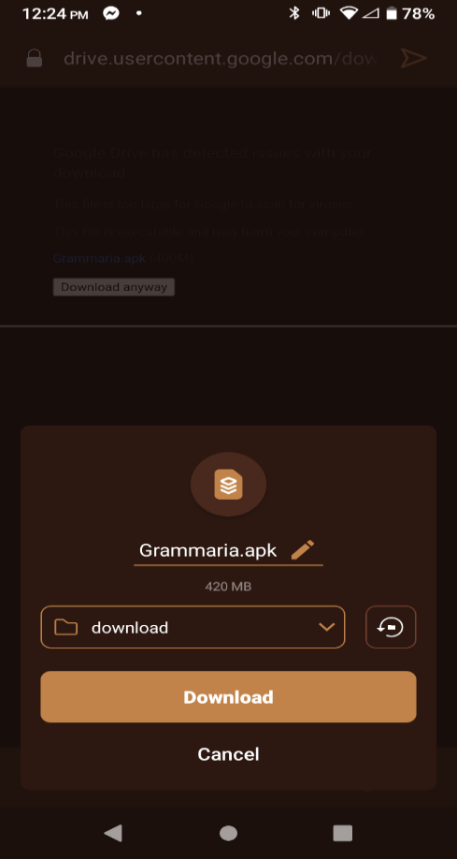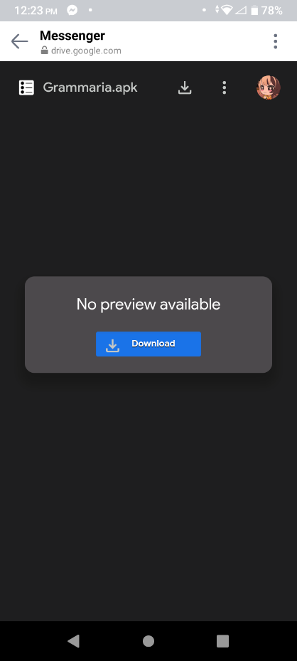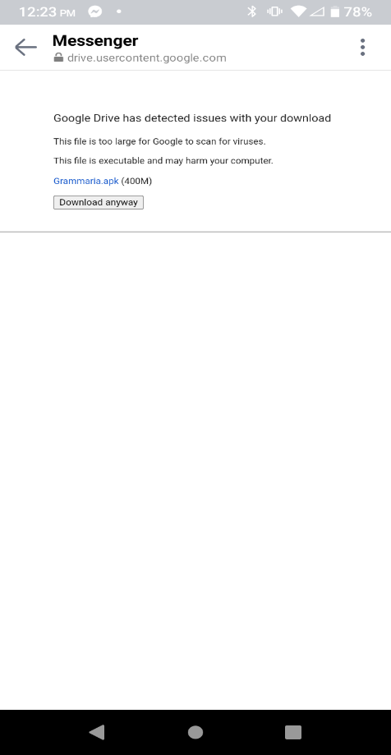

1. Click Download.
2. Click download anyway.
3. A window will appear and click download

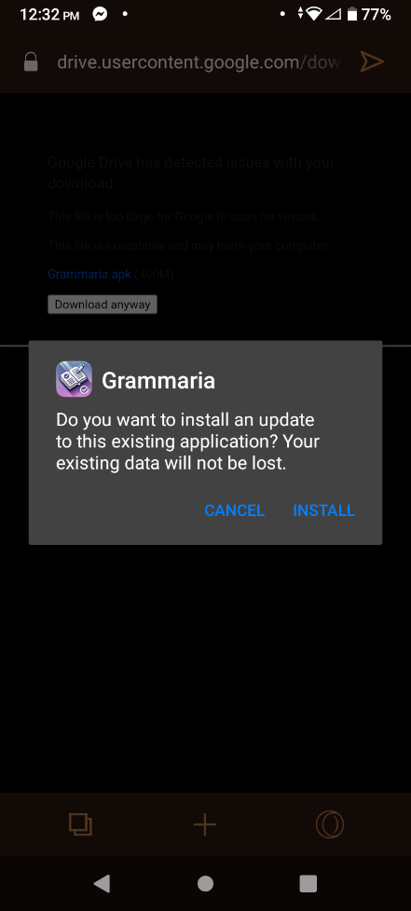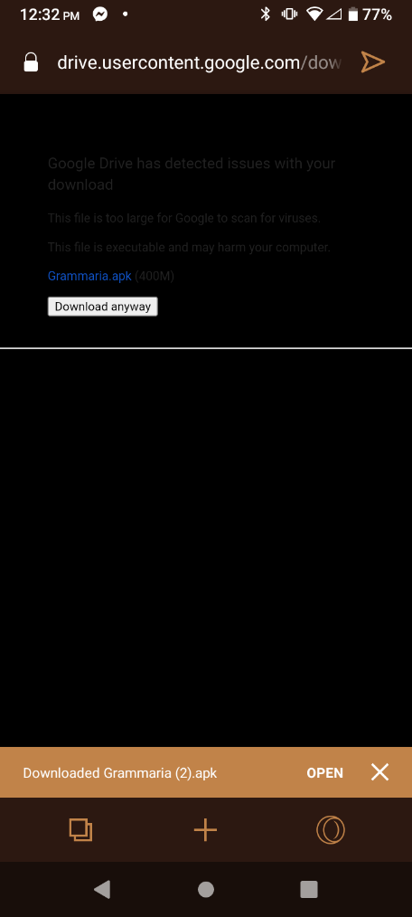**How to Install:**

1. Click the installed file
2. Click “Install” when a window popped out

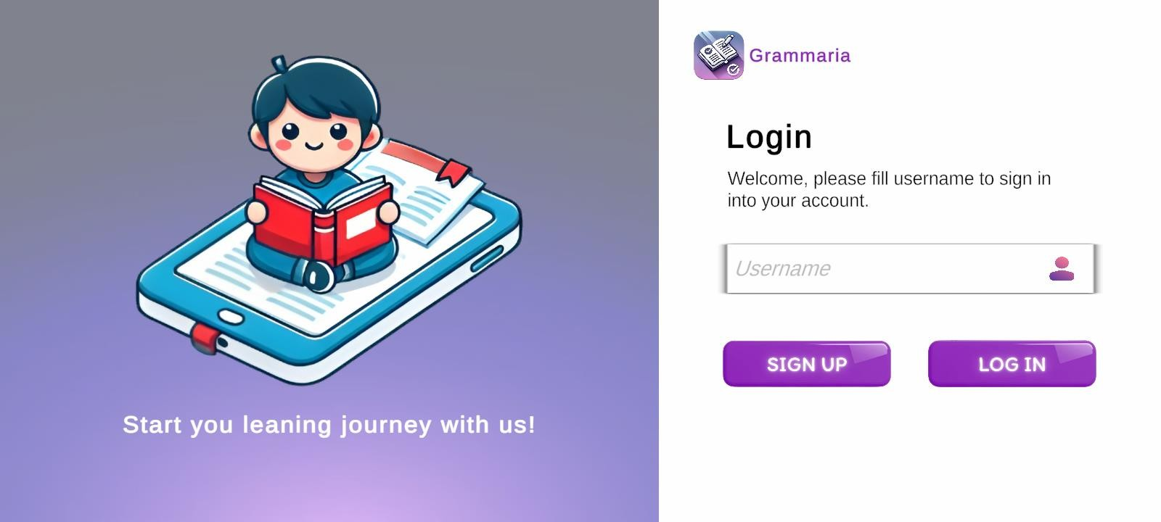**How to Use:**

Login/Signup

1. Click “Sign Up” if you don’t have an account.
2. Click “Login” if you have an existing account.



Home

1. Click “Start” to proceed to topic selection

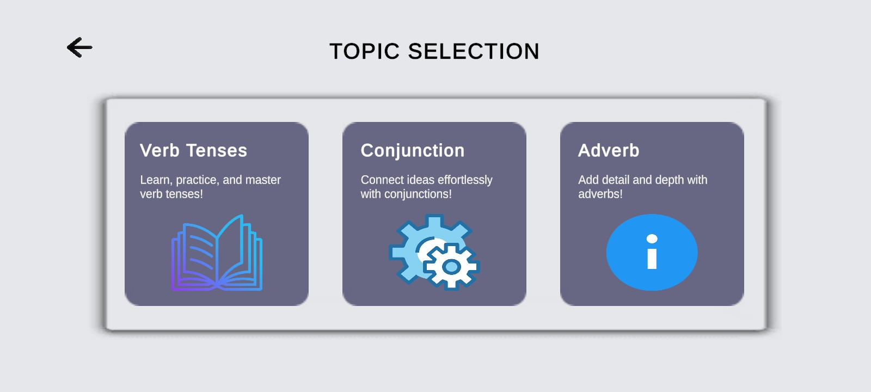

Topic Selection

1. Click “Verb Tenses” to learn all about tenses of verb.
2. Click “Conjunction” to learn all about conjunctions.
3. Click “Adverb” to learn all about adverbs.

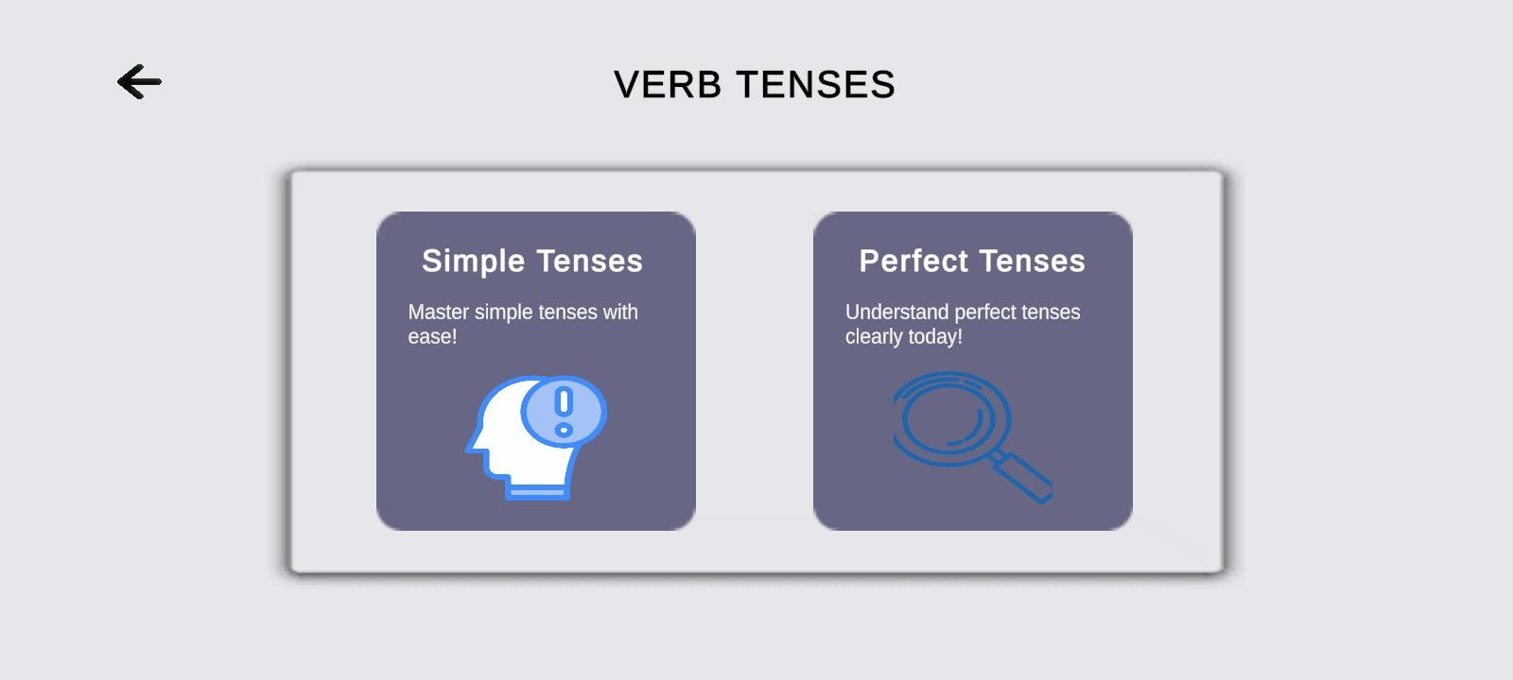

Verb Tenses Sub Topic Selection

1. After clicking on “Verb Tenses” topic you will have to choose a sub topic.
2. Click either “Simple Tense” or “Perfect Tense” to proceed.

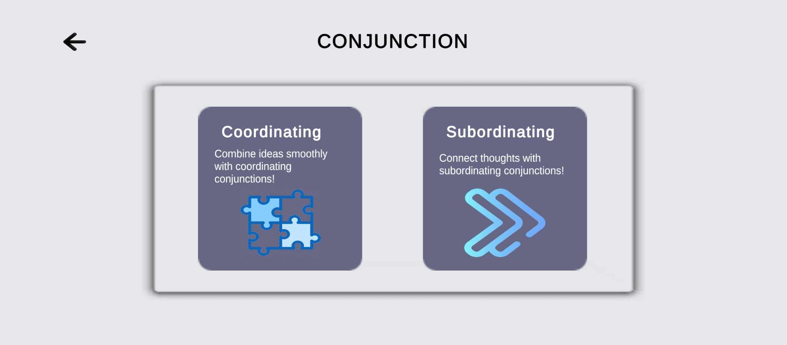

Conjunction Sub topic Selection

1. After clicking on “Conjunction” topic you will have to choose a sub topic.
2. Click either “Coordinating” or “Subordinating” to proceed.

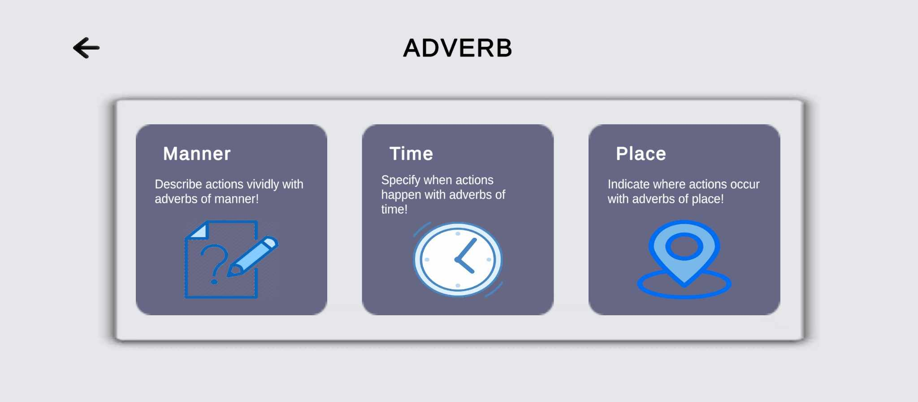

Adverb Sub topic Selection

1. After clicking on “Adverb” topic you will have to choose a sub topic.
2. Click either “Manner”, “Time” or “Place” to proceed.

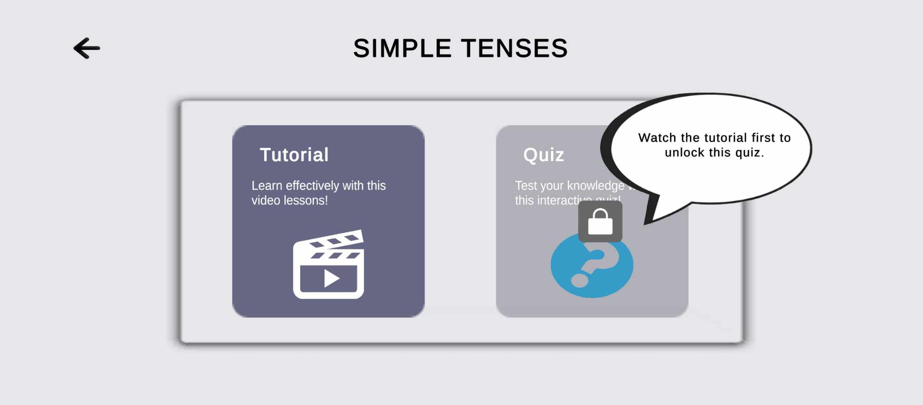

Sub topic Options

1. Each subtopics includes tutorial and quiz options. Initially, the quizzes are locked, indicated by lock icon. To unlock it, players must watch the tutorial first associated with that topic.

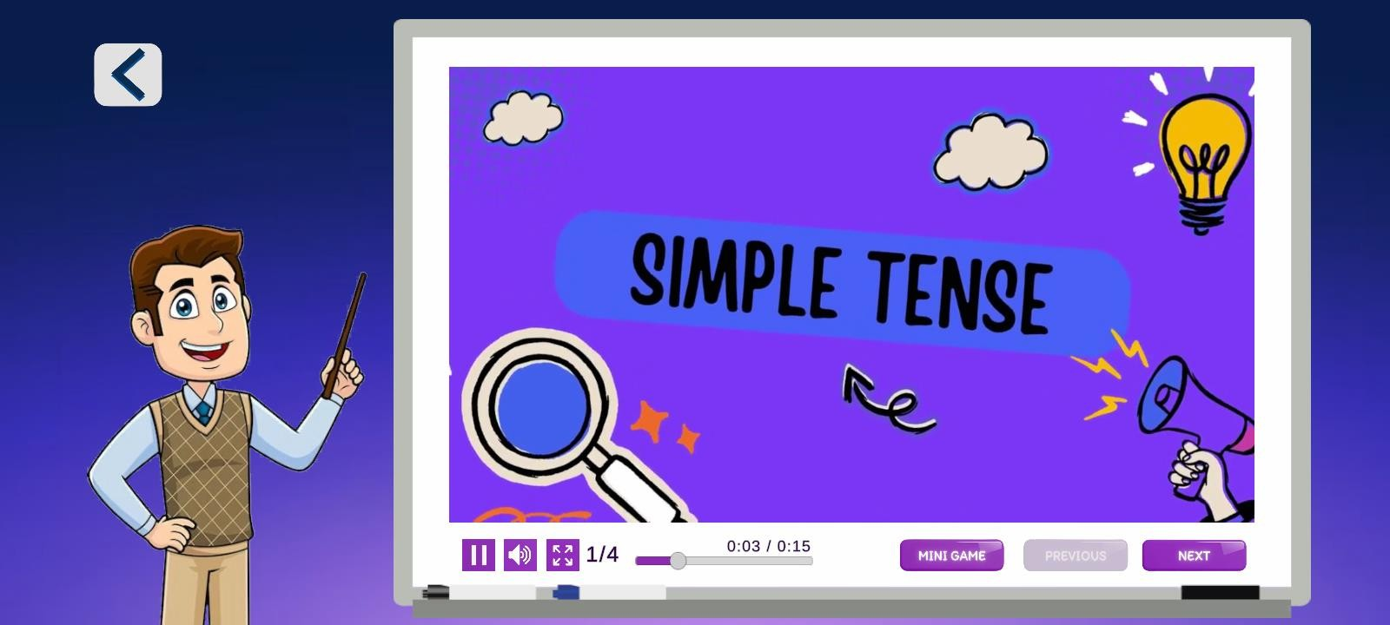

Tutorial Video

1. Watch all the tutorial video to learn and unlock the Quiz of each topic.
2. Click “Pause” Button to pause the video.
3. Click the “Sound” Button to mute or unmute the video.
4. Click the “Fullscreen” Button to make the video larger.
5. Click the “Mini Game” to access the word search.
6. Click the “Next” to proceed with the video tutorial.

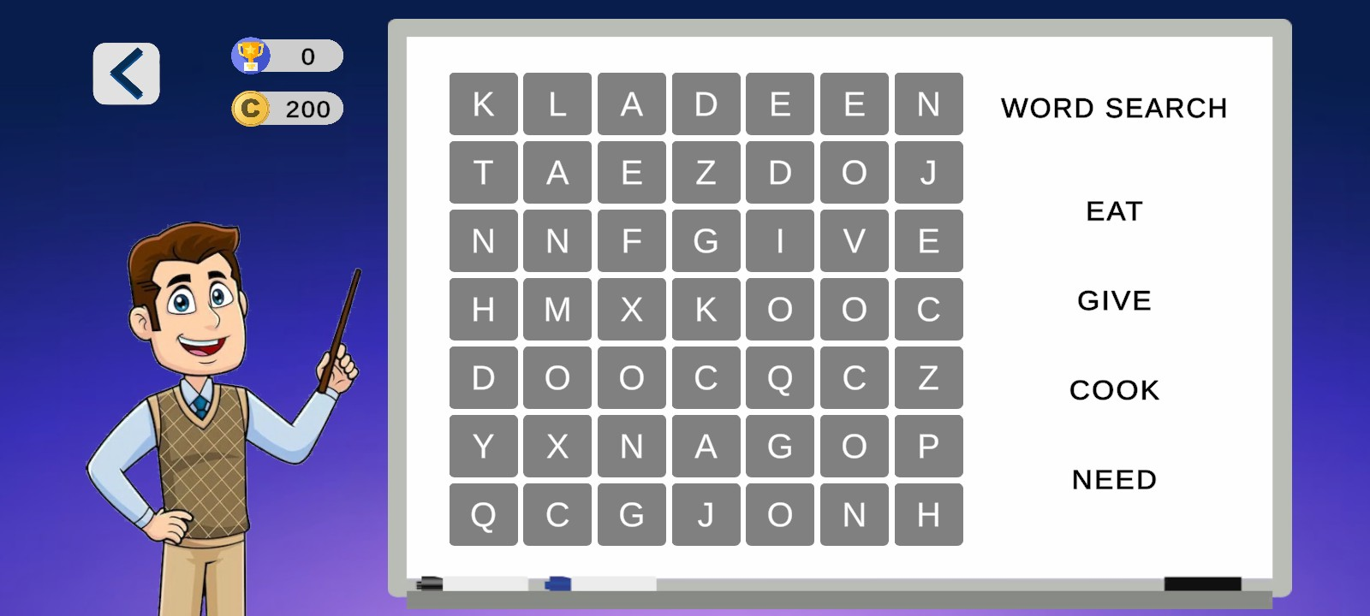

Mini Game

1. Find the word listed on the right.
2. Tap the correct letters in a straight line to form the word.

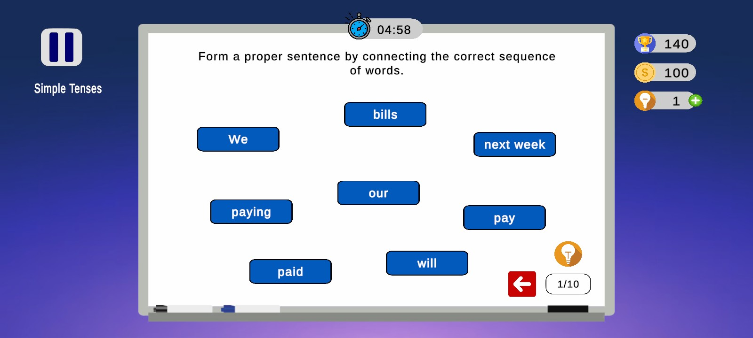

Simple Tense Quiz

1. Form a correct sentence by connecting the words in the correct order.
2. Achieve at least 8 correct answer to pass the quiz and earn coins.

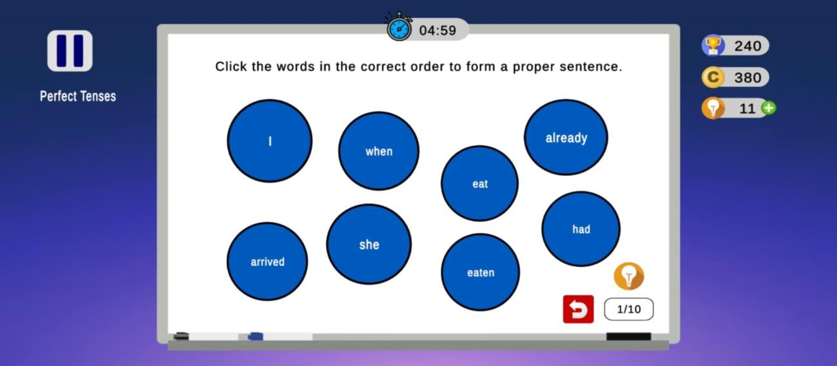

Perfect Tense Quiz

1. Tap the words in the correct sequence to form a correct sentence.
2. Achieve at least 8 correct answer to pass the quiz and earn coins.

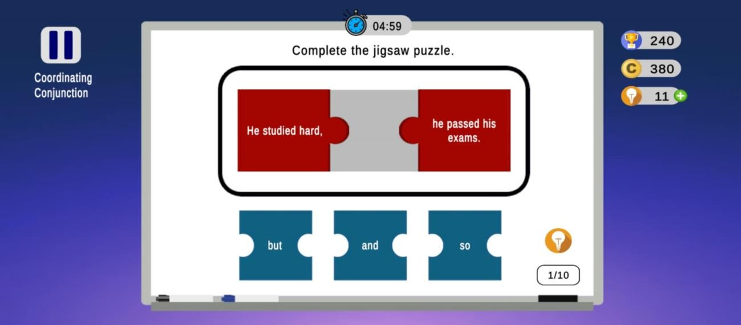

Coordinating Conjunction Quiz

1. Drag the right conjunction to complete the sentence.
2. Achieve at least 8 correct answer to pass the quiz and earn coins.

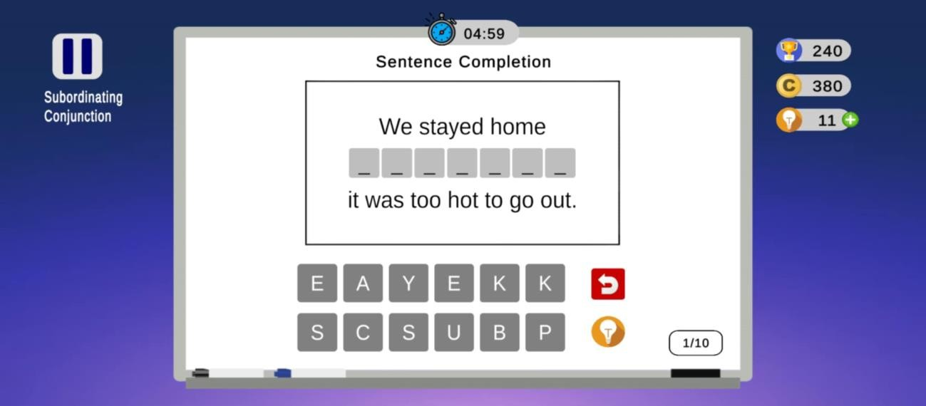

Subordinating Conjunction Quiz

1. Spell the correct conjunction to complete the sentence.
2. Achieve at least 8 correct answer to pass the quiz and earn coins.

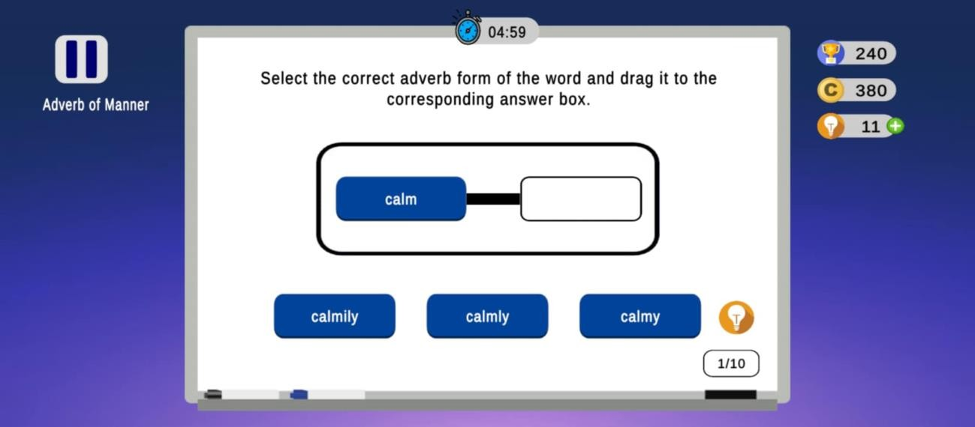

Adverb of Manner Quiz

1. Choose and click the correct adverb form of the adjectives given.
2. Achieve at least 8 correct answer to pass the quiz and earn coins.

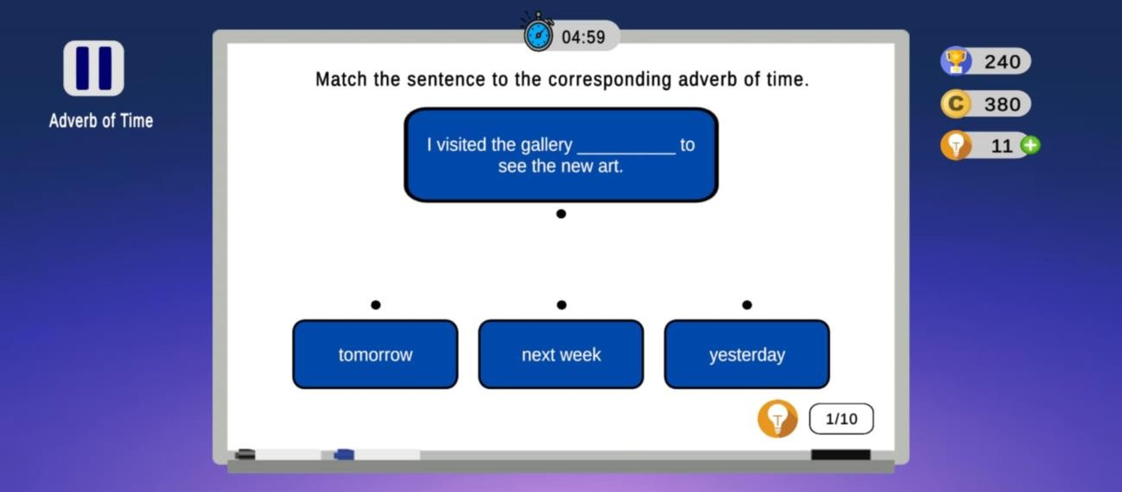

Adverb of Time Quiz

1. Connect the correct adverb of time to complete the sentence
2. Achieve at least 8 correct answer to pass the quiz and earn coins.

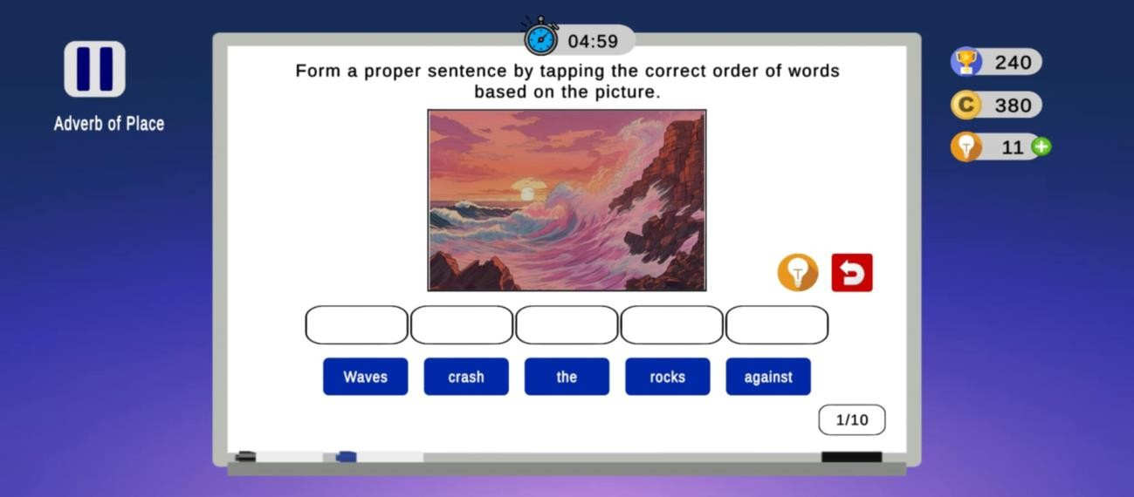

Adverb of Place

1. Form a sentence by clicking the words in the correct order based on the picture.
2. Achieve at least 8 correct answer to pass the quiz and earn coins.



User Profile

1. Tap the “User Profile” icon to see your progress and high scores.

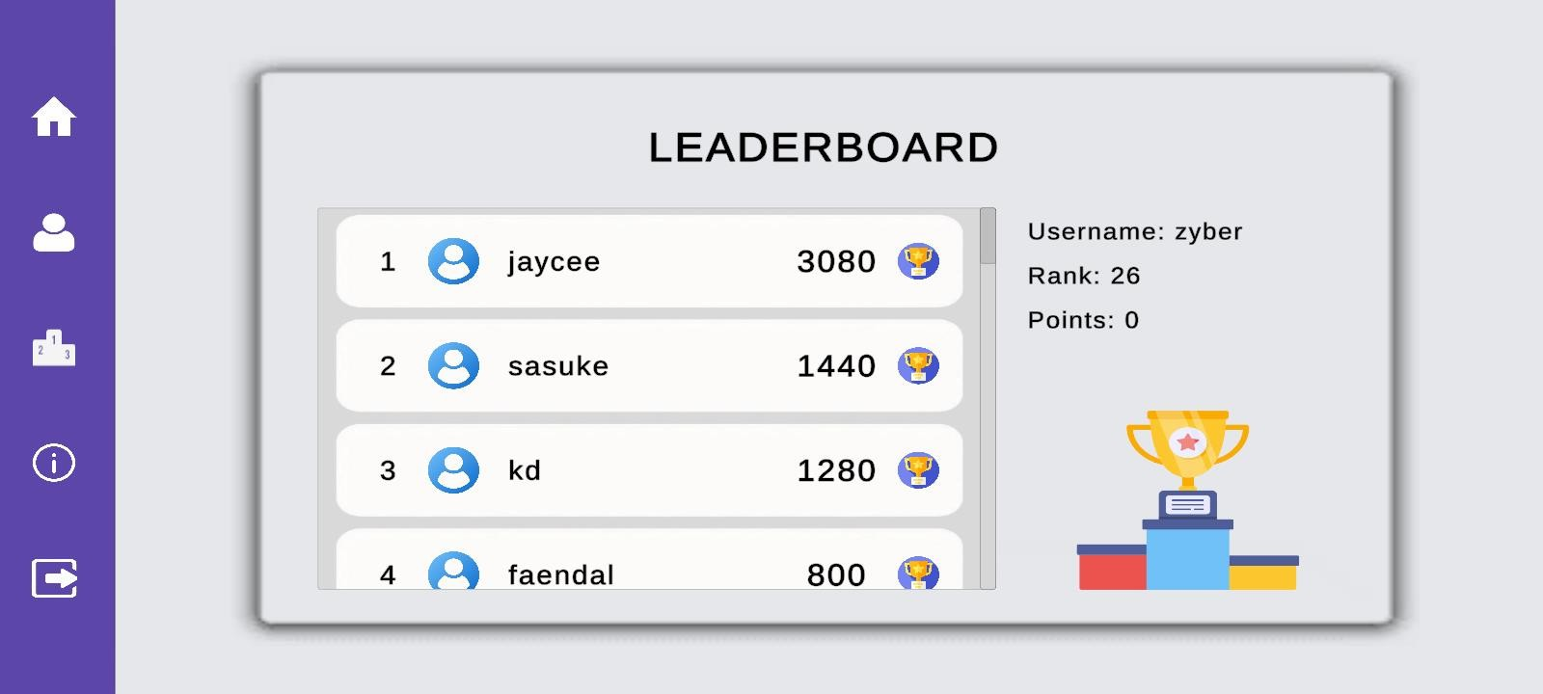

Leaderboard

1. Tap the “Leaderboard” icon to view your ranking based on your points.

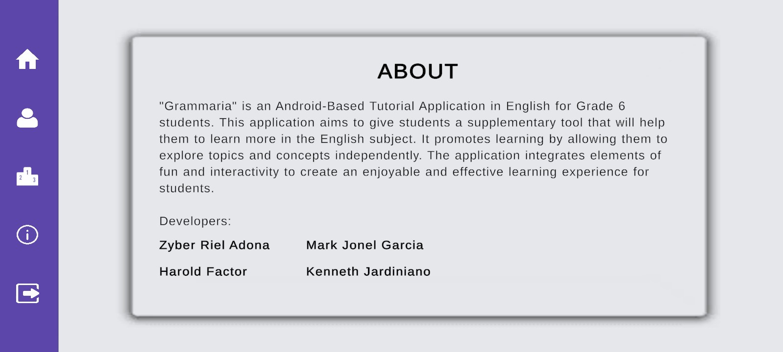

About

1. Tap the “About” icon to learn about the game and developers.

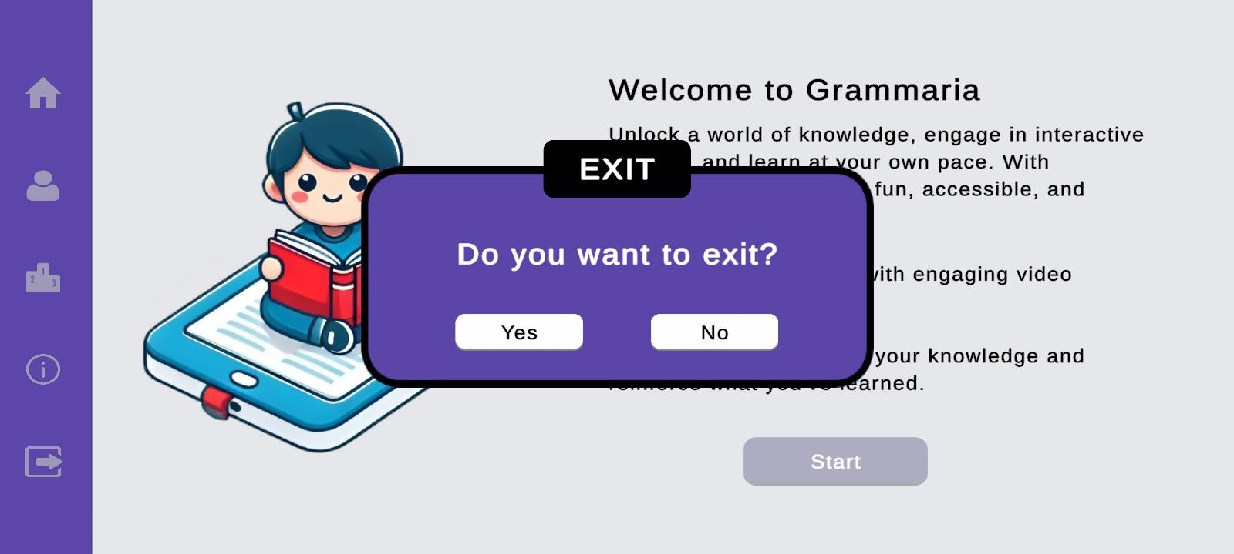

Exit

1. Tap yes if you want to exit the application and no if you want to stay.

Appendix k

Sample Accomplishment and Consultation Form



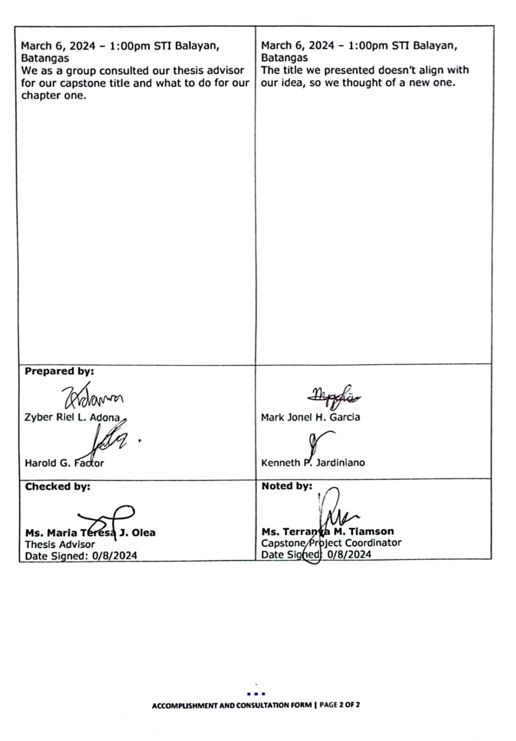

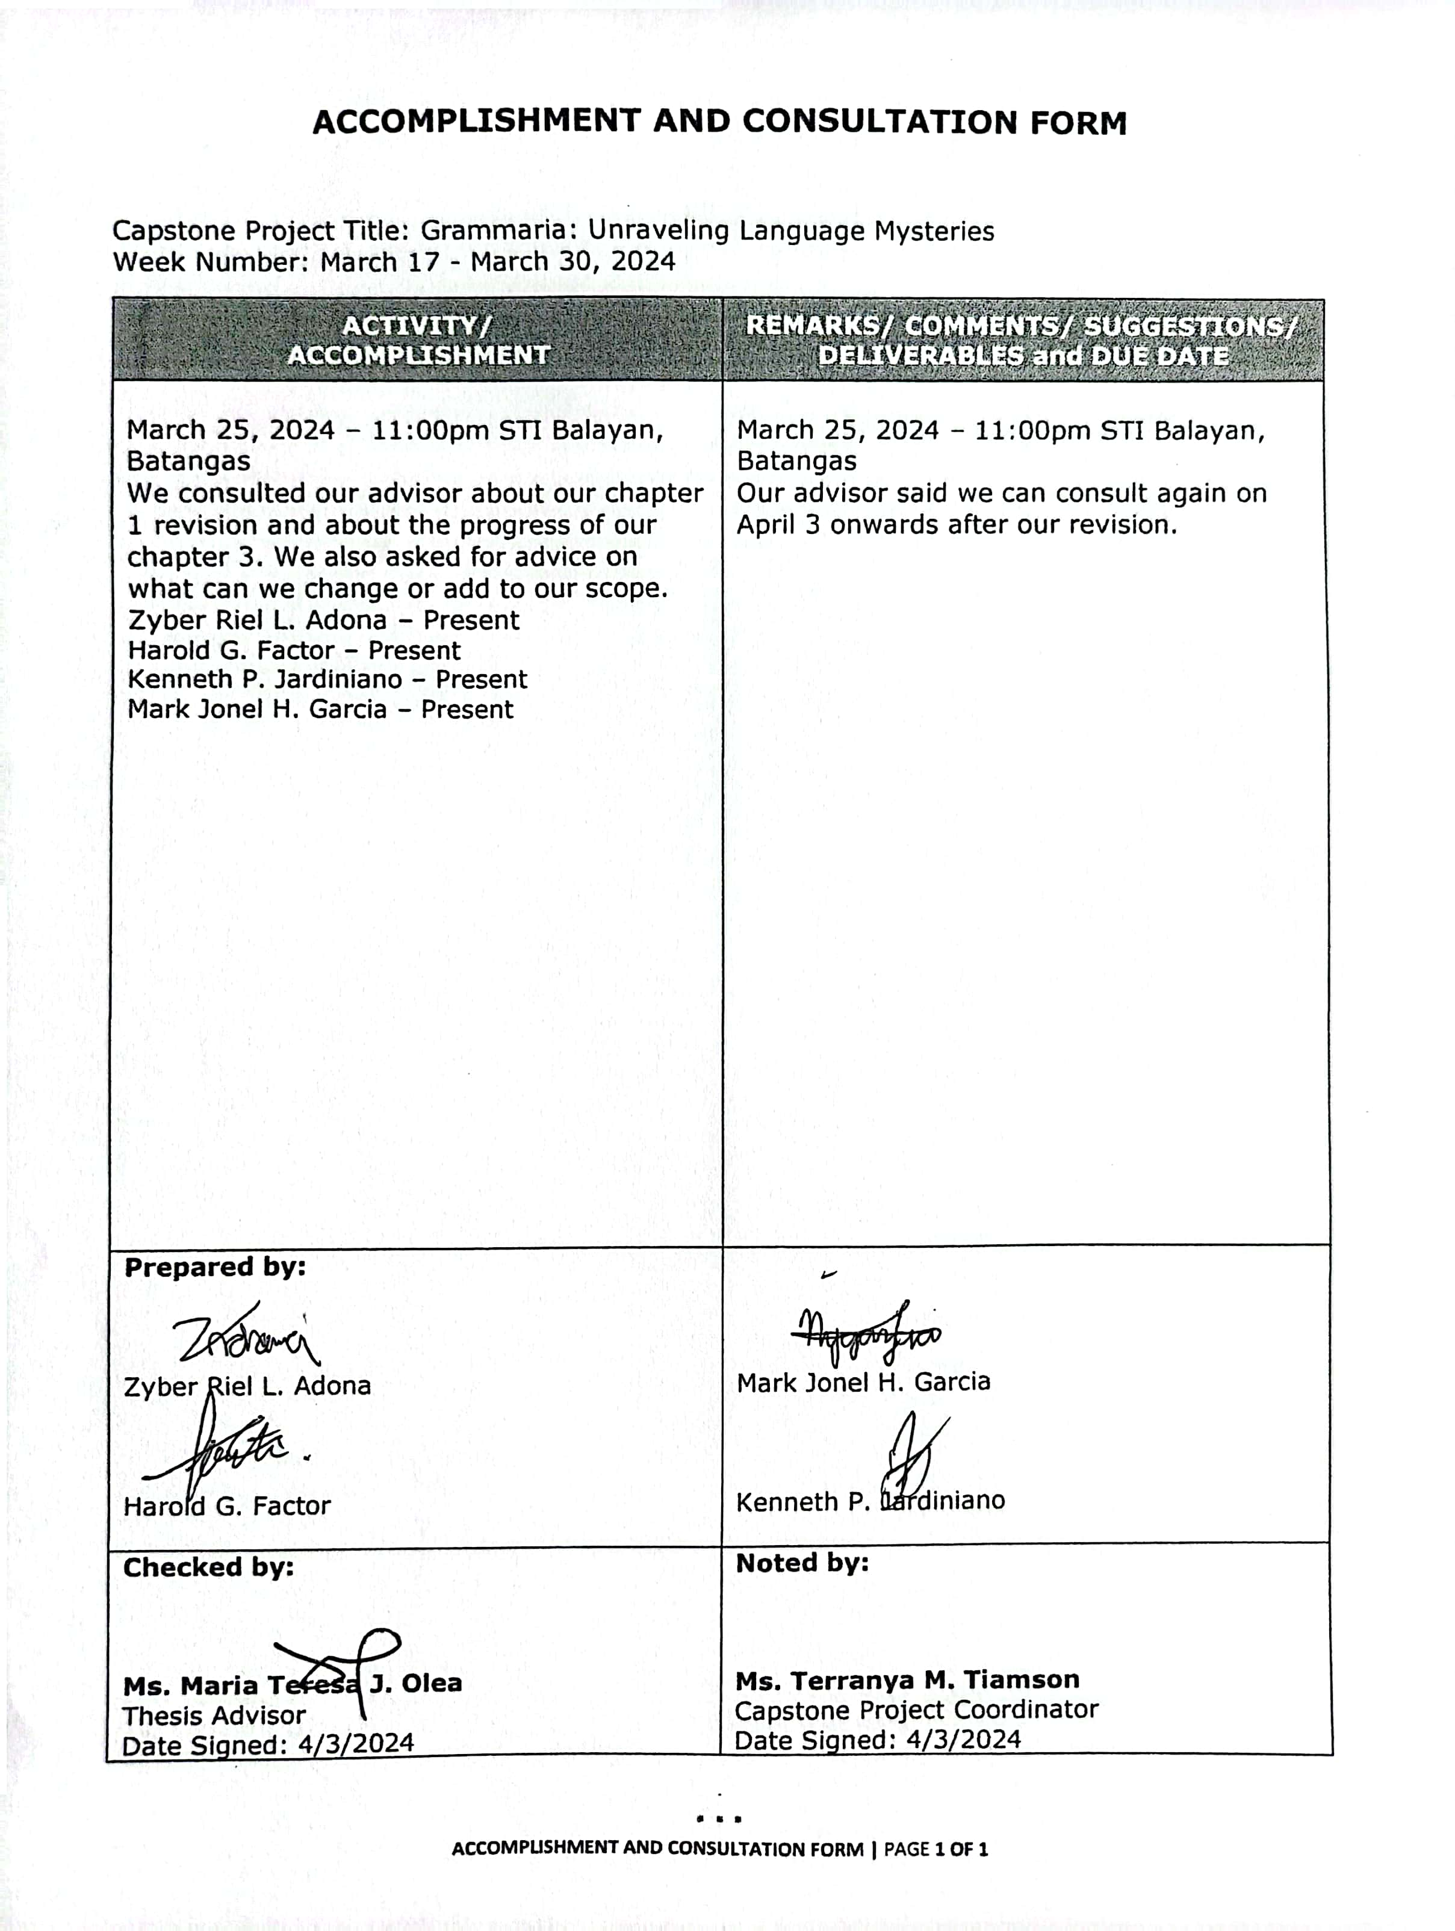

Appendix L

Personal Technical Vitae

Curriculum Vitae of

Zyber Riel L. Adona

Brgy Lumbangan, Nasugbu, Batangas

zyberrieladona05@gmail.com

09476932276

EDUCATIONAL BACKGROUND

|  |  |  |
| --- | --- | --- |
| Level | Inclusive Dates | Name of school/ Institution |
| Tertiary | 2021 - Present | STI College Balayan |
| Senior High School | 2019 - 2021 | Pantalan Senior High School |
| Junior High School | 2015 - 2019 | Lian Institute |
| Elementary | 2009 - 2015 | Nasugbu West Central School |

AFFILIATIONS

|  |  |  |
| --- | --- | --- |
| Inclusive Dates | Name of Organization | Position |
| 2021-Present | Young Computer Programmers Association | Member |
|  |  |  |

SKILLS

* Proficient in programming languages such as Java, C# and SQL
* Basic knowledge in SAP Business One
* Basic knowledge in Blender
* Basic knowledge of graphic design tools like Canva
* Computer Literature (MS Office such as Word, Excel, PowerPoint)
* Excellent communication and teamwork skills

TRAININGS, SEMINARS, OR WORKSHOPS ATTENDED

|  |  |
| --- | --- |
| Inclusive Dates | Title of Training, Seminar, or Workshop |
| 2022 | Java Foundation |
| 2023 | Completion of SAP Business One |



Curriculum Vitae of

Harold G. Factor

Baclaran, Balayan, Batangas

Haroldfactor2003@gmail.com

0948-029-8778

EDUCATIONAL BACKGROUND

|  |  |  |
| --- | --- | --- |
| Level | Inclusive Dates | Name of school/ Institution |
| Tertiary | 2021 - Present | STI College Balayan |
| Senior High School | 2019 - 2021 | STI College Balayan |
| Junior High School | 2015 - 2019 | La Conception College |
| Elementary | 2009 - 2015 | Baclaran Elementary School |

AFFILIATIONS

|  |  |  |
| --- | --- | --- |
| Inclusive Dates | Name of Organization | Position |
| 2021-Present | Young Computer Programmers Association | Member |
|  |  |  |

SKILLS

* Computer Proficient (Microsoft Word, Excel, Access, Outlook, and PowerPoint)
* Ability to work individually or in a team
* Willing to work collaboratively

Curriculum Vitae of

Mark Jonel H. Garcia

017, Tagudtod, San Nicolas, Batangas

markjonelgarcia0@gmail.com

0906-715-9448

EDUCATIONAL BACKGROUND

|  |  |  |
| --- | --- | --- |
| Level | Inclusive Dates | Name of school/ Institution |
| Tertiary | 2021 - Present | STI College Balayan |
| Senior High School | 2019 - 2021 | Rizal College of Taal |
| Junior High School | 2015 - 2019 | Maabud National High School |
| Elementary | 2009 - 2015 | San Nicolas Central School |

AFFILIATIONS

|  |  |  |
| --- | --- | --- |
| Inclusive Dates | Name of Organization | Position |
| 2021-Present | Young Computer Programmers Association | Member |
|  |  |  |

SKILLS

* Knowledgeable in using MS Offices (Word, PowerPoint, Excel)
* Basic knowledge in Mobile Application and Web Development
* Basic Knowledge in SAP Business One
* Basic Knowledge in 2D and 3D digital graphic design using Synfig and Blender
* Good Communication Skills

TRAININGS, SEMINARS, OR WORKSHOPS ATTENDED

|  |  |
| --- | --- |
| Inclusive Dates | Title of Training, Seminar, or Workshop |
| 2023 | Completion of SAP Business One |



Curriculum Vitae of

Keneth P. Jardiniano

Tuyun-tuyun, Tuy, Batangas

kenjardiniano@gmail.com

0969-283-0380

EDUCATIONAL BACKGROUND

|  |  |  |
| --- | --- | --- |
| Level | Inclusive Dates | Name of school/ Institution |
| Tertiary | 2021 - Present | STI College Balayan |
| Senior High School | 2019 - 2021 | Dr. Francisco L. Calingasan Memorial Colleges Doundation Inc. |
| Junior High School | 2015 - 2019 | Dr. Francisco L. Calingasan Memorial Colleges Doundation Inc. |
| Elementary | 2009 - 2015 | Gregorio Agoncillo Elementary School |

AFFILIATIONS

|  |  |  |
| --- | --- | --- |
| Inclusive Dates | Name of Organization | Position |
| 2021-Present | Young Computer Programmers Association | Member |
|  |  |  |

SKILLS

* Computer Proficient (Microsoft Word, Excel, Access, Outlook, and PowerPoint)
* Ability to cooperate
* Willing to work collaboratively

TRAININGS, SEMINARS, OR WORKSHOPS ATTENDED

|  |  |
| --- | --- |
| Inclusive Dates | Title of Training, Seminar, or Workshop |
| 2023 | Completion of SAP Business One |